**Institute of Information Technology**

**University of Dhaka**

**Topic: Automated Supply Chain Management System**

**Software Requirement Specification & Analysis (SE-406)**

**Submitted by:**

**Group 6**

**Umme Kulsum Tumpa - 1307  
 Mosamma Sultana Trina - 1313**

**Labib Muntasir - 1319**

**Rony Majumder - 1325  
 Fareya Azam -1331**

**Submitted to:**

**Dr. Kazi Muheymin-Us-Sakib**

**Professor**

Institute of Information Technology

University of Dhaka



**Table of Contents**

**1.Introduction**

**1.1 Propose**

**1.2 Intended Audience**

**1.3 Conclusion**

**2. Automated Supply Chain Management System Inception**

**2.1 Introduction**

**2.2 Current Business Structure and Block Diagram of HR, Warehouse, Purchase and Accounts management system**

2.2.1 HR Management system

2.2.1.1 Employee Attendance

2.2.1.2 Employee Salary

2.2.1.3 Employee leave

2.2.1.4 Employee overtime

2.2.1.5 General notices

2.2.1.6 Insurance/Injury cost claim

2.2.1.7 Help and support

**2.2.2 Warehouse Management System**

2.2.2.1 Inventory Management System

2.2.2.2 Transportation Management System

2.2.2.3 Logistics and Distribution Management System

**2.2.3 Purchase Management System**

**2.2.4 Accounts Management System**

**2.3 Inception**

**2.3.1 Identifying the client of our project**

**2.3.2 Icebreaking**

**2.3.3 Identify the Stakeholders**

**2.3.4 Identifying The Multiple Viewpoints Of The Stakeholder**

2.3.4.1 Employees' Point of View

2.3.4.2 Supervisors' Point of View

2.3.4.3 Management Point of View

2.3.4.4 Owner's Point of View

2.3.4.5 Buyers' and Suppliers' Point of View

**2.3.5 Proposed solutions**

**2.3.6 Nature of the solution that is desired**

**2.2.7 Conclusion**

**3. Elicitation of garments automation system**

**3.1 Collaborative requirements gathering**

**3.2 Quality function deployment**

3.2.1 Normal Requirements

3.2.2 Expected Requirements

3.2.3 Exciting Requirements

**3.3 Usage Scenario**

**3.3.1 Registration and Authentication System:**

A.Create Account

B.Login

C.Update Account

**3.3.2 Human Resource Management System**

A.Attendance

B.Application

C.Notices

**3.3.3 Purchase Management System**

* Purchase Request
* Goods Receipt
* Invoice Processing
* Supplier Performance Evaluation

**3.3.4 Accounts Management System**

* Salary Calculation and Confirmation
* Online Payment System
* On-Site Payment System
* Expense and Revenue Management
* Expense Tracking and Reporting

**3.3.5 Warehouse Management System**

* Inventory Management
* Transport Management
* Logistics and Distribution Management

**3.3.6 Production and Buyer Interaction Management**

* Production Negotiation and Buyer Interaction
* Sales and Income Management

**4. Scenario based modeling**

**4.1 Introduction**

**4.2 Use case Diagram**

* Primary Actor
* Secondary Actor

**4.3 Use case diagrams**

Level - 0

Level - 1

Level - 1.1

Level - 1.1.1

Level - 1.2

Level - 1.2.1

Level - 1.3

Level - 1.4

Level - 1.5

Level - 1.6

**4.4 Activity Diagram**

Activity diagram ID: 01

Activity diagram ID: 02

Activity diagram ID: 03

Activity diagram ID: 04

Activity diagram ID: 05

Activity diagram ID: 06

Activity diagram ID: 07

Activity diagram ID: 08

Activity diagram ID: 09

Activity diagram ID: 10

Activity diagram ID: 11

Activity diagram ID: 12

Activity diagram ID: 13

Activity diagram ID: 14

Activity diagram ID: 15

Activity diagram ID: 16

Activity diagram ID: 17

**4.5 Swim lane diagrams**

Swim lane Diagram ID: 01

Swim lane Diagram ID: 02

Swim lane Diagram ID: 03

Swim lane Diagram ID: 04

Swim lane Diagram ID: 05

Swim lane Diagram ID: 06

Swim lane Diagram ID: 07

Swim lane Diagram ID: 08

Swim lane Diagram ID: 09

Swim lane Diagram ID: 10

Swim lane Diagram ID: 11

Swim lane Diagram ID: 12

Swim lane Diagram ID: 13

**5. Data Based Modeling**

5.1 Noun Listing

5.2 Potential to be data object

5.3 Final Data Object list

5.4 Relations Between Data and Objects

5.6 ER DIAGRAM

5.7 Schema

**6. Class-based Modeling**

6.1 List of verbs

6.2 General Classification

6.3 Potential to be Class

6.4 Selection Criteria

6.5 Selected Classes

6.6 Finally Selected Classes

6.7 Class Cards

6.8 CRC Diagram

**7. Behavioral Modeling**

7.1 Event Identification

7. 2 State Transition diagrams

**8. Sequence Diagram**

**9. Data Flow**

**1. Introduction**

In today's dynamic business landscape, companies seek efficient and effective supply chain management to deliver products to their customers promptly and cost-effectively. An Automated Supply Chain Management System (ASCMS) serves as a software solution that empowers businesses to optimize their supply chains by streamlining processes, providing real-time data insights, and facilitating seamless collaboration among supply chain partners.

This Software Requirement Specification (SRS) document outlines the specific requirements for an ASCMS tailored to a multinational garment industry. The system will encompass the management of crucial supply chain aspects, focusing on warehouse operations, financial transactions, human resource management, and procurement activities.

**1.1 Purpose**

This document outlines the Software Requirement Specification (SRS) for the Automated Supply Chain Management System (ASCMS), emphasizing functional, non-functional, and supporting requirements in warehouse, accounts, HR, and purchase management. The requirements are independently numbered and categorized per industry standards.

The ASCMS SRS acts as the official communication tool between stakeholders and the development team, establishing a baseline for uniformity and consistency. It serves as a common reference point for both parties.

Through collaborative efforts, the ASCMS SRS will evolve iteratively, ensuring alignment with stakeholder needs and supply chain management dynamics. The document focuses on warehouse management, with sub-modules like inventory, transport, logistics, and distribution management strategically integrated for operational efficiency. The ASCMS SRS aims to meet and exceed industry standards, providing a robust foundation for the development of an advanced and effective Automated Supply Chain Management System.

**1.2 Intended Audience**

This SRS report is crafted for key stakeholders involved in the development of the Automated Supply Chain Management System (ASCMS):

1. Users and Administrators: Refer to this document to ensure that ASCMS aligns with customer expectations and criteria for essential functionality.
2. Project Managers: Utilize it for planning milestones, establishing timelines, and monitoring progress, ensuring alignment with customer needs throughout the development lifecycle.
3. Designers: Use this SRS as a foundation for system design, ensuring that the design meets customer expectations.
4. Developers: Rely on this document to understand the required functionality and specifications for developing ASCMS, linking requirements to the software they create.
5. Testers: Utilize the SRS to derive comprehensive test plans and cases, running tests on partial and final software to ensure alignment with specified requirements.
6. Quality Assurance Team: Refer to the SRS to ensure overall quality and compliance, reviewing the completed system against the documented requirements.
7. Customer Representatives: Use this document as a benchmark to validate that ASCMS aligns with their business needs, providing feedback to ensure customer satisfaction.

This concise overview ensures the SRS serves as a central guide for effective communication and collaboration across the development lifecycle.

**1.3 Conclusion**

This Software Requirements Specification (SRS) document clearly explains the requirements for the Automated Supply Chain Management System (ASCMS). It provides a common understanding for everyone involved in the project, ensuring that the system meets the needs of all stakeholders. This detailed SRS paves the way for the successful implementation of an ASCMS that optimizes supply chain operations and drives business success in the garment industry.

**2. Automated Supply Chain Management System Inception**

The inception part of our SRS is briefly discussed in this part .

**2.1 Introduction**

The Automated Supply Chain Management System (ASCMS) is a software solution designed to enhance communication and streamline transactions among stakeholders, including supply chain employees, engineers, supervisors, and management. This document serves as an initial demand list, capturing the stakeholders' requirements and expectations for the anticipated software. The envisioned features and interfaces of the ASCMS aim to simplify and optimize their workflow, offering a comprehensive solution to facilitate efficient supply chain management.

**2.2 Current Business Structure and Block Diagram of HR, Warehouse, Purchase and Accounts management system**

The purpose of this project is to automate communication and management between the worker, supervisors, engineers and management. The current system is completely manual and paper based, causing human error and time consuming efforts on both ends of the communication. Our goal is to lessen the hassle and time required of the employees and management and automate the communication and warehouse management among all entities.

Currently, the functionalities of some departments of our consideration are manual. Let us look at different functionalities.

**2.2.1 HR Management system**

**2.2.1.1 Employee Attendance**

Employee attendance is taken manually everyday. It is a paper based system.

**2.2.1.2 Employee Salary**

Employee salary is given out monthly, based on attendance and hourly wage. The supervisor of a unit is responsible for taking attendance and salary from management and distributing it to the employees and engineers.

**2.2.1.3 Employee leave**

Employee leaves are conducted manually by letting the supervisor know. Since the supervisor has no data stored of employee absences and presence, employee leaves are not calculated appropriately.

**2.2.1.4 Employee overtime**

Employee overtime requests are taken manually and based on the amount of requests granted manually.

**2.2.1.5 General notices**

Employees have to submit their application for leave and employee's identity, reason for leave, date, total number of days applied for leave etc will be recorded manually into a database based on that application. To inform any notice, the department head will declare the notice to everyone in person.

**2.2.1.6 Insurance/Injury cost claim**

The insurance and injury claims are made manually, making the process hectic and time consuming.

**2.2.1.7 Help and support**

Regarding help and support, the employee must contact the supervisor directly. There are no alternatives if the supervisor is unavailable.

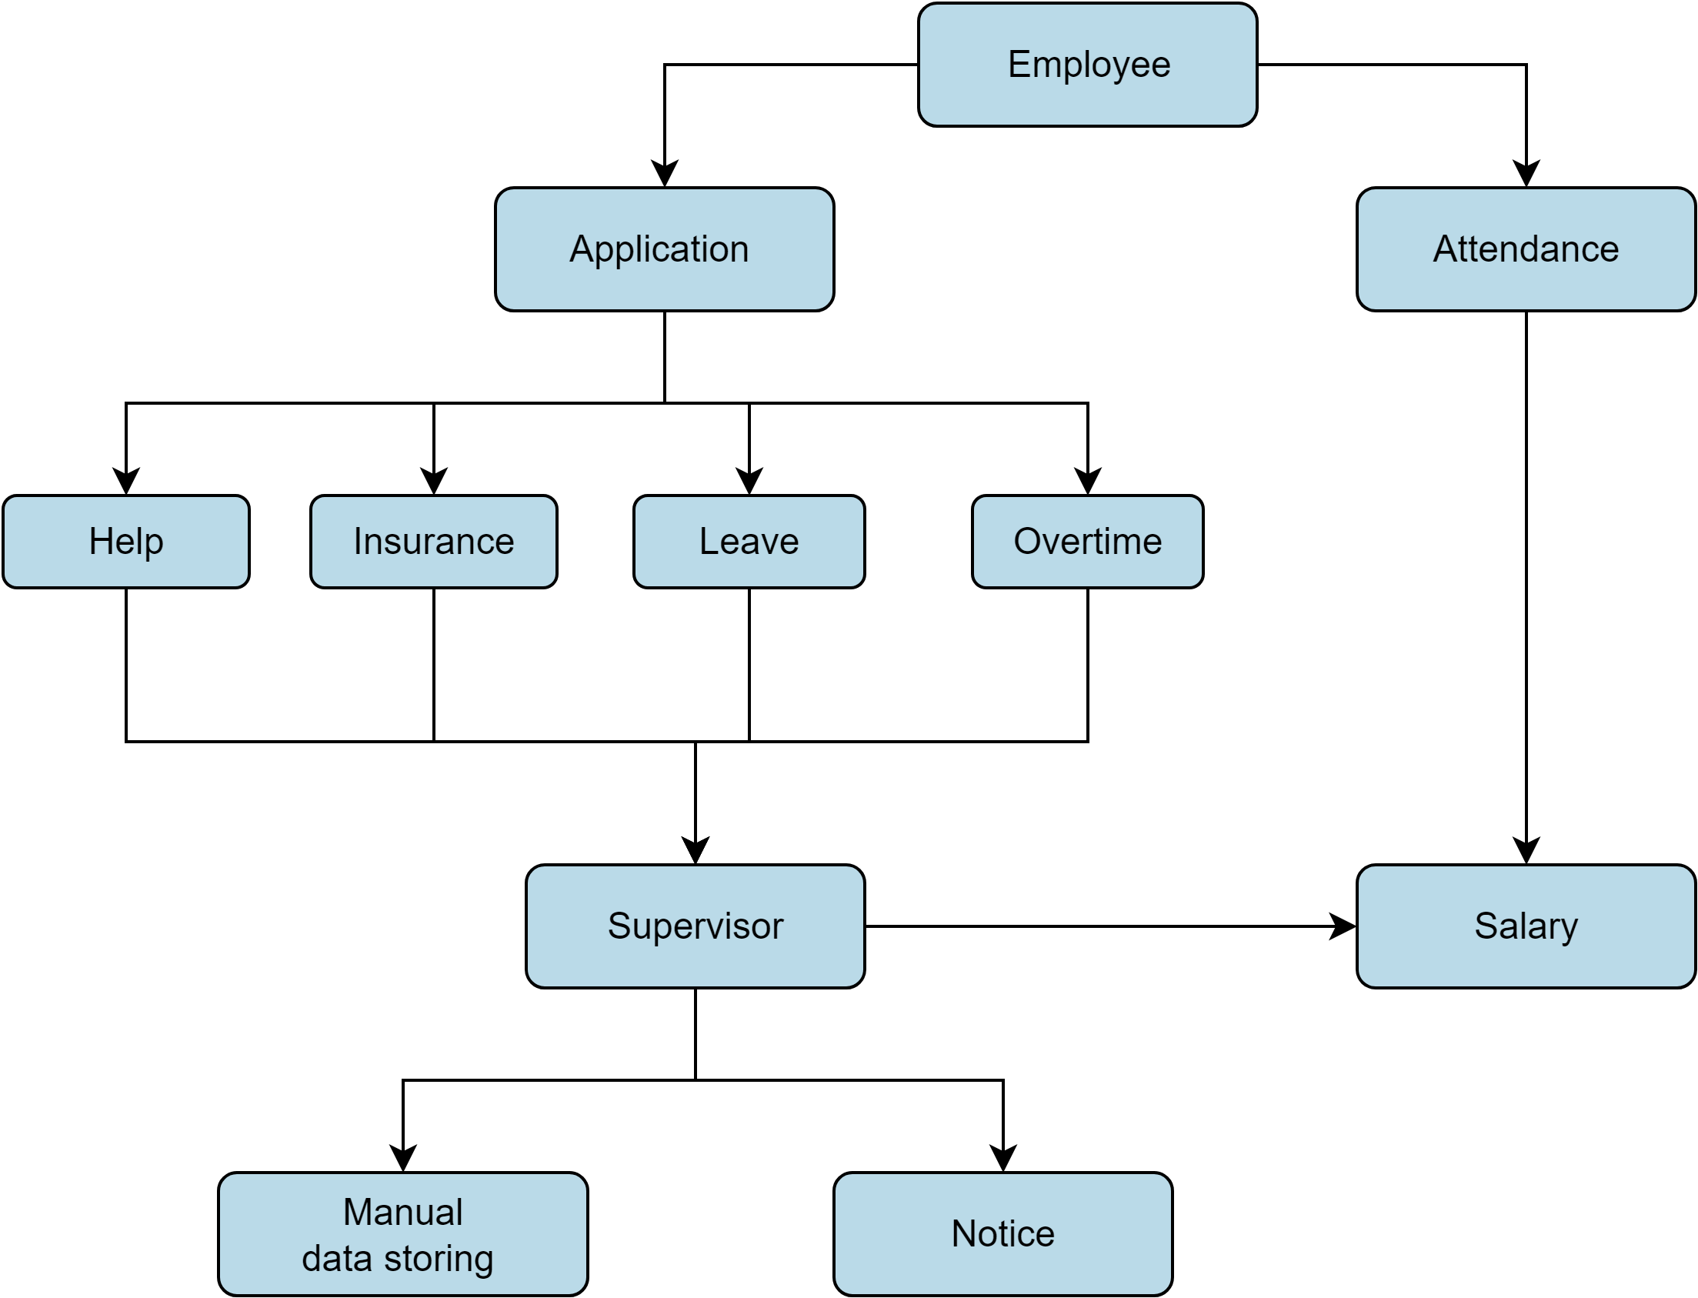

*Figure 1: Current system of UTC garment industry*

**2.2.2 Warehouse Management System**

**2.2.2.1 Inventory Management System**

Inventory management can be defined as a list of raw materials, components or complete products in a well organized way. Paper based system is error prone, not easily maintainable, and lacks transparency. Data retrieval and searching is inconvenient. It is hard to make an instant report when information about stored products or raw materials is needed.

[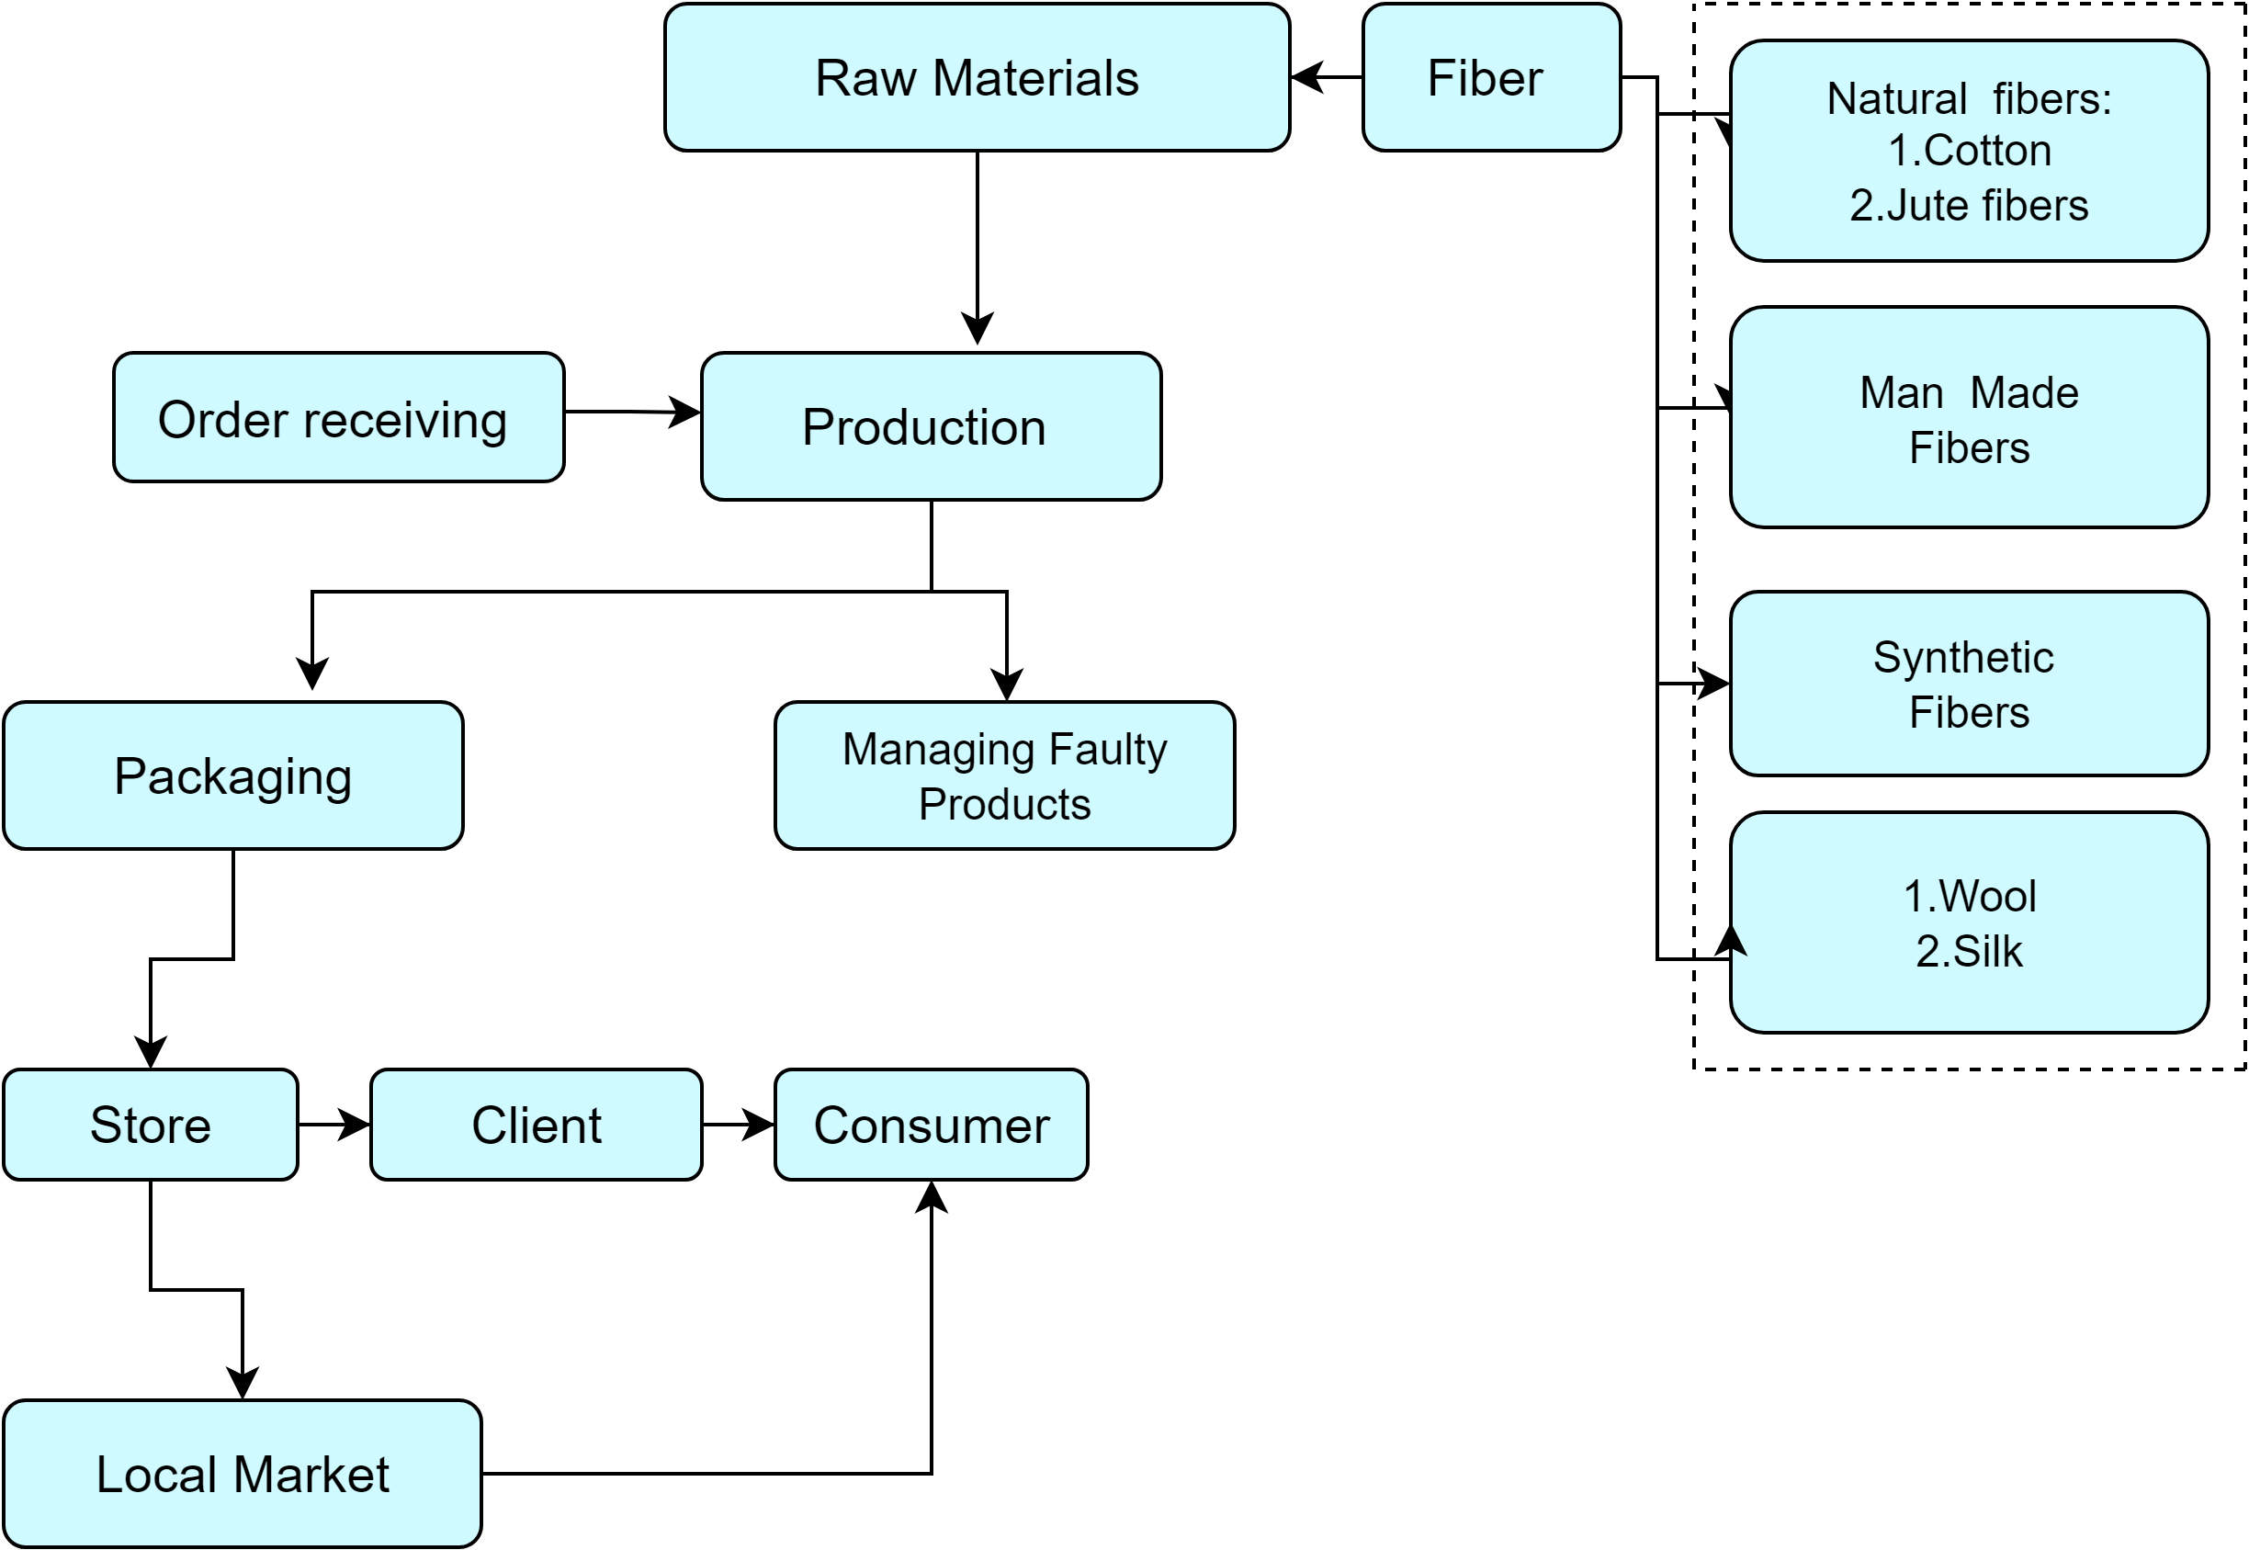](https://app.diagrams.net/?page-id=fCPulB_Hnb7UA6qnRGfe&scale=auto#G1J9j9oEXMUon114qUOrtN2BLuVOUg-V7_)

*Figure 2 : Current system of warehouse of the garment industry*

**2.2.2.2 Transportation Management System**

After the meticulous process of curating the latest fashion trends for their customers, The company's store management takes the next step towards excellence. Once the order list is compiled, it seamlessly transitions into our advanced Transportation Management System (TMS).The current Transport system only manages the selection of vehicles with minimum cost and ensures the delivery report within time limit.

[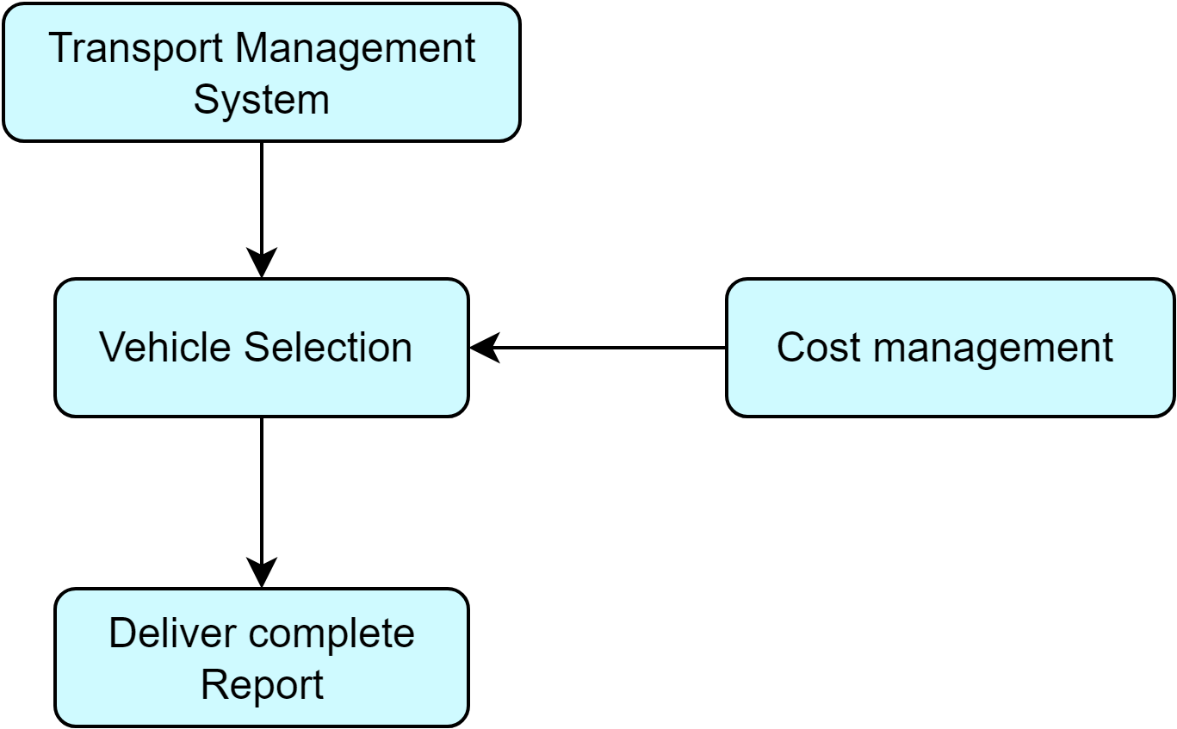](https://app.diagrams.net/?page-id=6Y3PNru83evn0i-B6YQX&scale=auto#G1U1fKzMDu52IpsvZqwEQhMH4KJvDL7TPv)

*Figure 3: Current Transportation Management System*

**2.2.2.3 Logistics and Distribution Management System**

The Logistics and Distribution System, store management sends orders to the warehouse, which communicates with production for fulfillment. The Transport Management System (TMS) ensures smooth transportation from production to the warehouse and store. TMS-generated reports after fulfilling the order without any fault to the store management, streamlining the entire supply chain for optimal efficiency.

[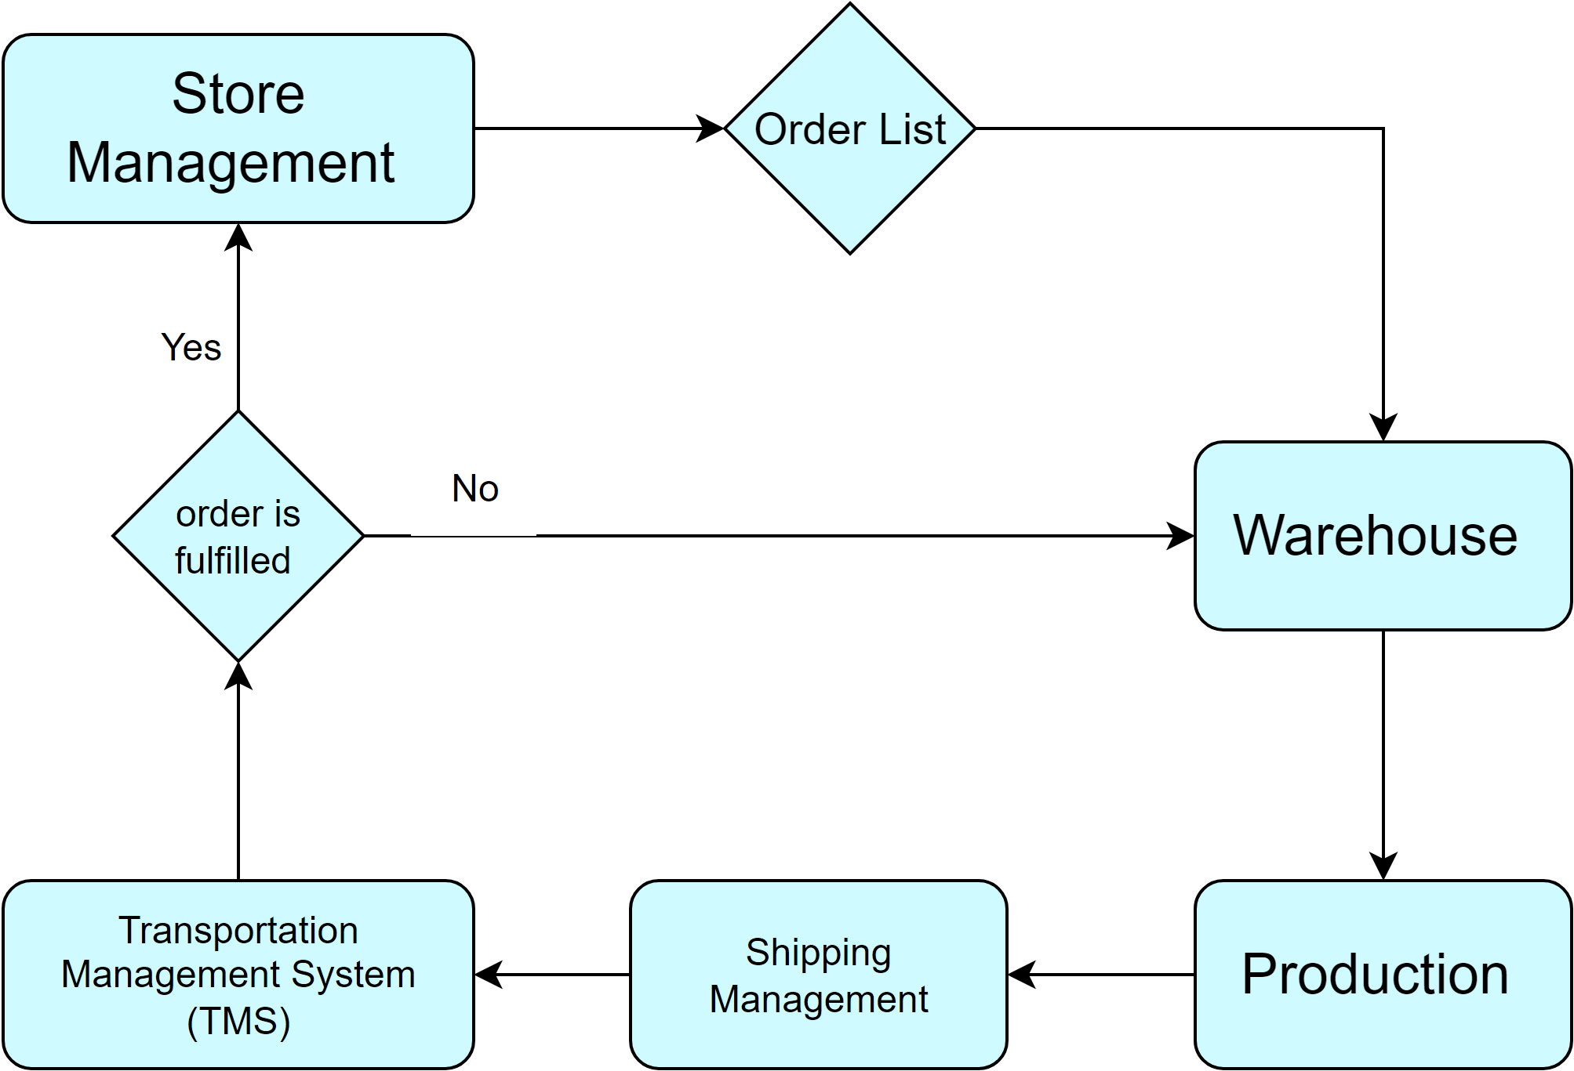](https://app.diagrams.net/?page-id=mu10D5aESWPt9nxkGkNi&scale=auto#G1xyi5TnUMoE_GdYWH3SZmER18XPZMz_H8)

*Figure 4: current logistic and distribution system*

**2.2.3 Purchase Management System**

Purchase Management involves the streamlined handling of procurement processes, from buyer requests to supplier orders, ensuring efficient supply chain operations.Here is the current purchasing process.

[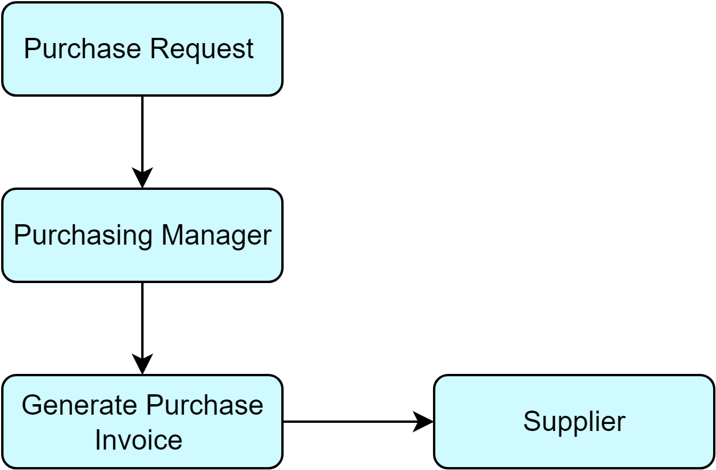](https://app.diagrams.net/?page-id=gpetD4FUKNiX0r6nztvr&scale=auto#G13rc63Nv6FhObozqcSXpQa02r9kR64Fbu)

*Figure 5: current purchase management*

**2.2.4 Accounts Management System**

[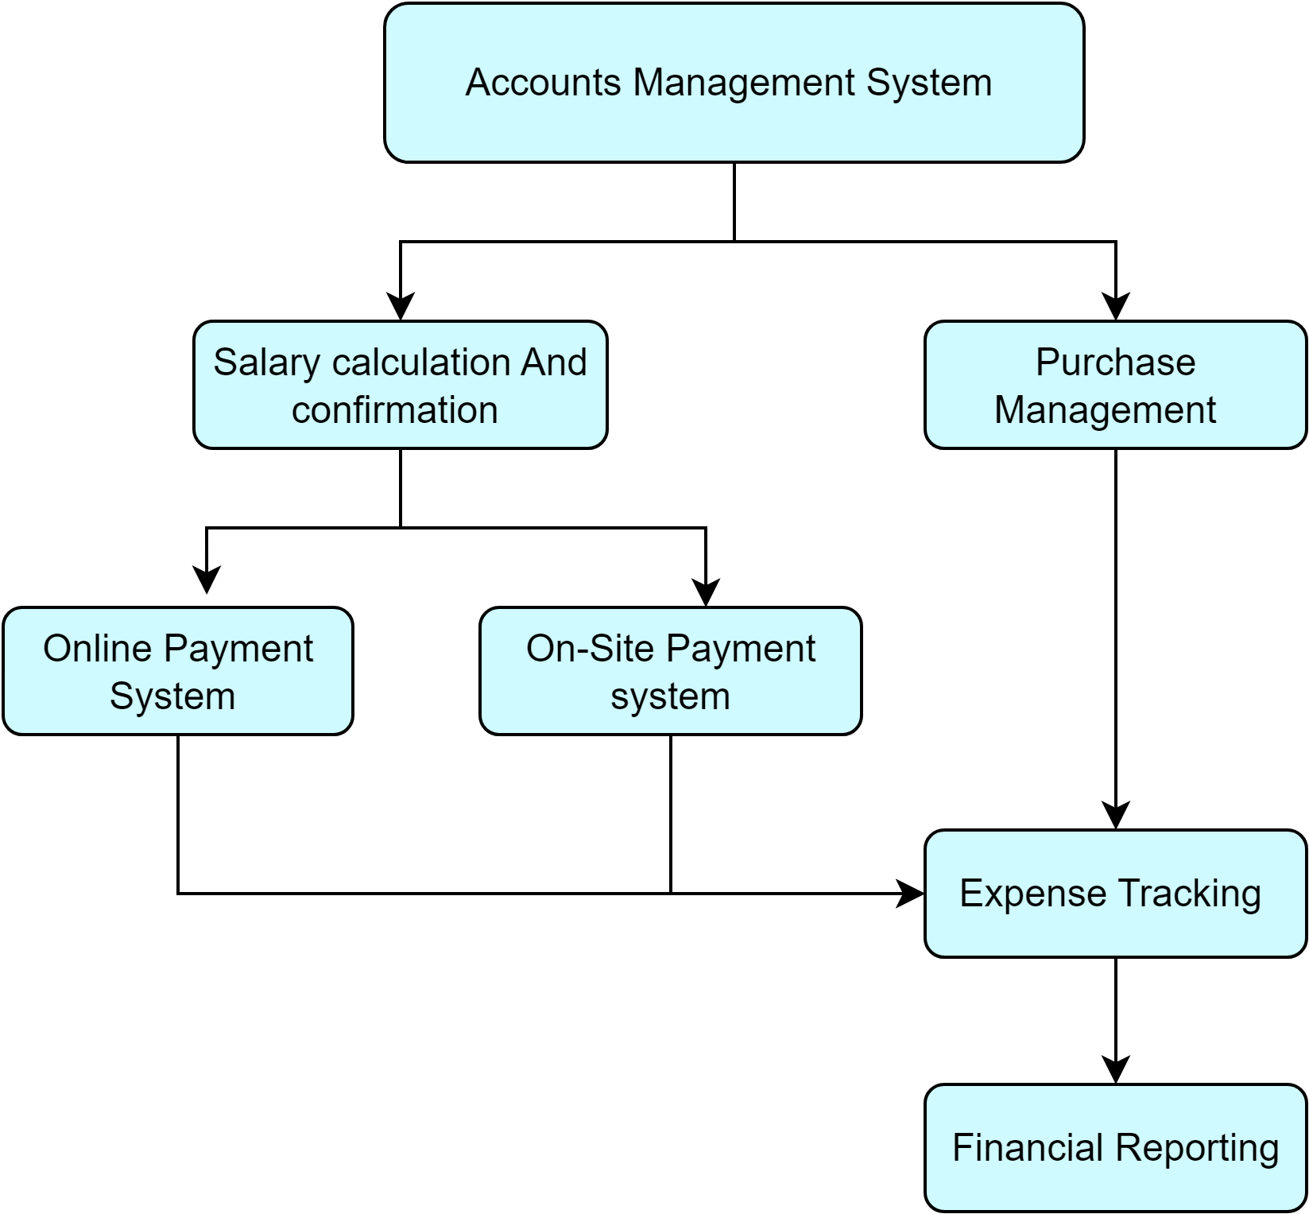](https://app.diagrams.net/?page-id=K4vuH7fse9hgyixSHNaJ&scale=auto#G1y1tqdi0Gb787XyGeQLf1pSAXJpO4x_Zv)

*Figure 6: current accounts management*

**2.3 Inception**

At first, we entered into the inception stage. This stage includes how our project will start and what are the scopes and limitations. The main goal of this phase is to identify the requirements & demands and then establish some sort of mutual understanding between the software team and the customers. They are the intended users of our software. In order to make this phase effective we took the following steps:

• Identifying the client of our project

• Icebreaking

• Identifying the stakeholders of a course

• Identifying the multiple viewpoints of the stakeholders

**2.3.1 Identifying the client of our project**

First, we have identified the location from where we will start our project. Normally, the garment worker, supervisor and management will act as the stakeholder. To identify all the stakeholders, we must go through a systematic approach. As our initial stakeholder, we have analyzed the requirements.

**2.3.2 Icebreaking**

Icebreaking refers to an activity that is used to introduce people to each other so that they feel more relaxed together, so that the communication is open. We started this phase by talking to garment workers and they informally expressed their expectations. We also carried out meetings with engineers and management of the garment factories. The behavior of garment workers, engineers and management was positive and all of them want this change in garments management and automation. We evaluated the problem with our proper solution and established a communication between the stakeholders and the software developer team. After getting the confirmation that the current solution doesn’t compromise the user requirements and is feasible to be implemented by the developer team, we started the SRS of the project with the communicated schemes.

**2.3.3 Identify the Stakeholders**

Stakeholders refer to any person or group who will be affected directly or indirectly by the system.

Stakeholders include end-users who interact with the system and everyone else in an organization who

may be affected by its installation. Identification of the stakeholders was done from the information

provided by the management and workers of the garment factory. The stakeholders of our system are given below:

* Employees
* Supervisors
* Managers
* Owner
* Buyers
* Suppliers

**2.3.4 Identifying The Multiple Viewpoints Of The Stakeholder**

Different stakeholders expect different benefits from the system as every person has his own point of

view. So, we have to recognize the requirements from multiple viewpoints. Different viewpoints of the

stakeholders about the expected software are given below:

**2.3.4.1 Employees' Point of View**

* User-Friendly Interface
* A smartphone-based system for convenient access and interaction with the ASCMS.
* All HR functionalities consolidated in one place, covering attendance, payment, leave requests, overtime requests, and support services.
* Efficient notifications for any updates or notices relevant to workers.
* Ensuring the privacy of transaction history for each worker, maintaining confidentiality.
* Providing a dedicated platform for queries, requests, and enabling the quick raising of alarms in case of accidents.

**2.3.4.2 Supervisors' Point of View**

* Efficient Employee Management
* A simple and efficient system designed to handle a large number of employees.
* Easy-to-use interface for seamless interaction with the ASCMS.
* Generating tables for streamlined inventory management.
* Storing comprehensive inventory details at different stages of the supply chain.
* Maintaining detailed employee information for better supervision and management.

**2.3.4.3 Management Point of View**

* Easy storage and retrieval of employee information for efficient management.
* Implementation of an online payment system for hassle-free salary disbursements.
* Keeping track of inventory throughout the supply chain process.
* Implementing a simple and efficient system for both employee and inventory management.

**2.3.4.4 Owner's Point of View**

* Access to a centralized system providing a comprehensive overview of employee activities, inventory status, and overall business performance.

**2.3.4.5 Buyers' and Suppliers' Point of View**

* A user-friendly interface for buyers and customers to track their orders and shipments.
* Providing a platform for queries, feedback, and efficient customer support services.

**2.3.5 Proposed solutions**

After observing the existing system and taking the points mentioned above into consideration, we have decided to do automation in the following areas:

* Registration and Authentication System
* Human Resource Management System
* Purchase Management System
* Accounts Management System
* Warehouse Management System
* Production and Buyer Interaction Management

**2.3.6 Nature of the solution that is desired**

After communicating with the client and stakeholders, we identified the basic desires of them that the software should offer. The basic desires that the client and the stakeholders stated were as follows-

* Responsive and user-friendly interface
* It should automate and streamline different HR functions
* Online payment system should be integrated
* Manage the raw material information, and stocks
* Workers should be able to raise alarms in case of any accidents

**2.2.7 Conclusion**

The primary objective of the Automated Supply Chain Management System (ASCMS) is to model and design software tailored for the administration and employees involved in the supply chain, focusing on enhancing employee, inventory, and procurement management systems. Emphasizing simplicity, the software aims to minimize the time required for managing employees, handling inventory, and facilitating procurement processes. The success of this software project hinges on effective collaboration with stakeholders, ensuring a clear understanding of their needs, desired functionalities, and how the system can offer convenience while saving time and energy. By prioritizing stakeholder input, the ASCMS aims to deliver a solution that optimizes supply chain operations and contributes to overall business efficiency.

**3. Elicitation of garments automation system**

Requirements elicitation (also called requirements gathering) combines elements of problem solving, elaboration, negotiation, and specification. In order to encourage a collaborative, team-oriented approach to requirements gathering, stakeholders work together to identify the problem, propose elements of the solution, negotiate different approaches, and specify a preliminary set of solution requirements. In our

elicitation phase, we completed the following tasks –

* Collaborative Requirements Gathering
* Quality Function Deployment
* Usage Scenarios

**3.1 Collaborative requirements gathering**

We have conducted meetings with the stakeholders, such as employees, admins and supervisors. These meetings helped us to identify the problem, propose elements of the solution, negotiate different approaches, and specify a preliminary set of solution requirements.

**3.2 Quality function deployment**

QFD or Quality Function Deployment is a focused methodology for carefully listening to the voice of the customer and then effectively responding to those needs and expectations.

On visiting “ITC” we have identified some sectors where digitalization in management can be made. We have identified several stakeholders which include employees [workers, supervisors, admins].

**3.2.1 Normal Requirements**

Normal requirements reflect objectives and goals stated for a product or system during meetings with the customer. Those are the basic requirements that fulfills client satisfaction. The Normal requirements we came up with are the following:

* User Authentication: Login and Sign Up for admin, supervisors, and employees.
* Employee Registration: Employees sign up using unique identifiers such as Employee ID, phone number, and password.
* Login Credentials: All users log in with their phone number and password.
* Password Recovery: Option for users to reset forgotten passwords.
* User Access: Users must be logged in before any operation.
* Admin and Supervisor Access: Predefined accounts for admins and supervisors.
* Attendance Tracking: Integration of a card puncher for employee attendance.
* Leave, Insurance, Overtime: Automation of application processes, following company policies.
* Insurance Claims: Semi-automated process requiring supervisor and HRM admin approval.
* Notices: Notification system for sending notices to employee profiles.
* Payroll Management: Salary calculated based on attendance and overtime, with bonuses for special occasions.

**3.2.2 Expected Requirements**

These requirements are so obvious that the customer need not explicitly state them. Their absence can create significant dissatisfaction. The expected requirements of our system are given below:

* User-Friendly Interface: Interactive and user-friendly design.
* Automated Payment: System for automated payment processing.
* Secure Database: Reliable and responsive database with secure user profiles.
* System Backup: Restoration of backup database in case of system failure.
* Reporting System: Monthly and annual overviews of employee attendance, leave, and overtime.
* Confirmation Notifications: Salary transactions stored in the database, confirmed via SMS.
* Inventory Management: Implementation of an inventory management system.

**3.2.3 Exciting Requirements**

* Demand Forecasting:Analyzing historical data to predict future demand and optimize product accordingly.
* Real time tracking with GPS
* Help and Support System: Access to a panel connecting employees directly with HR for assistance.
* Supply Chain Analysis: Examination of previous raw material needs for upcoming requirements.
* Cloud-Based Backup: Cloud-based backup of the database.
* Visualized Reports: Visualization of reports based on statistical analysis for enhanced decision-making.

**3.3 Usage Scenario**

The automation process of the supply chain management of the garment will be used by the stakeholders. The employees and workers can use their features via mobile app. The admins and HR management will have the option to use a web-based interface. But if they want, they can also use the app. This system will deal with Registration and Authentication System, Accounts Management, Human Resources Management, Warehouse Management and Purchase Management along with some analytics as exciting features.

**3.3.1 Registration and Authentication System:**

There will be three modules in this subsystem. They are:

* Create Account
* Login
* Update Account

**Create Account**

In the account creation process, a recently recruited employee begins by providing their designated employee ID and phone number. The system rigorously verifies this information against the employee database, ensuring accuracy. Upon successful validation, an OTP is generated and sent via SMS to the worker's phone. Inputting the received OTP triggers the system to validate and grant access for the worker to set up a password securely. This chosen password is then stored in the database, intricately linked to the worker's unique account. Simultaneously, the worker is prompted to input their preferred payment method and associated details, such as bank account number or bkash number. Consequently, the worker's account is successfully created, establishing a seamless and secure connection to the employee database, complete with authentication credentials and integrated payment details.

**Login**

Users, including workers, supervisors, managers, and administrators,supplier commence the login process by inputting their employee ID and password. The system meticulously cross checks these credentials against the stored information in the database. Successful validation culminates in the user being seamlessly granted access to the system, with their specific access privileges determined by their assigned role—whether it be a worker, supervisor, manager, or administrator. This robust authentication process ensures effective login and tailored system access based on the user's designated role.

**Update Account**

Once logged into the system, any user, including workers, supervisors, managers, and administrators, seeking to update their account details initiates the process by selecting the option to modify account information. The system, in turn, prompts the user to input their employee ID for verification purposes. Subsequently, an OTP is generated and dispatched to the user's phone number, adding an extra layer of validation. Upon successful OTP verification, the user gains access to the account modification interface. While logged in, the user has the ability to edit various personal data fields, including present address, permanent address, preferred payment method, payment information, and even their user photo. Implementing these changes involves the generation of another OTP; once verified, the updated information seamlessly replaces the existing data in the database. It's noteworthy that exclusive administrative rights are requisite for modifications related to designation, working place, and shift in the database, ensuring that these changes are automatically reflected in the user's account as well.

**3.3.2 Human Resource Management System**

Human resource management will manage the daily wages, solve the problems that employees face frequently and take a count on their issues. The modules are:

* Attendance
* Application
* Notices

**Attendance**

Employees commence their workday by recording attendance through a card attendance machine, both at the start and end of their garment shifts. The system calculates the working hours for the day and stores this information, including the date, in the database, linked to the corresponding account. This data is pivotal for salary calculation.

**Application**

The application module empowers workers to submit various requests to their supervisors. Four sub-modules include Leave, Overtime, Insurance Claim, and Help and Support. In the Leave sub-module, employees apply for leave by specifying dates and reasons, with predefined categories like festival, medical, annual, and maternity leave. The supervisor receives notifications with additional details, and upon approval, relevant information is stored in the database, impacting salary calculations. Overtime requests, governed by predefined policies, are submitted by employees, with the system notifying supervisors of relevant details for approval. Insurance Claim applications, involving necessary documentation, are sent to supervisors, and approved claims progress to admin approval. Notifications and SMS updates keep the employee informed throughout the process. The Help and Support sub-module allows employees to seek assistance by selecting categories such as payment support, workplace support, or harassment, directing requests to supervisors or administration for prompt action.

**Notices**

The Notices module enables supervisors and admin to disseminate information through the system, reaching employees via SMS and Dashboard notifications. Notices are tailored according to designation, with supervisors' messages sent to their specific teams, while admin notices reach all employees. This centralized communication streamlines information dissemination and ensures that employees are promptly informed of important updates or announcements.

**3.3.3 Purchase Management System**

The Purchase Management module in our automated supply chain system facilitates efficient procurement. In the company's demand it allows to initiate purchase requests, enables seamless goods receipt confirmation by warehouse employees, ensures accurate invoice processing by accounts managers, and provides supplier performance analytics for strategic decision-making by managers. The sub-modules are:

* Purchase request
* Goods Receipt
* Invoice processing
* Supplier performance evaluation

**Purchase Request**

In the company's demand, recognizing a need for additional inventory, initiates a purchase request within the system, specifying required items, quantities, and relevant details. The system validates this request and notifies the purchasing manager. The purchasing manager reviews the request, communicating with the warehouse manager if necessary. Upon approval, the purchasing manager converts the request into a purchase order. As a result, a purchase order is generated and forwarded to the supplier for fulfillment.

**Goods Receipt**

Upon the arrival of purchased items at the warehouse, the warehouse employee utilizes the system to confirm the goods' receipt. In the event of any discrepancies, the warehouse worker communicates with the purchasing manager for resolution.

**Invoice Processing**

With goods received and the supplier submitting an invoice, the accounts manager reviews the invoice, cross checking it with the purchase order. If the information aligns, the system proceeds to process payment to the supplier. In the case of any discrepancies, the accounts manager communicates with the purchasing manager for resolution. Subsequently, the payment is successfully processed, and the financial records are promptly updated.

**Supplier Performance Evaluation**

When a predefined time period has elapsed since the last transaction with a specific supplier, the system generates supplier performance analytics, considering factors like delivery time, product quality, and adherence to terms. The manager reviews these analytics and makes decisions regarding whether to continue or reconsider the relationship with the supplier. If necessary, the manager communicates these decisions to the purchasing manager for the formulation of future procurement strategies. Consequently, supplier performance evaluations play a crucial role in influencing future procurement decisions within the automated supply chain management system, involving key stakeholders such as warehouse workers, accounts managers, and purchase managers.

**3.3.4 Accounts Management System**

Efficiently managing financial aspects, the Accounts Management System in our Automated Supply Chain Management integrates seamlessly with salary calculations, payment methods, and additional accounting functionalities. The system encompasses four key sub-modules:

* Salary Calculation and Confirmation
* Online Payment System
* On-Site Payment System
* Expense and Revenue Management
* Expense Tracking and Reporting

**Salary Calculation and Confirmation**

As the end of the month arrives, the Accounts Manager initiates the salary calculation process within the system. The system computes individual employee salaries, taking into account attendance, leave, insurance, and bonuses, and stores this information in the database. Following the calculation, the supervisor is promptly notified to confirm the accuracy of the salary details. Upon confirmation, the salary information is made accessible on the employee's dashboard, providing a concise summary of paid leave, insurance, bonuses, and the final balance. This streamlined process ensures accurate and transparent communication of salary details to the concerned stakeholders within the Automated Supply Chain Management System.

**Online Payment System**

For employees who have chosen the online payment option, the process is straightforward. They can conveniently conduct online transactions through banking, bkash, rocket, or nagad using their respective account numbers. Upon the successful transfer of their salary, the system ensures seamless communication by sending an SMS to the employee's phone number. This SMS contains essential transaction details, including the amount and withdrawal date, which are systematically stored in the database. This user-friendly approach provides employees with a secure and efficient means of receiving their salaries through the Automated Supply Chain Management System.

**On-Site Payment System:**

In the case where employees opt for on-site payment, the process is efficiently managed by the supervisor. The employee initiates the on-site payment by providing their employee ID and phone number to the supervisor. Subsequently, the system enhances security by sending an OTP to the linked phone number for verification. The employee shares the OTP with the supervisor, who then enters it into the payment system. Following successful verification, the supervisor provides the salary to the employee on-site. This entire transaction is seamlessly documented in the database, updating the payment status with withdrawal details and the supervisor's name. This on-site payment process ensures a secure and transparent method for employees to receive their salaries within the Automated Supply Chain Management System.

**Expense and Revenue Management**

The Expense and Revenue Management sub-module seamlessly integrates with the Accounts Management System. It efficiently records supplier expenses and buyer revenues, offering streamlined bill payment options for suppliers and flexible payment methods for buyers. Here online banking, bkash, Nagad , rocket or cash would be used for paying suppliers and receiving revenue from buyers. Then the accounts manager would enter the paid or received bills into the system. The system ensures real-time tracking and categorization of expenses and revenues, contributing to accurate financial reporting. Integrated into comprehensive financial reports, it provides valuable insights for strategic decision-making and optimized financial management.

**Expense Tracking:**

When the Accounts Manager needs to record incurred expenses, the process is efficiently managed through the system.The manager logs expenses, capturing details such as purpose, amount, and date directly into the system. Subsequently, the system promptly updates the expense records in the database, categorizing them for comprehensive financial reporting. This streamlined approach allows the Accounts Manager to generate monthly or annual expense reports, providing valuable insights for managerial analysis and informed decision-making within the Automated Supply Chain Management System.

**Financial Reporting:**

When managers seek financial insights for strategic decision-making, the system efficiently generates comprehensive financial reports within the Automated Supply Chain Management System and sends a copy of a report to the Administrator . These reports offer valuable insights into salary expenditures, overall expenses, and the organization's financial health. Managers can easily review and modify(if needed) these reports to make informed budgetary decisions, forecast future financial needs, and optimize resource allocation. This integral functionality ensures that managers have the necessary tools for strategic planning and financial management within the ASCMS, benefiting stakeholders such as employees, supervisors, managers, owners, buyers, and suppliers.

**3.3.5 Warehouse Management System**

**Inventory Management**

The warehouse is actively receiving and dispatching products. The supervisor updates the database upon the arrival of raw materials. Information includes product type, quantity, corresponding PO number, department of origin, and arrival date. The system, in turn, promptly updates inventory levels and notifies the accounts department of the received goods. When moving materials, the supervisor updates the departure date, quantity, product type, destination department, and PO number. The system calculates and updates the remaining product amount in the database, triggering notifications if levels run low. The system generates reports for the supervisor, displaying product usage, storage in the current month, and storage in the current week. Visualization of database queries provides insights.

**Transport Management**

Products need transportation between departments and between production and buyers. The Logistics Manager initiates a transport request, specifying products, quantities, and destination department or buyers location. The system assigns a suitable vehicle based on product type and quantity. Upon successful delivery, the system updates the status, triggering notifications to relevant stakeholders. Our automated system involves connecting with GPS-enabled devices on vehicles or utilizing third-party GPS services. This would enable real-time vehicle tracking on a system map, enabling stakeholders to monitor transportation progress. Automated notifications will be implemented for departure, actual arrival, and delays due to factors like traffic or vehicle unavailability. Customized notifications will be tailored for buyers and production departments, providing details such as expected delivery times and any encountered delays. The user interface will be enhanced to prominently display real-time tracking information, estimated arrival times, and delays for quick understanding. A feature will be added for analysis and performance evaluation. Security measures, including authentication mechanisms, will ensure the secure access of GPS data and notifications to authorized personnel.

**Logistics and Distribution Management**

In Logistics and Distribution Management, the Distribution Coordinator orchestrates the distribution of products, factoring in demand, location, and delivery schedules. The system facilitates the loading of products into vehicles, confirming the shipment and updating distribution status. For external distribution to buyers, the system ensures a streamlined process, while internal distribution between departments is also managed seamlessly. Buyers gain transparency and enhanced satisfaction as they can track the delivery status through the system. This dual focus on external and internal distribution optimizes efficiency and customer experience throughout the supply chain.

**3.3.6 Production and Buyer Interaction Management**

The Production Management and Buyer Interaction module in the Automated Supply Chain Management System (ASCMS) establishes a seamless channel of communication between the production department and buyers. This module not only facilitates the sale of ready-made products but also ensures transparent communication and efficient coordination throughout the entire process.

* Production Negotiation and Buyer Interaction
* Sales and Income Management

**Production Negotiation and Buyer Interaction Management**

The Production Negotiation and Buyer Interaction module within ASCMS serves as a pivotal interface for product managers to engage in negotiations with buyers. Here, product managers communicate with buyers, showcasing detailed product information and specifications. The module enables seamless discussions regarding pricing and transportation options. Product managers can efficiently address buyer inquiries, providing real-time updates on product details and collaborating on cost considerations. The negotiation outcomes, including agreed-upon prices and transportation preferences, are systematically recorded within the system, ensuring transparent and traceable interactions between the production department and buyers.

**Sales and Income Management**

The Sales and Income Management module streamlines the process of notifying the system about product sales and market demand. As products are sold, the buyers are notified and the production management input this information to the system, triggering updates to inventory levels and recording income generated from sales. The module also captures market demand trends, allowing for strategic planning and production adjustments. Income from product sales is automatically added to the financial records, providing a real-time overview of revenue. This seamless integration of sales data enhances decision-making processes, ensuring that the system remains informed about market dynamics, product demand, and financial gains from sales transactions.

**4. Scenario based modeling**

The success of the Automated Supply Chain Management System (ASCMS) hinges on user satisfaction. To effectively capture user interactions and preferences, the requirements modeling process begins with the creation of scenarios using UML, including use cases, activity diagrams, and swimlane diagrams. This user-centric approach ensures the ASCMS is tailored to meet the diverse needs of its stakeholders.

**4.1 Introduction**

For the Automated Supply Chain Management System (ASCMS), success is measured by user satisfaction. Knowing how users, including workers, supervisors, and managers, want to use the system is crucial. This understanding helps the software team define requirements accurately, setting the stage for analysis and design models. The process starts with creating scenarios, including Use Cases, activity diagrams, and swimlane diagrams.

**4.2 Use case Diagram**

A use case is a list of actions or event steps typically defining the interactions between a role (actor) and a system to achieve a goal. The actor can be a human or other external system. In this modeling, use case diagram is a graphical depiction of a user's possible interactions with a system. A use case diagram shows various use cases and different types of users the system has and will often be accompanied by other types of diagrams as well. Use case diagrams are a blueprint for the system. Due to their simplistic nature, use case diagrams can be a good communication tool for stakeholders. The drawings attempt to mimic the

real world and provide a view for the stakeholder to understand how the system is going to be designed. Use case diagrams consist of actors, use cases and their relationships. The diagram is used to model the system/subsystem of an application. A single use case diagram captures a particular functionality of a system.

**Primary Actor**

Primary actors interact to achieve required system function and derive the intended benefit from the system. They work directly and frequently with the software.

**Secondary Actor**

Secondary actors support the system so that primary actors can do their work. They either produce or consume information

**4.3 Use case diagrams**

Use Case diagrams give the non-technical view of the overall system.

**Level - 0**

**Use Case Name:** Automated Supply Chain Management System

**Primary Actors:** Administrators, Managers, Supervisors, Employees, Buyers, Suppliers

**Secondary Actors:** Payment, Card Attendance Machine, SMS/Email, GPS

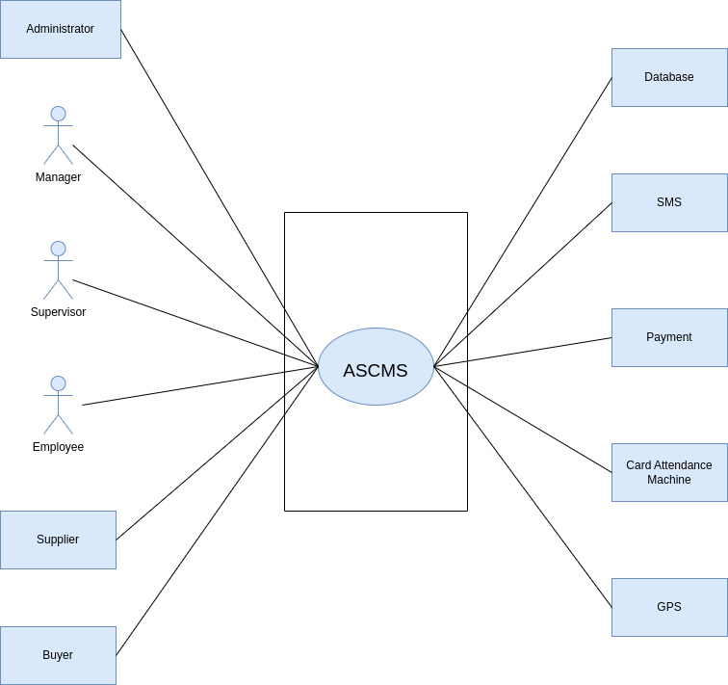*Figure 7: Use case diagram level 0: Automated Supply Chain Management System*

**Level - 1**

**Use Case Name:** Automated Supply Chain Management System(detailed)

**Primary Actors:** Administrators, Managers, Supervisors, Employees, Buyers, Customers

**Secondary Actors:** Payment, Card Attendance Machine, SMS

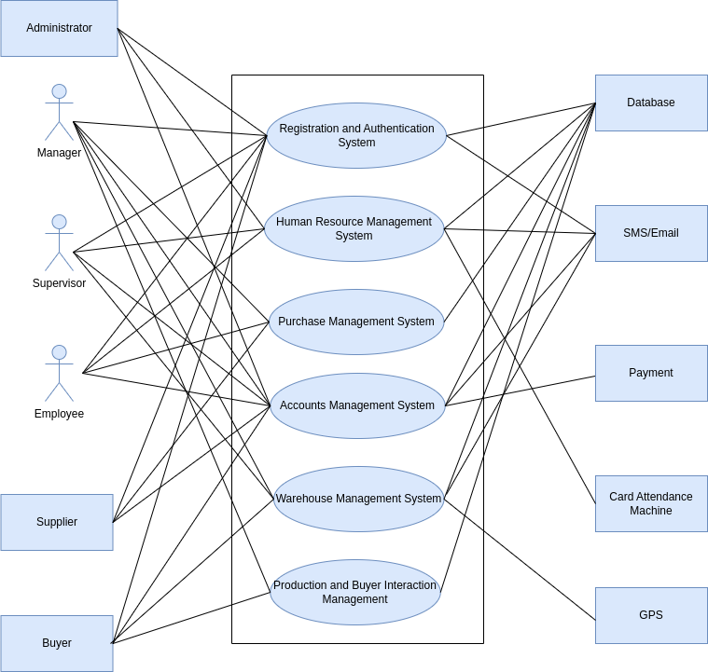

*Figure 8: Use case diagram level 1: Automated Supply Chain Management System(detailed)*

**Description of Use Case Diagram level 1:**

**1. Registration and Authentication System (3.3.1):**

The Registration and Authentication System consists of three modules: Create Account, Login, and Update Account. In the Create Account module, employees provide essential details, undergo rigorous verification, and receive a secure OTP for account creation. The Login module ensures a robust authentication process for users based on their employee ID and password, granting role-specific access upon successful validation. The Update Account module allows users to modify their information securely, with OTP verification for account changes and exclusive administrative rights for certain updates.

**2. Human Resource Management System (3.3.2):**

The Human Resource Management System encompasses Attendance, Application, and Notices modules. The Attendance module tracks work hours through card attendance, crucial for salary calculations. The Application module enables employees to submit various requests, including leave, overtime, insurance claims, and general support. Notices facilitate communication by allowing supervisors and admins to disseminate information tailored to specific designations, ensuring efficient information flow.

**3. Purchase Management System (3.3.3):**

The Purchase Management System integrates Purchase Request, Goods Receipt, Invoice Processing, and Supplier Performance Evaluation modules. The Purchase Request module initiates requests based on inventory needs, leading to the creation of purchase orders upon approval. Goods Receipt ensures accurate recording of received items, while Invoice Processing verifies and processes supplier invoices. Supplier Performance Evaluation assesses supplier metrics, influencing future procurement decisions strategically.

**4. Accounts Management System (3.3.4):**

The Accounts Management System comprises Salary Calculation, Online Payment System, On-Site Payment System, and Expense Tracking modules. Salary Calculation automates the end-of-month salary process, incorporating attendance, leave, and bonuses. The Online Payment System facilitates secure transactions for employees choosing electronic payment methods. The On-Site Payment System ensures secure on-site transactions, and the Expense Tracking module allows the manager to log and categorize expenses for comprehensive financial reporting.

**5. Warehouse Management System (3.3.5):**

The Warehouse Management System involves Inventory Management, Transport Management, and Logistics and Distribution Management modules. Inventory Management updates product details upon receipt and departure, providing real-time insights through reports. Transport Management optimizes product transportation, utilizing GPS for tracking and sending notifications. Logistics and Distribution Management streamlines internal and external distribution processes, enhancing efficiency and customer experience.

**6. Production and Buyer Interaction Management (3.3.6):**

The Production and Buyer Interaction Management module includes Production Negotiation and Buyer Interaction, and Sales and Income Management. The former facilitates negotiations, showcasing product details and terms between product managers and buyers. The latter streamlines sales notifications, updates inventory levels, and captures market demand trends, providing real-time revenue insights and supporting strategic planning.

**Level - 1.1**

**Use Case Name:** Registration and AuthenticationSystem

**Primary Actors:** Administrators, Managers, Supervisors, Employees, Buyers, Customers

**Secondary Actors:** Database, SMS/Email

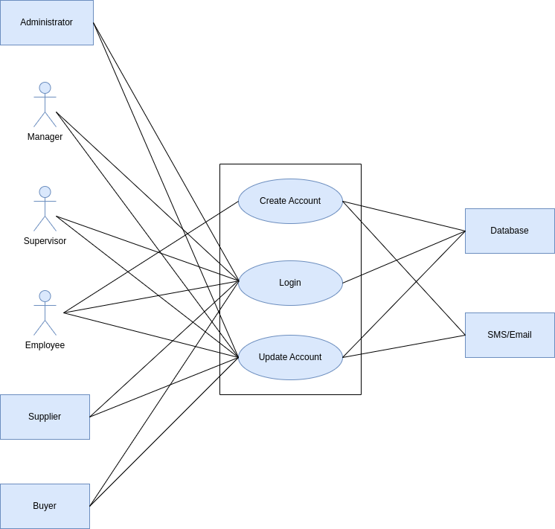

*Figure 9: Use case diagram level 1.1 :* Registration and AuthenticationSystem

**Description of Use Case Diagram level 1.1:**

**Create Account:**

New employees input designated IDs and phone numbers, verified against the database. Upon successful verification, an OTP is sent for secure validation.

Integrated Account Setup: The system establishes a seamless connection, linking the chosen password, and integrating payment details.

**Login:**

Users input IDs and passwords, cross-checked against stored database information. Successful validation grants access with tailored privileges based on designated roles.

**Update Account:**

Users initiate updates, inputting employee ID for verification. An OTP is sent, adding an extra layer of security for account modification. Users can edit personal fields, with another OTP verifying and seamlessly updating the database.

**Action-Replay:**

**Action:** New employee (John) initiates the account creation process.

**Reply:** System verifies provided employee ID and phone number against the database.

Action: Successful verification triggers the generation of an OTP.

Reply: OTP is sent via SMS to John's phone for secure validation.

Action: John inputs the received OTP.

Reply: System validates OTP and grants access for John to set up a secure password.

Action: John inputs preferred payment method and associated details.

Reply: System successfully creates John's account, intricately linking the password and integrating payment details.

Action: Users (including John) commence the login process.

Reply: System cross-checks entered employee ID and password against stored information.

Action: Successful validation culminates in seamless access.

Reply: User-specific access privileges are determined based on assigned roles (worker, supervisor, manager, or administrator).

Action: Any user (including John) logged into the system seeks to update account details.

Reply: User initiates the process by selecting the option to modify account information.

Action: System prompts the user to input their employee ID for verification.

Reply: An OTP is generated and dispatched to the user's phone for an additional layer of validation.

Action: Upon successful OTP verification, the user gains access to the account modification interface.

Reply: User can edit various personal data fields, including address, payment method, and user photo.

Action: Implementing changes generates another OTP for verification.

Reply: Updated information seamlessly replaces existing data in the database, ensuring security.

**Level - 1.1.1**

**Use Case Name:** Update Account

**Primary Actors:** Administrators, Managers, Supervisors, Employees, Buyers, Customers

**Secondary Actors:** Database, SMS/Email

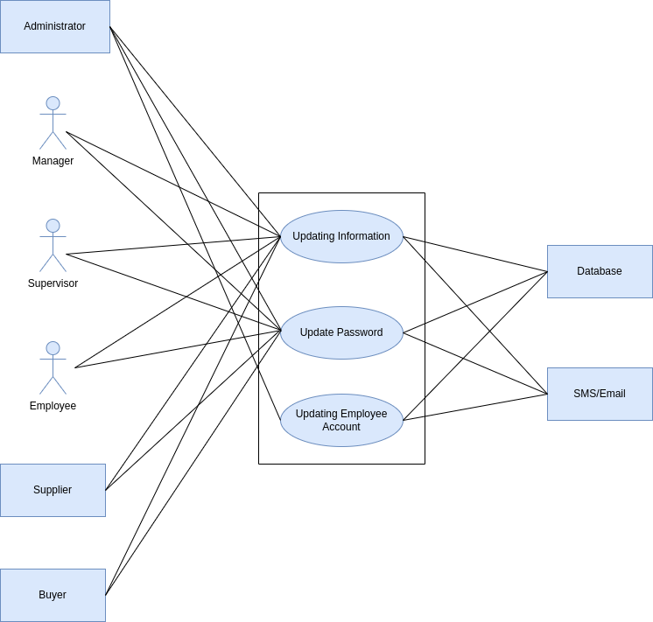

*Figure 10: Use case diagram level 1.1.1 : Update Account*

**Description of Use Case Diagram level 1.1.1:**

The "Update Account" module enables users (workers, supervisors, managers, and administrators) to modify their account details securely. Upon login, users input their employee ID for verification, and an OTP is sent for added security. Successful OTP verification grants access to an interface where users can edit personal details. Another OTP is generated for changes, ensuring security. Administrative rights are required for specific modifications, automatically updating the user's account.

**Action Replay:**

Action: User selects to modify account information.

Reply: System prompts for employee ID; OTP sent for verification.

Action: Successful OTP verification grants access to the modification interface.

Reply: User edits details; another OTP generated for changes.

Action: Updated information replaces existing data.

Reply: Administrative rights ensure automatic reflection of changes.

**Level - 1.2**

**Use Case Name:** Human Resource Management System

**Primary Actors:** Administrator, Supervisor, Employee

**Secondary Actors:** Database, SMS/Email, Card Attendance Machine

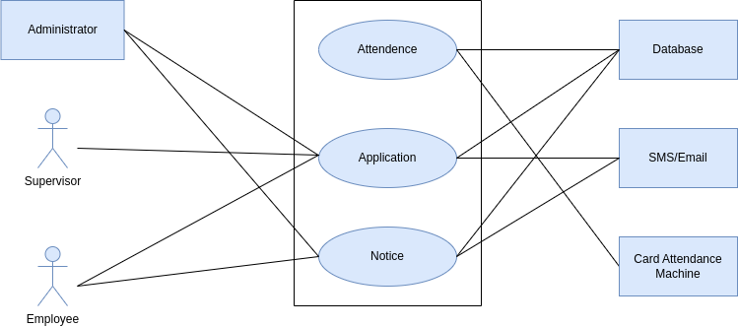

*Figure 11: Use case diagram level 1.2 : Human Resource Management System*

**Description of Use Case Diagram level 1.2:**

The "Human Resource Management System" encompasses three modules: "Attendance," where employees record their work hours using card attendance machines; "Application," comprising sub-modules for Leave, Overtime, Insurance Claim, and Help and Support, enabling various requests; and "Notices," facilitating information dissemination through SMS and Dashboard notifications. The Leave sub-module handles leave requests with predefined categories, impacting salary calculations. Overtime requests follow predefined policies, with supervisors approving details. Insurance Claim applications involve documentation, progressing to admin approval. Help and Support allows employees to seek assistance in various categories, directing requests to supervisors or administration.

**Action replay:**

Action: Employee records attendance using a card machine.

Reply: System calculates working hours, storing data for salary calculation.

Action: Employee submits leave request with specific dates and reasons.

Reply: Supervisor receives notifications, approves request; information stored impacts salary calculations.

Action: Employee submits overtime request; system notifies supervisor.

Reply: Supervisor approves details.

Action: Employee submits Insurance Claim application with documentation.

Reply: Supervisor reviews; approved claims progress to admin for approval.

Action: Employee seeks assistance through Help and Support.

Reply: Requests directed to supervisors or administration for prompt action.

Action: Supervisors and admin disseminate information via Notices.

Reply: Employees receive information through SMS and Dashboard notifications.

**Level - 1.2.1**

**Use Case Name:** Application

**Primary Actors:** Administrator, Supervisor, Employee

**Secondary Actors:** Database, SMS/Email

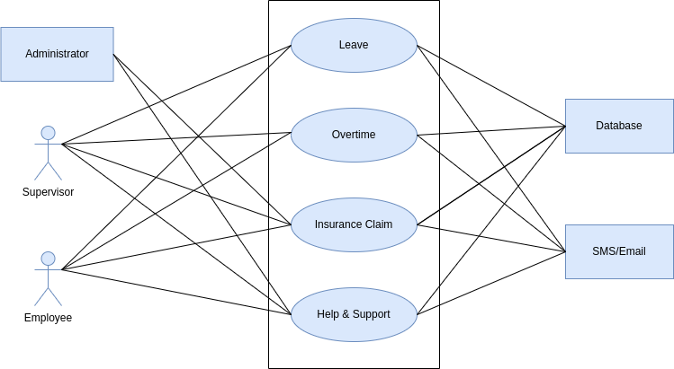

*Figure 12: Use case diagram level 1.2.1 : Application*

**Description of Use Case Diagram level 1.2.1:**

The "Application" module within the Human Resource Management System empowers workers with four sub-modules: "Leave," where employees request leave with predefined categories, impacting salary calculations upon approval; "Overtime," governed by policies, with supervisors approving relevant details; "Insurance Claim," involving documentation and progressing to admin approval; and "Help and Support," enabling employees to seek assistance in categories like payment support, workplace support, or harassment, directing requests to supervisors or administration. Notifications and SMS updates keep employees informed throughout these processes.

**Action Replay:**

Action: Employee applies for leave, specifying dates and reasons.

Reply: Supervisor receives notifications, approves request; information stored impacts salary calculations.

Action: Employee submits Overtime request; system notifies supervisor.

Reply: Supervisor approves details.

Action: Employee submits Insurance Claim application with documentation.

Reply: Supervisor reviews; approved claims progress to admin for approval.

Action: Employee seeks assistance through Help and Support.

Reply: Requests directed to supervisors or administration for prompt action; Notifications keep the employee informed.

**Level - 1.3**

**Use Case Name:** Purchase Management System

**Primary Actors:** Supplier, Employee, Manager

**Secondary Actors:** Database

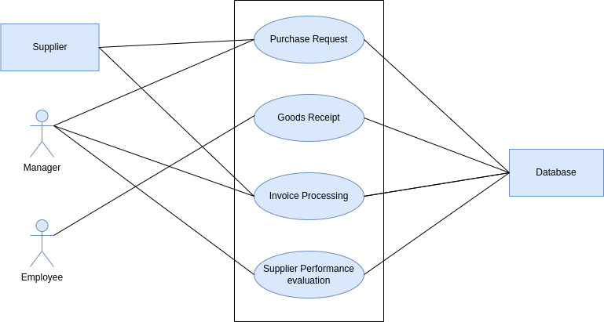

*Figure 13: Use case diagram level 1.3 : Purchase Management System*

**Description of Use Case Diagram level 1.3:**

The "Purchase Management" module in the Automated Supply Chain System comprises four sub-modules: "Purchase Request," where inventory needs trigger requests specifying items and quantities; "Goods Receipt," enabling warehouse employees to confirm received items; "Invoice Processing," involving cross-checking invoices with purchase orders for accurate payments; and "Supplier Performance Evaluation," which generates analytics for strategic decisions based on factors like delivery time and product quality.

**Action Replay:**

Action: Company initiates a purchase request for additional inventory.

Reply: Purchasing manager validates, communicates with warehouse manager if needed, converts request to a purchase order, and forwards it to the supplier.

Action: Warehouse employee confirms goods receipt upon item arrival.

Reply: Any discrepancies communicated with the purchasing manager for resolution.

Action: Accounts manager reviews supplier's invoice, cross-checks with purchase order.

Reply: System processes payment if information aligns; discrepancies communicated with purchasing manager for resolution.

Action: System generates supplier performance analytics after a predefined time.

Reply: Manager reviews analytics, makes decisions on the supplier relationship; communicates decisions to purchasing manager for future procurement strategies.

**Level - 1.4**

**Use Case Name:** Accounts Management System

**Primary Actors:** Supervisor, Employee, Manager, Suppliers, Buyers

**Secondary Actors:** Database, Payment, SMS/Email

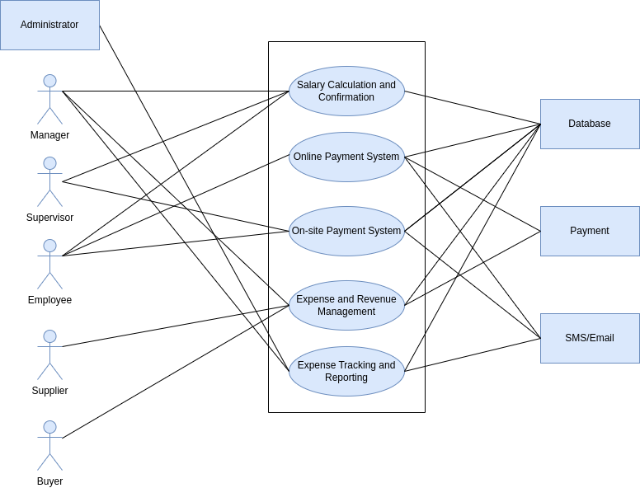

*Figure 14 : Use case diagram level 1.4 : Account Management System*

**Description of Use Case Diagram level 1.4:**

The "Accounts Management System" within our Automated Supply Chain Management consists of five key sub-modules: "Salary Calculation and Confirmation," streamlining the end-of-month process for calculating individual employee salaries; "Online Payment System," facilitating convenient online transactions for employees choosing this payment method; "On-Site Payment System," efficiently managing on-site payments with enhanced security features; “The Expense and Revenue Management” sub-module further integrates streamlined bill payments for suppliers and flexible methods for buyers, contributing to real-time tracking and comprehensive financial reporting, and "Expense Tracking," allowing the Accounts Manager to record and categorize incurred expenses for comprehensive financial reporting.

**Action Replay:**

Action: Accounts Manager initiates salary calculation at month-end.

Reply: System computes salaries, notifies supervisor for confirmation, and updates accessible salary details on the employee's dashboard.

Action: Employees opting for online payment conduct transactions through banking methods.

Reply: System sends SMS with transaction details upon successful transfer, systematically stores information in the database.

Action: Employees opting for on-site payment provide ID and phone number to the supervisor.

Reply: System sends OTP for verification, supervisor enters OTP, updates payment status in the database with withdrawal details.

Action: Accounts Manager logs supplier expenses and buyers revenue.

Reply: System prompts payment method, Accounts Manager enters details and the bills are paid(suppliers) or received(buyers).

Action: Accounts Manager logs incurred expenses, capturing purpose, amount, and date.

Reply: System promptly updates expense records in the database, categorizing them for financial reporting.

Action: System generates comprehensive financial reports for strategic decision-making.

Reply: Reports are sent to the Administrator, offering insights into salary expenditures, overall expenses, and the organization's financial health for review and modification by managers.

**Level - 1.5**

**Use Case Name:** Warehouse Management System

**Primary Actors:** Supervisor, Manager, Buyer

**Secondary Actors:** Database, GPS, SMS/Email

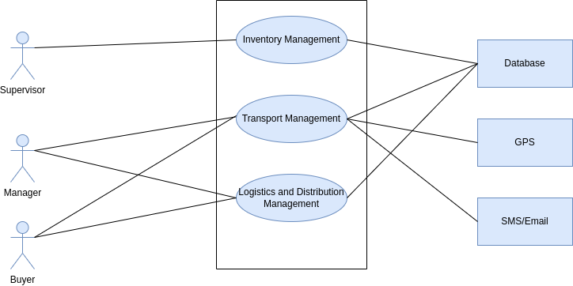

*Figure 15: Use case diagram level 1.5 : Warehouse Management System*

**Description of Use Case Diagram level 1.5:**

The "Warehouse Management System" comprises three sub-modules: "Inventory Management," overseeing the active reception and dispatch of products with real-time updates on raw material arrivals, inventory levels, and product movements; "Transport Management," initiated by the Logistics Manager to facilitate product transportation between departments and to buyers, featuring real-time vehicle tracking, automated notifications, and a user-friendly interface; and "Logistics and Distribution Management," where the Distribution Coordinator orchestrates product distribution, ensuring streamlined processes for both external and internal distribution, enhancing transparency, and optimizing efficiency.

**Action Replay:**

Action: Supervisor updates the database upon raw material arrival.

Reply: System promptly updates inventory levels and notifies the accounts department.

Action: Supervisor updates material departure, triggering quantity and product type updates in the database.

Reply: System calculates remaining product amount, triggers notifications if levels run low, and generates reports for the supervisor.

Action: Logistics Manager initiates a transport request, specifying products and destination.

Reply: System assigns a suitable vehicle, updates delivery status upon successful delivery, and triggers notifications to stakeholders.

Action: Real-time vehicle tracking enabled through GPS devices or third-party services.

Reply: Stakeholders monitor transportation progress, receive automated notifications for departure, actual arrival, and delays.

Action: Distribution Coordinator orchestrates product distribution, facilitating loading and updating distribution status.

Reply: System ensures streamlined external and internal distribution, providing transparency and tracking capabilities for buyers.

Action: Enhanced user interface displays real-time tracking information, estimated arrival times, and delays.

Reply: Stakeholders, including buyers and production departments, gain quick insights for improved understanding.

Action: Security measures, including authentication mechanisms, ensure secure access to GPS data and notifications.

Reply: Authorized personnel securely access real-time tracking and notifications within the system.

**Level - 1.6**

**Use Case Name:** Production Negotiation and Buyer Interaction Management

**Primary Actors:** Manager, Buyer

**Secondary Actors:** Database

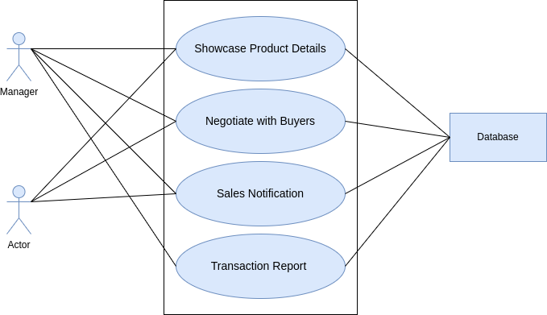

*Figure 16: Use case diagram level 1.6 : Production Negotiation and Buyer Interaction Management*

**Description of Use Case Diagram level 1.6:**

The "Production and Buyer Interaction Management" module in the Automated Supply Chain Management System (ASCMS) comprises two integral sub-modules: "Production Negotiation and Buyer Interaction," acting as a pivotal interface for negotiations between product managers and buyers, ensuring transparent communication and traceable interactions; and "Sales and Income Management," streamlining the process of notifying the system about product sales, capturing market demand trends, and providing real-time overviews of revenue, facilitating informed decision-making.

**Action Replay:**

Action: Product managers engage in negotiations with buyers, showcasing detailed product information and specifications.

Reply: System records negotiation outcomes, including agreed-upon prices and transportation preferences, ensuring transparent and traceable interactions.

Action: Sales occur, buyers are notified, and production management updates the system, triggering inventory level updates and recording income from sales.

Reply: System captures market demand trends, allowing for strategic planning, and adds income from product sales to financial records, providing a real-time overview of revenue.

Action: System updates inventory levels and financial records based on sales and market demand trends.

Reply: Seamless integration of sales data enhances decision-making processes, ensuring the system remains informed about market dynamics, product demand, and financial gains from sales transactions.

**4.4 Activity Diagram**

**Definition of Activity Diagram:** Activity diagrams are graphical representations of workflows of stepwise activities and actions with support for choice, iteration, and concurrency.

**Activity diagram ID: 01**

**Level 1.0**

**Name** : Automated Supply Chain Management System(detailed)

**Reference**: Use case level 1 (Figure : Use case diagram level 1: Automated Supply Chain Management System)

[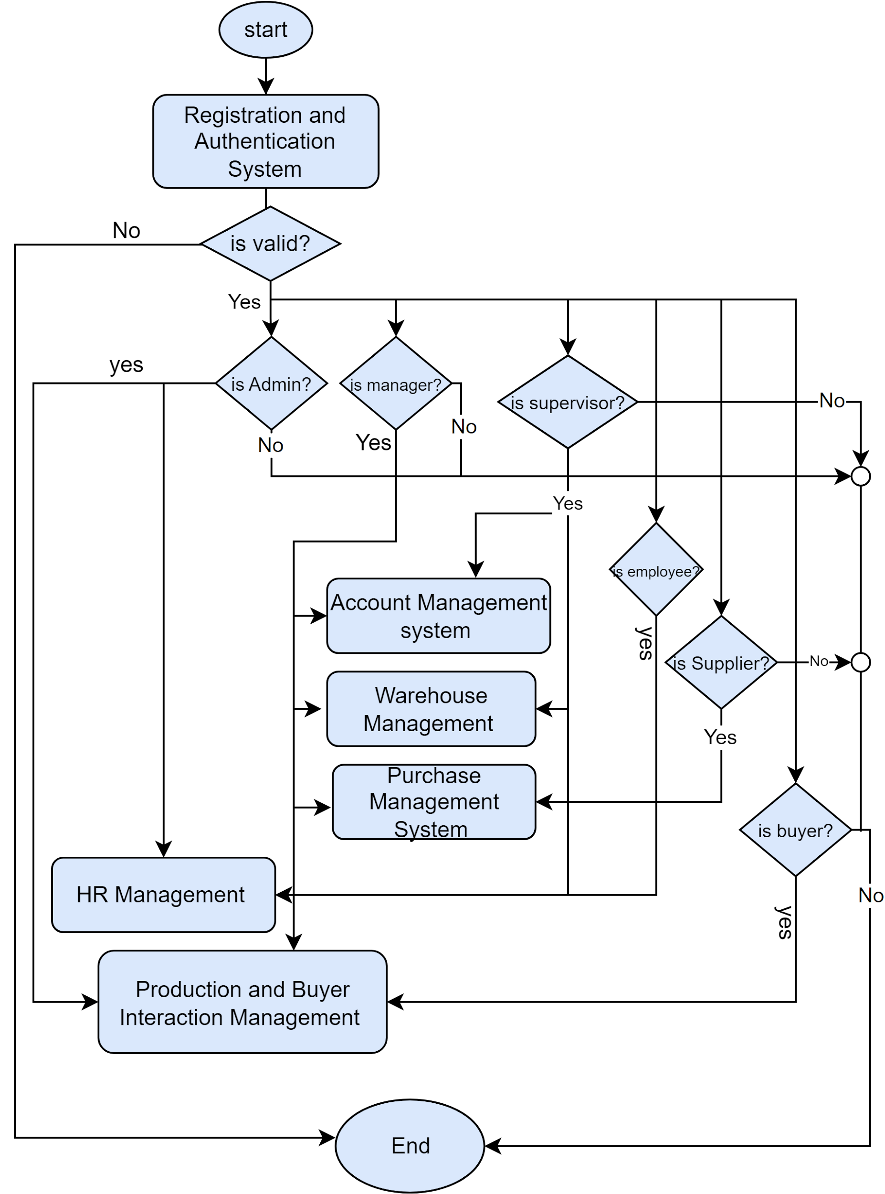](https://app.diagrams.net/?page-id=FXBZqMuN2_akIOn2zKCM&scale=auto#G1Gecygd64TFnD8bjjCDKTW7Z1xdgKOzr3)

*Figure 17: Activity diagram level 1: Automated Supply Chain Management System*

**Activity diagram ID: 02**

**Level 1.1**

Name : Registration and AuthenticationSystem

Reference: Use case level 1.1 (Figure : use case diagram level 1.1 Registration and AuthenticationSystem)

[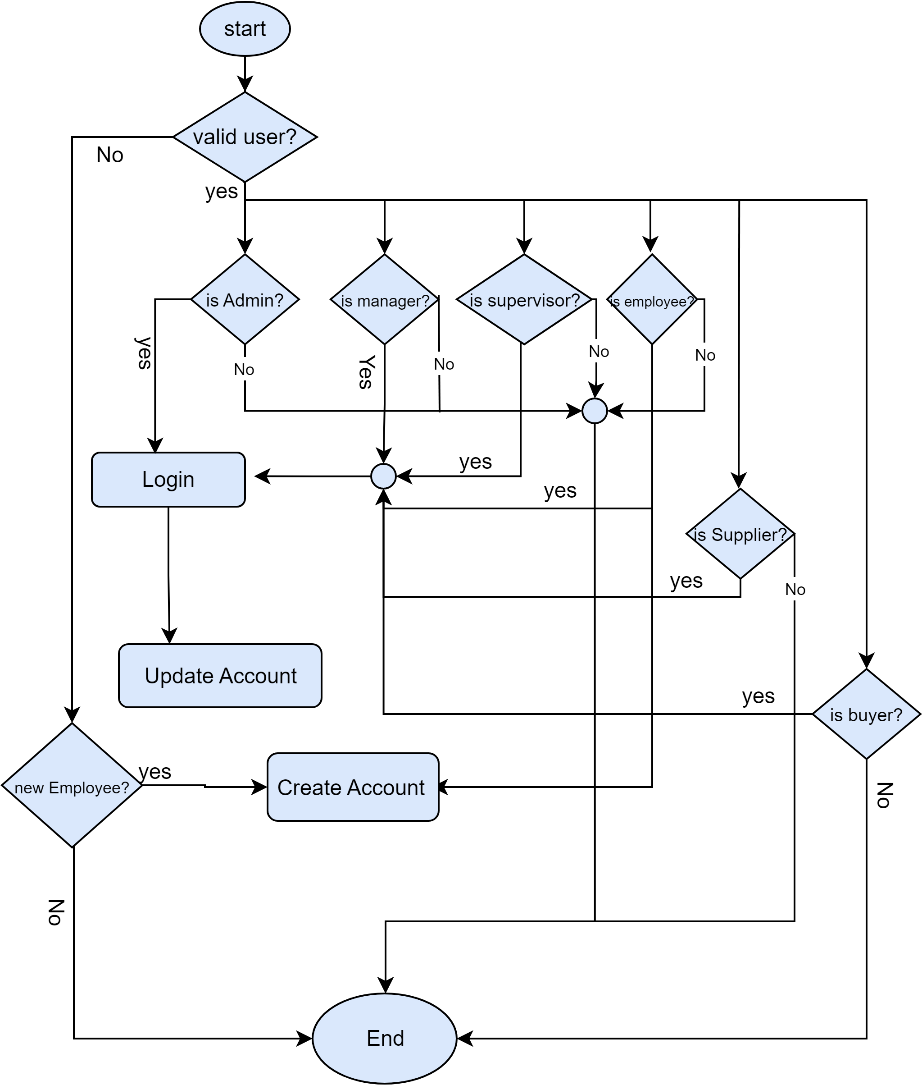](https://app.diagrams.net/?page-id=hW2jh-qa082lOHVd-jhK&scale=auto#G1b3phM_gXQoRS3EEoeWR_AVmuiwj9TZvB)

*Figure 18: Activity diagram level 1.1 Registration and Authentication**System*

**Activity diagram ID: 03**

**Level 1.1.2**

**Name :** Create Account

**Reference**: Use case level 1.1 (Figure: Use case diagram level 1.1 : Registration and AuthenticationSystem)

[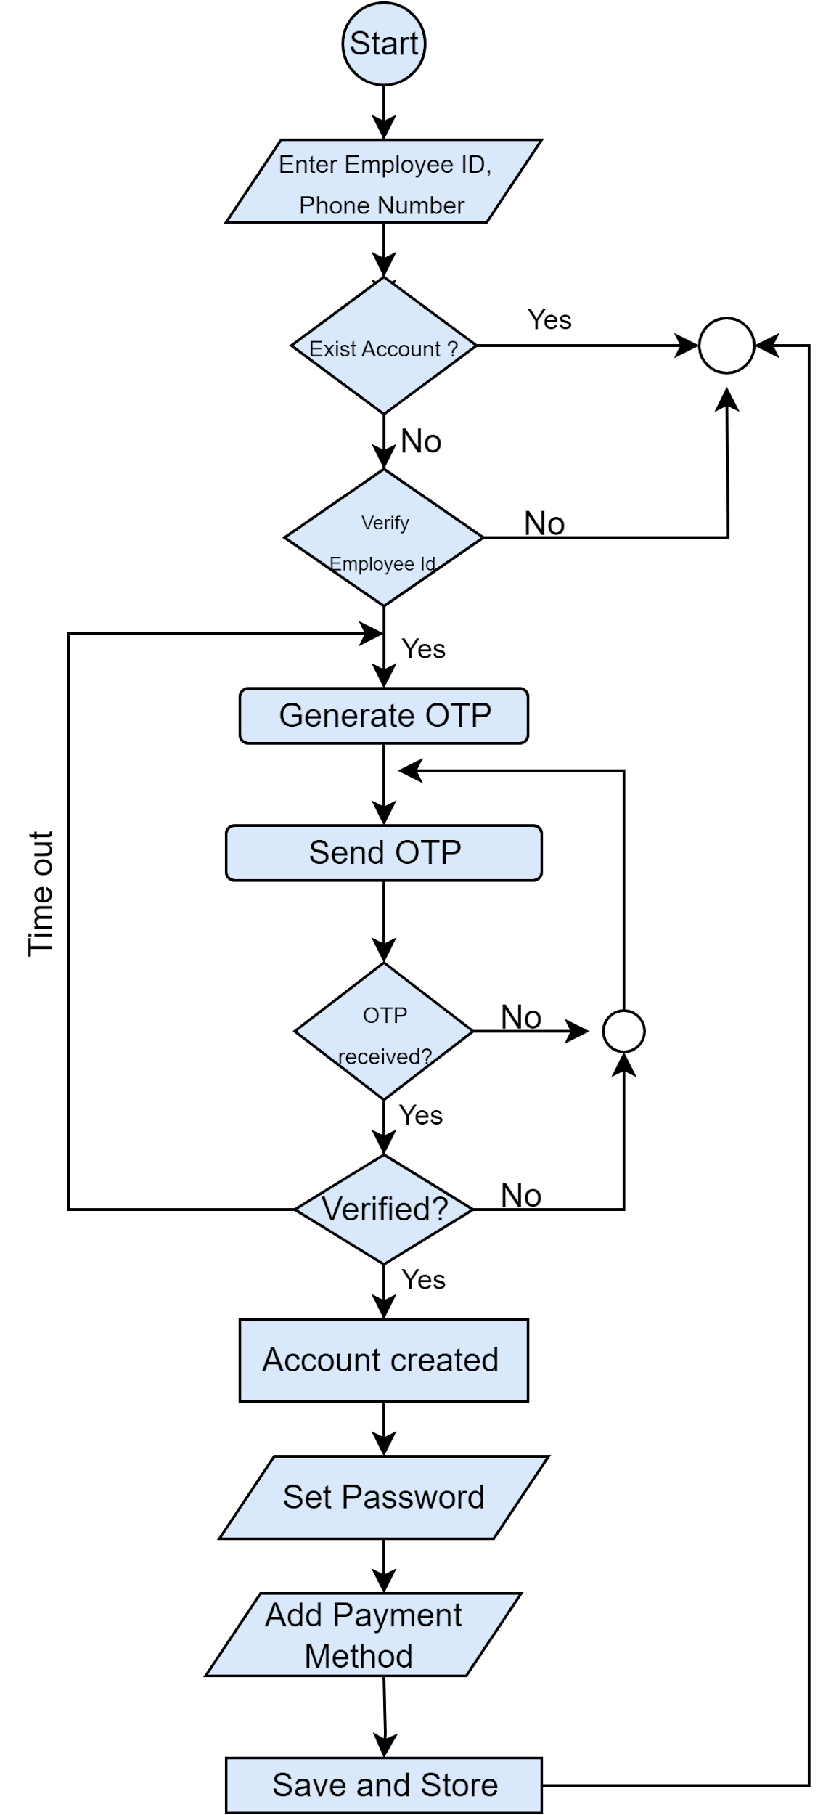](https://app.diagrams.net/?page-id=jqB5pN1I955_S1GqJgq1&scale=auto#G1Fmp078eleNaRAY6caTRTC8N1DwV3G4S4)

*Figure 19: Activity diagram level 1.1.2 Create Account*

**Activity diagram ID: 04**

**Level 1.1.3**

**Name :** Log in

**Reference**: Use case level 1.1 (Figure: Use case diagram level 1.1 : Registration and AuthenticationSystem)

[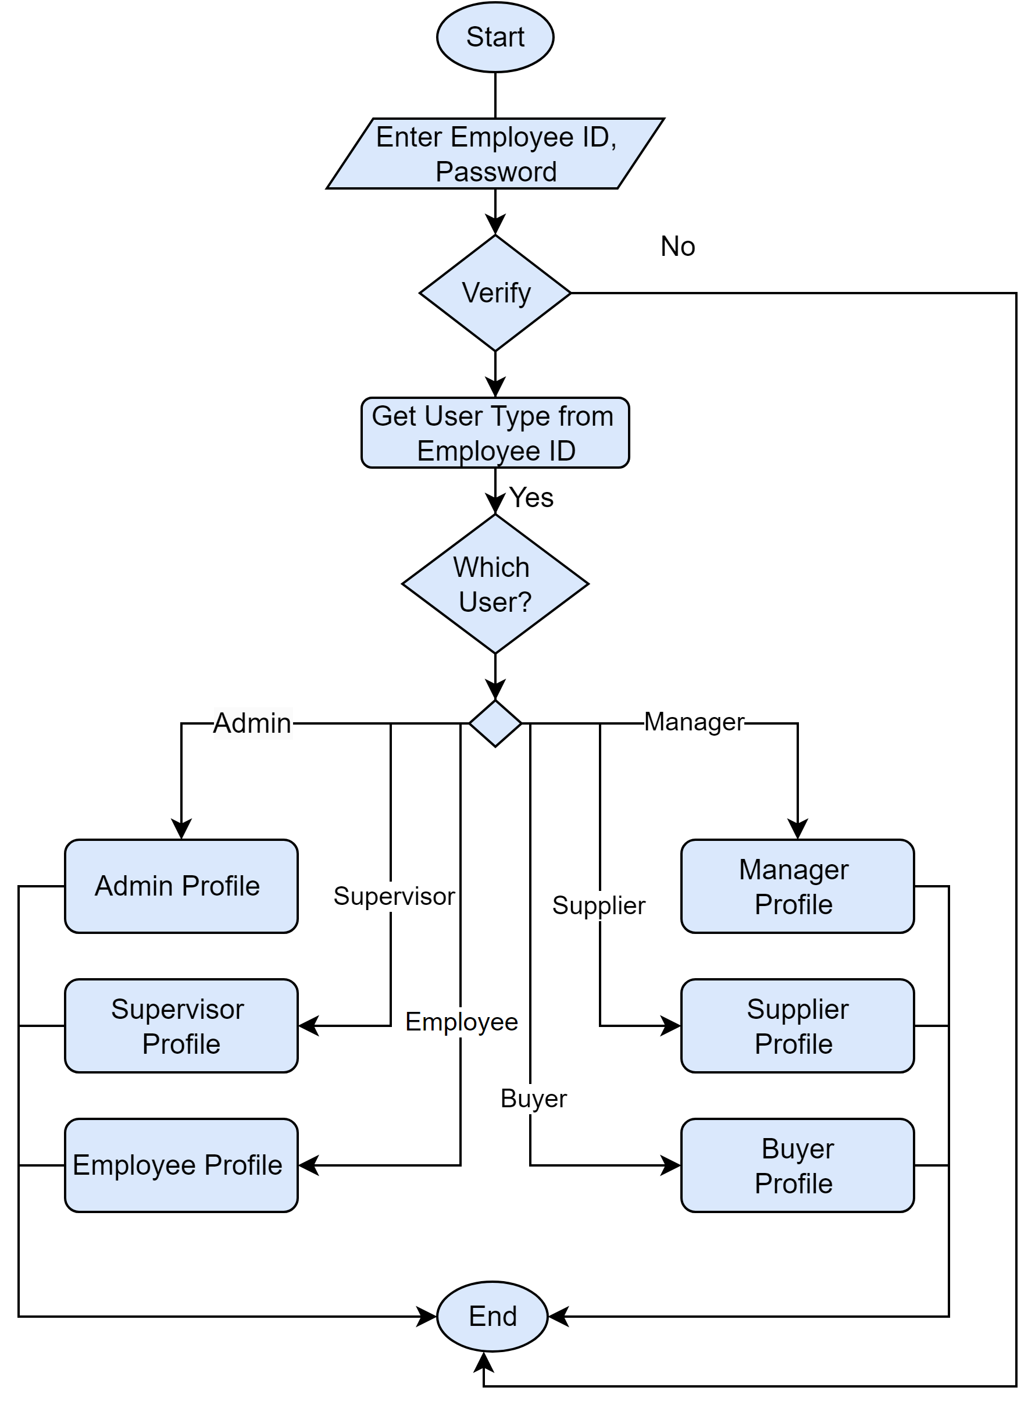](https://app.diagrams.net/?page-id=bS4NMTn0Yw5RSXsWV8UM&scale=auto#G1wweL8evcfFJhrzLsFm7dERHI7GKH7WwG)

*Figure 20 : Activity diagram level 1.1.3 log in*

**Activity diagram ID: 05**

**Level 1.1.1.1**

**Name :** Update Account information

**Reference**: Use case level 1.1.1 (Figure: Use case diagram level 1.1.1 : Update Account)

[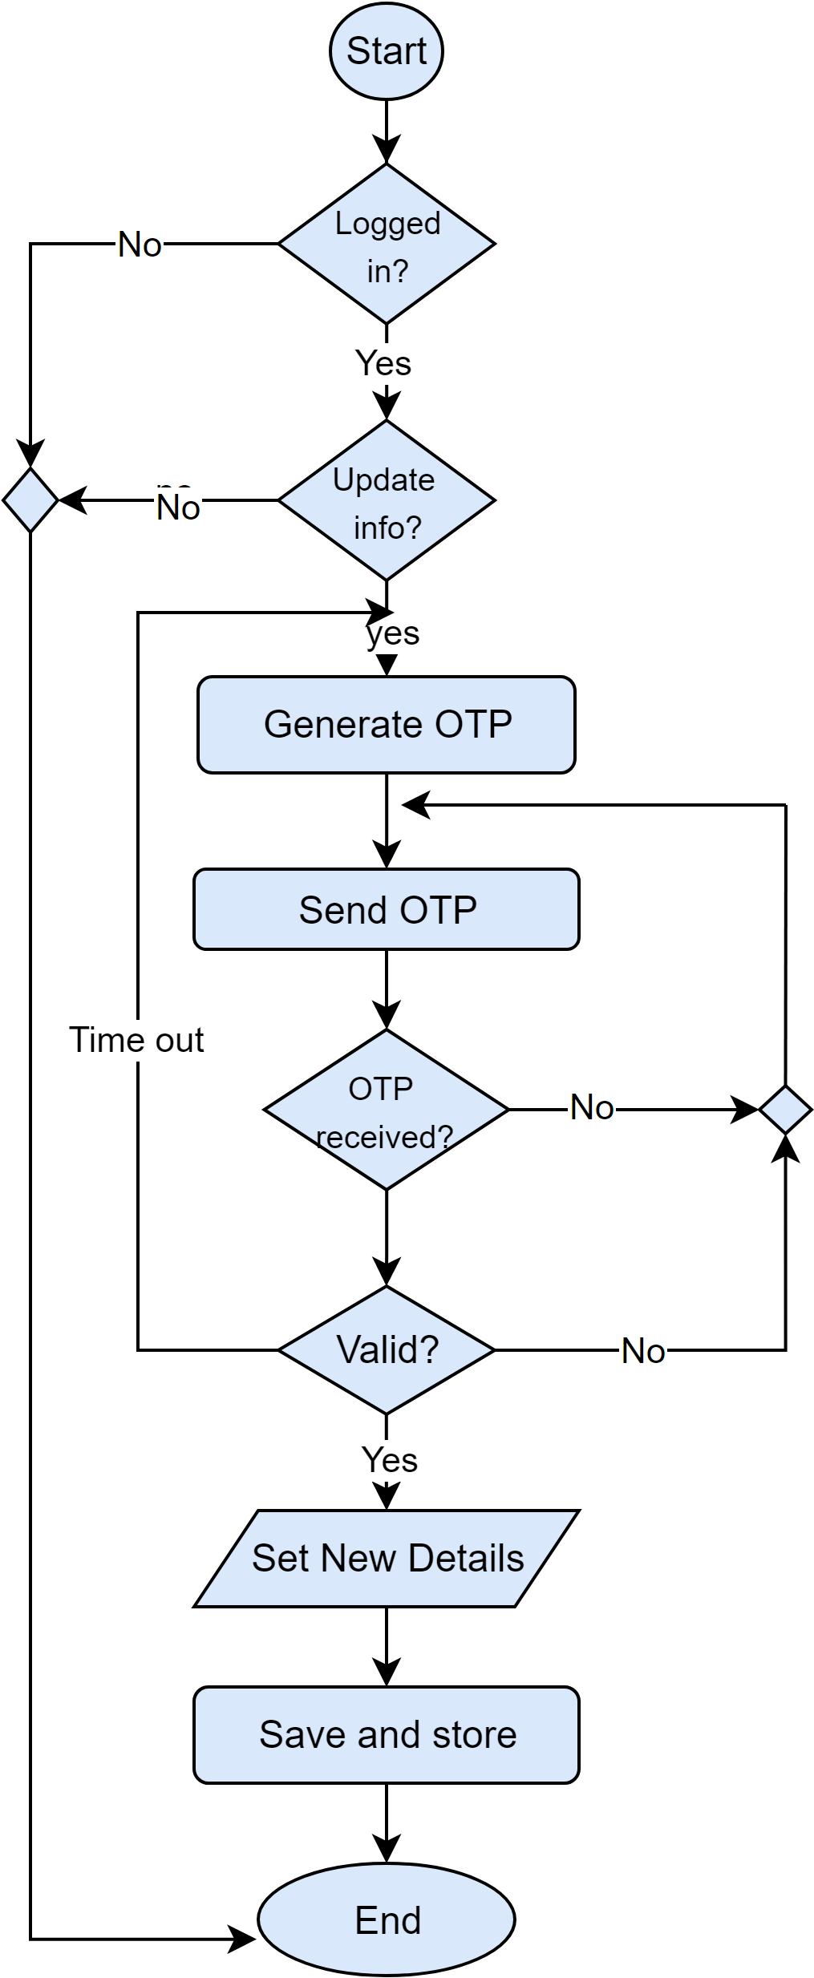](https://app.diagrams.net/?page-id=l824MvFeD1Ds0oDh4vfZ&scale=auto#G1Ays_bqFui3sOB1gXJSLc-zA0vTzifGKf)

*Figure 21 : Activity diagram level 1.1.1.1 Update Account information*

**Activity diagram ID: 06**

**Level 1.1.1.2**

**Name :** Update password

**Reference**: Use case level 1.1.1 (Figure: Use case diagram level 1.1.1 : Update Account)

[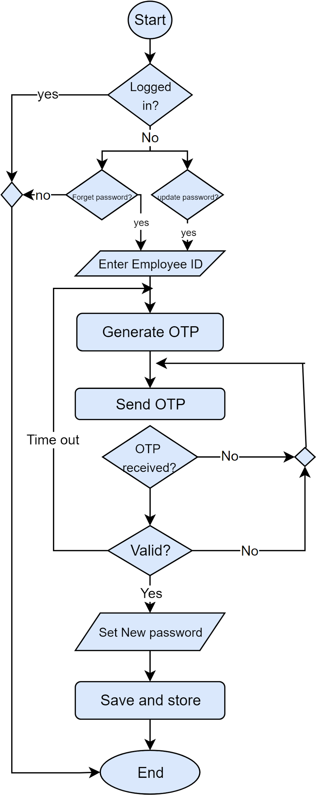](https://app.diagrams.net/?page-id=UPWvRrHmv5LD5qs8OZ9z&scale=auto#G1gG3fdLaZ3zENy24Ib9fTBPKBR5Ke_M_l)

*Figure 22 : Activity diagram level 1.1.1.2 Update Password*

**Activity diagram ID: 07**

**Level 1.1.1.3**

**Name :** Updating Employee Account

**Reference**: Use case level 1.1.1 (Figure: Use case diagram level 1.1.1 : Update Account)

[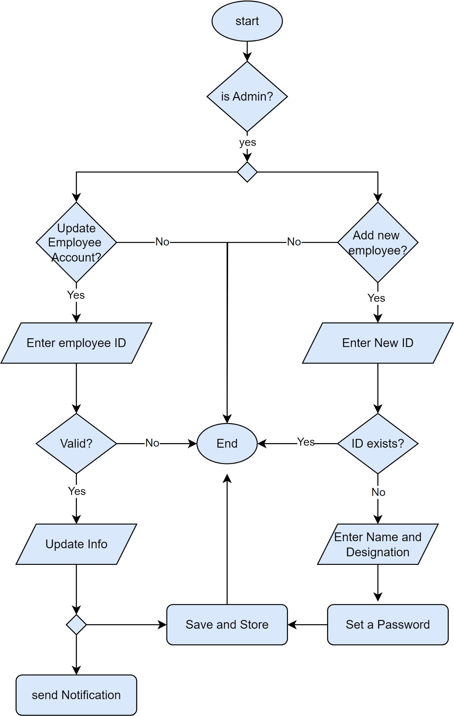](https://app.diagrams.net/?page-id=t87CVFyBYWtbGLlEO99g&scale=auto#G1gWAkBdoWvmTeXhxx5dXX6VXPL1SQTA8P)

*Figure 23 : Activity diagram level 1.1.1.3 Updating Employee Account*

**Activity diagram ID: 08**

**Level 1.2.1**

**Name :** Attendance

**Reference**: Use case level 1.2 (Figure: Use case diagram level 1.2 : Human Resource Management System)

[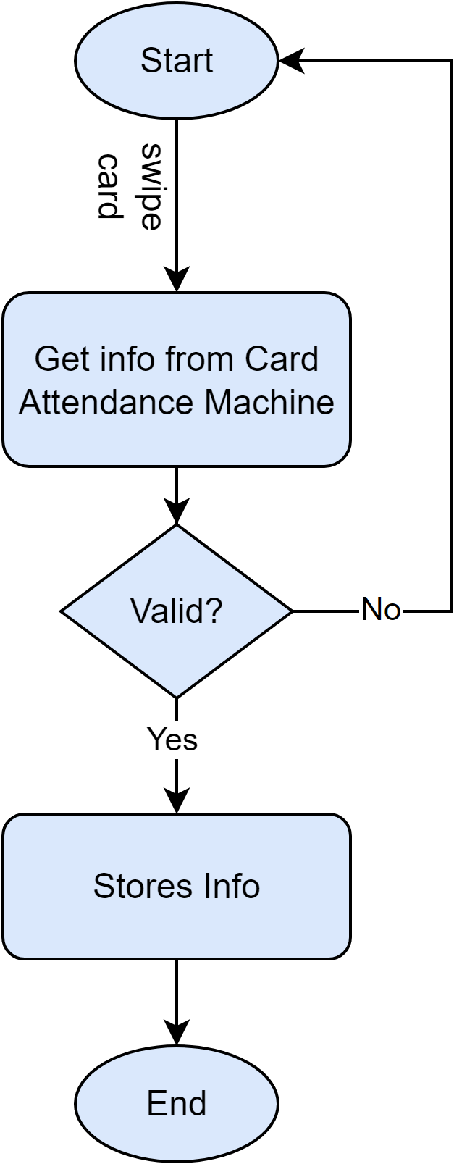](https://app.diagrams.net/?page-id=kDZmBWMdCpyz1NSh-sbk&scale=auto#G1QTolKNqcfPcCDini00frlDQZcA_jhZ4X)

*Figure 24 : Activity diagram level 1.2.1 Attendance*

**Activity diagram ID: 09**

**Level 1.2.2.1**

**Name :** Leave

**Reference**: Use case level 1.2.2(Figure:Use case diagram level 1.2.2 : Application)

[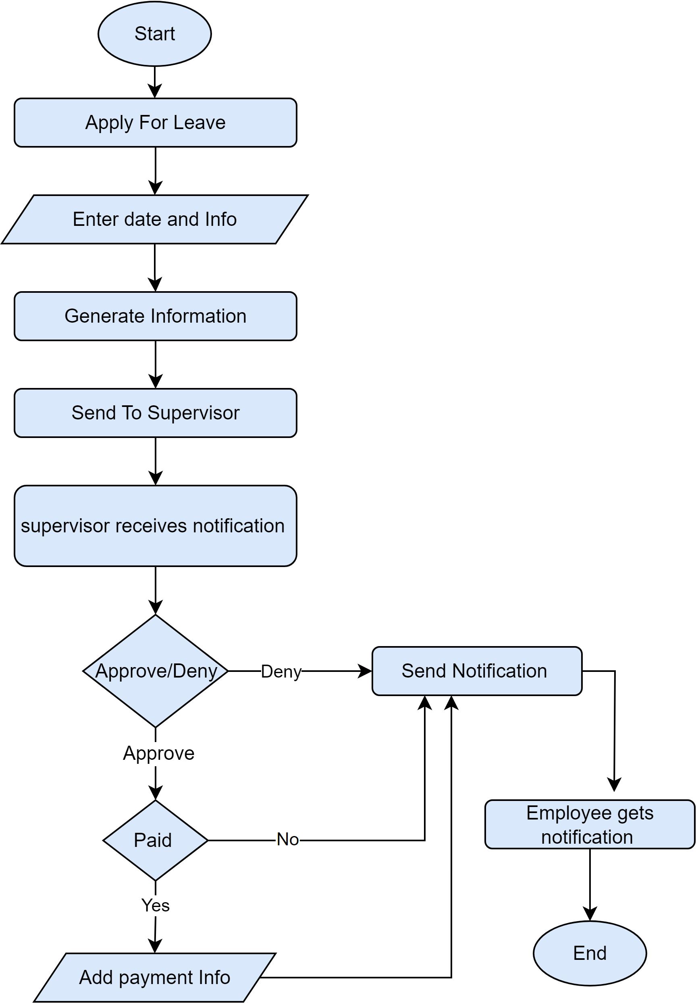](https://app.diagrams.net/?page-id=FmOhkxhrFN-EbOaCTJm6&scale=auto#G16LTMk44BVhIPKDw5osHLIw96APb8rrD6)

*Figure 25 : Activity diagram level 1.2.2.1 Leave*

**Activity diagram ID: 10**

**Level 1.2.2.2**

**Name :** Overtime

**Reference**: Use case level 1.2.2(Figure:Use case diagram level 1.2.2: Application)

[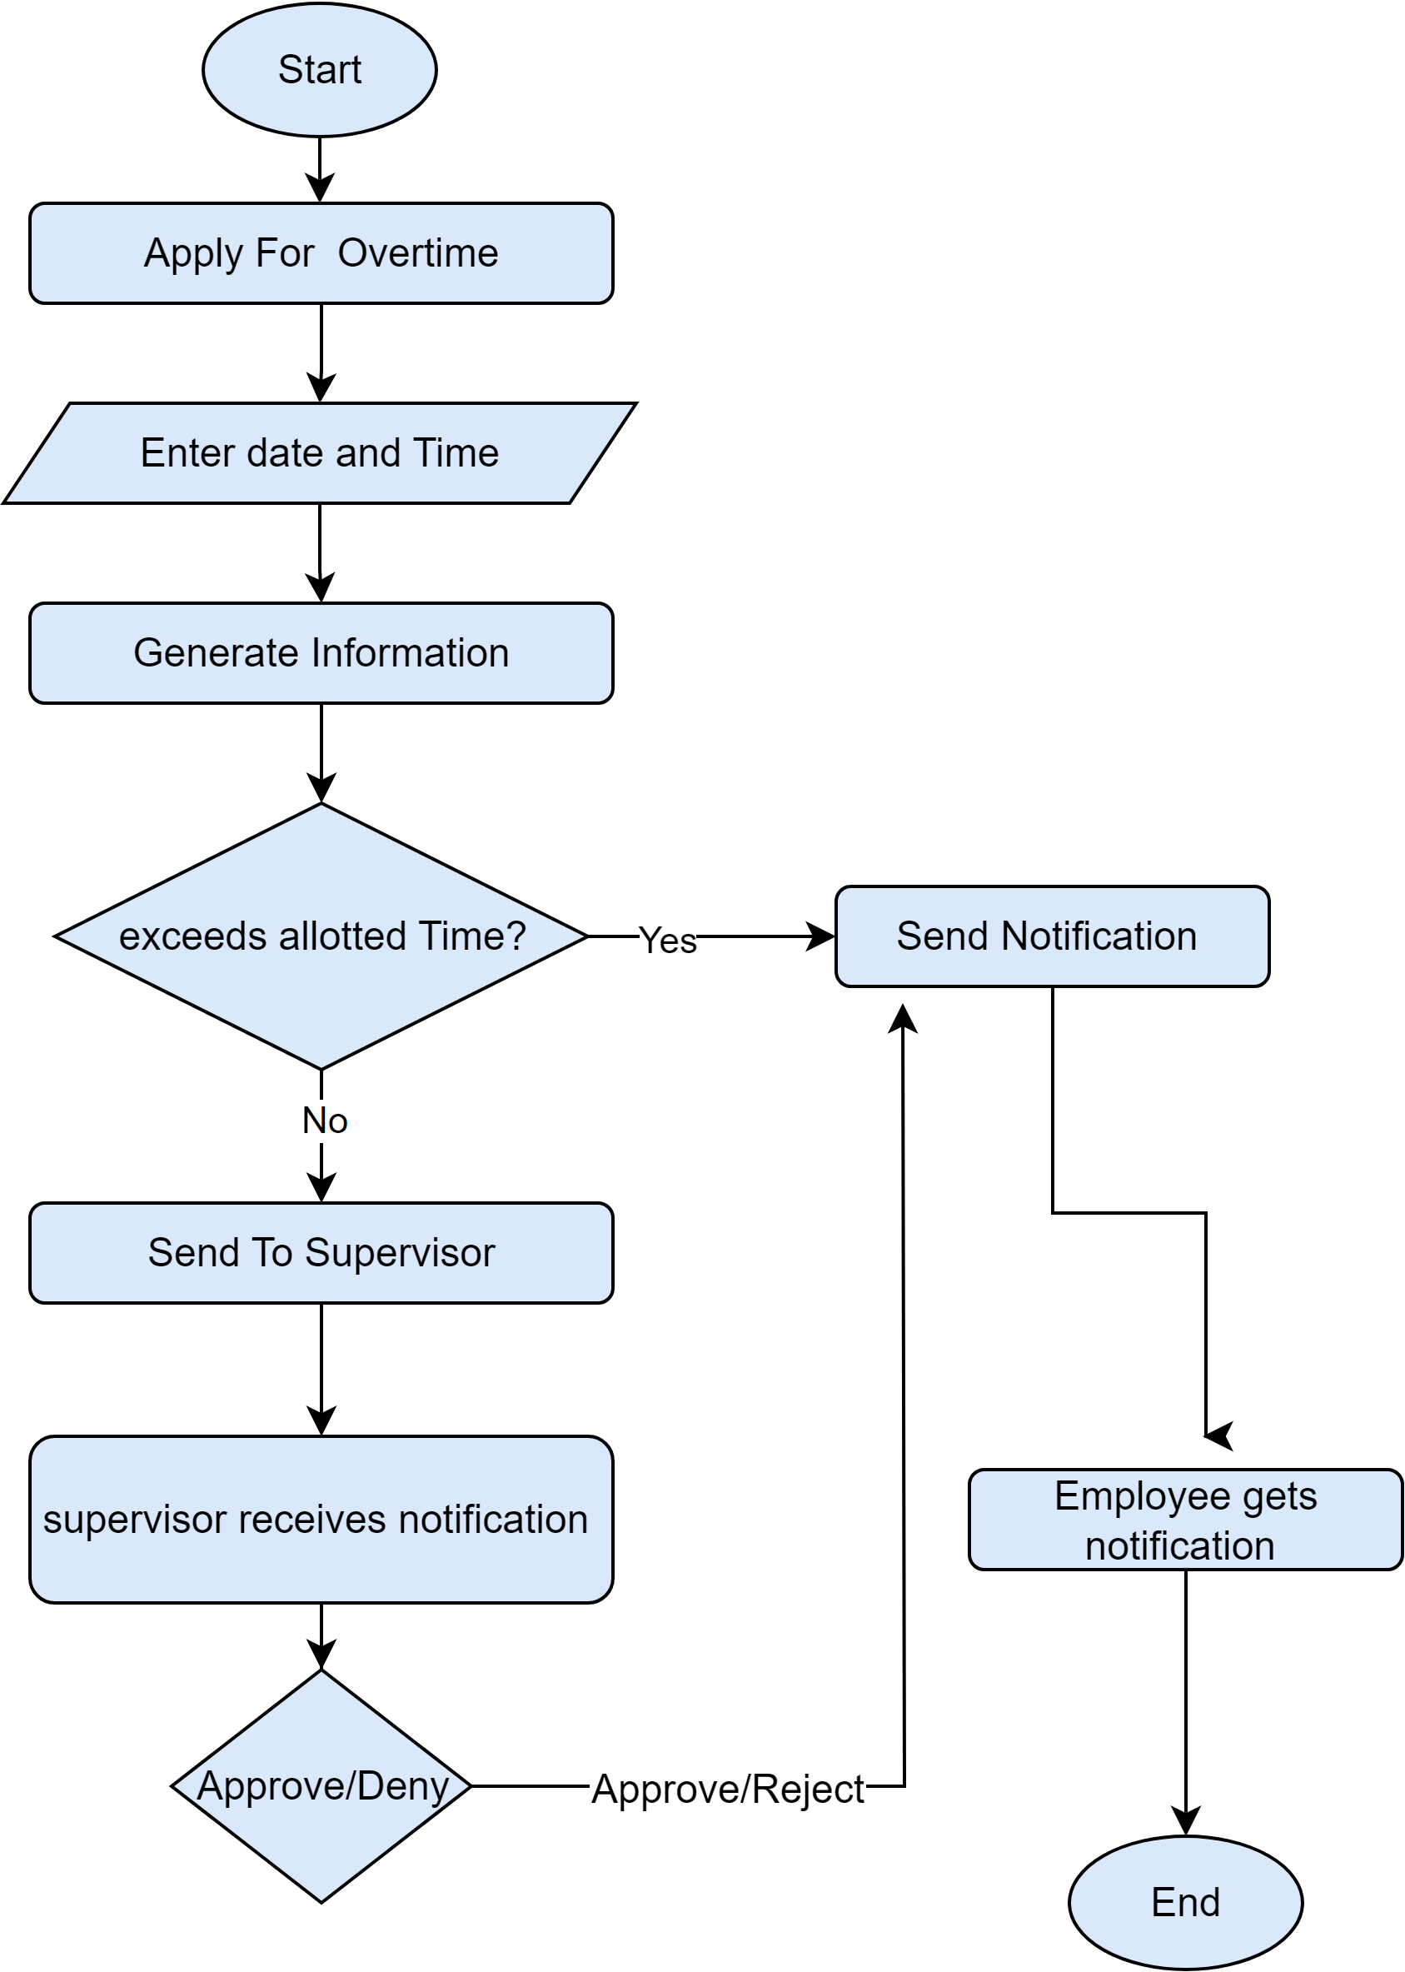](https://app.diagrams.net/?page-id=uBKtkRnzCjqXaSVZ2pdA&scale=auto#G14n-59gk-fQ0pQZ4hj9t4xuQ21myikXiB)

*Figure 26 : Activity diagram level 1.2.2.2 Overtime*

**Activity diagram ID: 11**

**Level 1.2.2.3**

**Name :** Insurance

**Reference**: Use case level 1.2.2(Figure:Use case diagram level 1.2.2 : Application)

[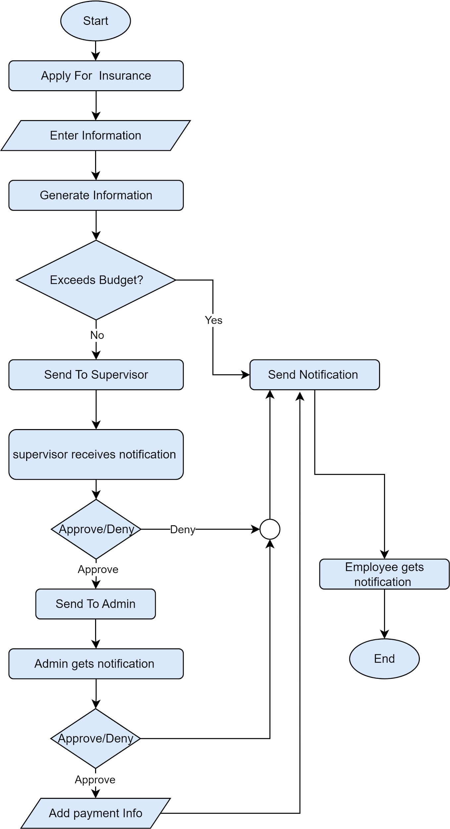](https://app.diagrams.net/?page-id=pgHvlzkAJJs7PTbdnDxL&scale=auto#G1ACHRAP6Rn7QtJyNFl9BZNW1Rsce1mev5)

*Figure 27: Activity diagram level 1.2.2.3 Insurance*

**Activity diagram ID: 12**

**Level 1.2.2.4**

**Name :** Help and support

**Reference**: Use case level 1.2.2(Figure:Use case diagram level 1.2.2: Application)

[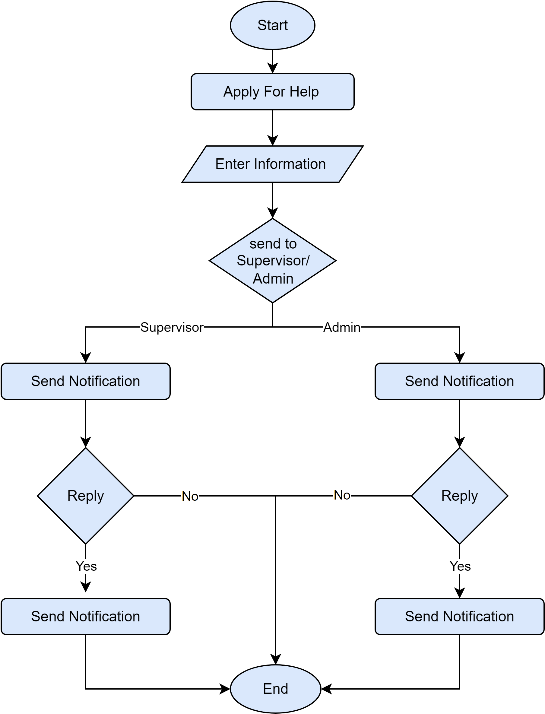](https://app.diagrams.net/?page-id=bzhG8B0WmGFz3AzPGd18&scale=auto#G1BOn5RY1-zafGo8NSbS6PaMqQTc_kitrD)

*Figure 29: Activity diagram level 1.2.2.4 Help and support*

**Activity diagram ID: 13**

**Level 1.2.3**

**Name :** Notice

**Reference**: Use case level 1.2 (Figure: Use case diagram level 1.2 :Human Resource Management System)

[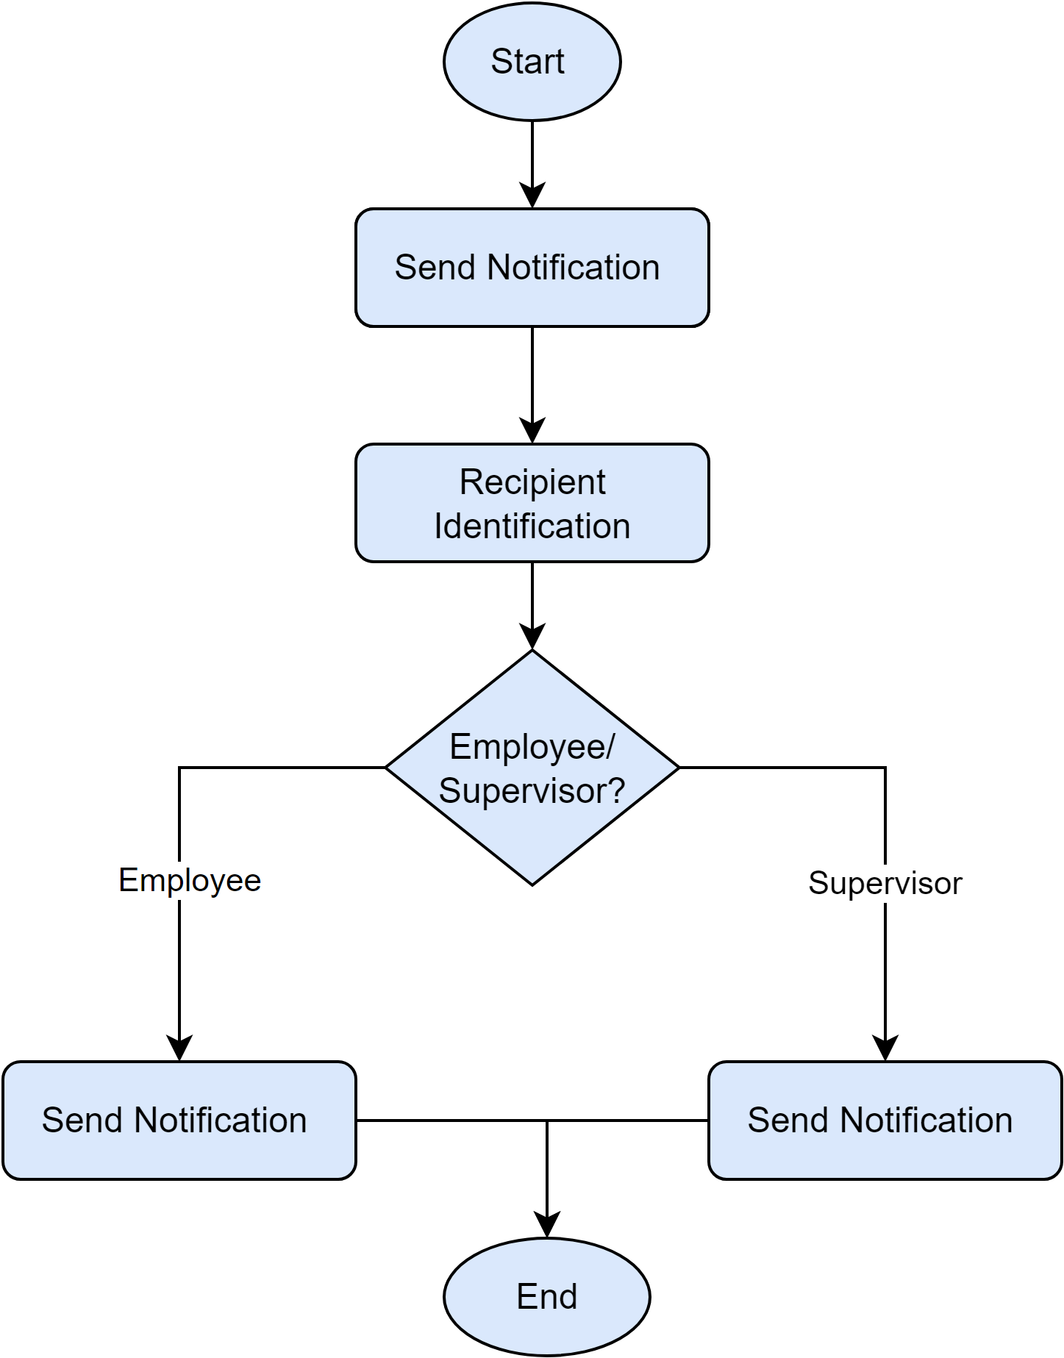](https://app.diagrams.net/?page-id=GUqEhw1s6GKE-szn_w_Y&scale=auto#G1bVY_KRo0n1JKRkb7MpsHTMBRjD7bZZXZ)

*Figure 30: Activity diagram level 1.2.3 Notice*

**Activity diagram ID: 14**

**Level 1.3**

**Name :**  Purchase Management System

**Reference**: Use case level 1.3 (Figure: Use case diagram level 1.3 :Purchase Management System)

[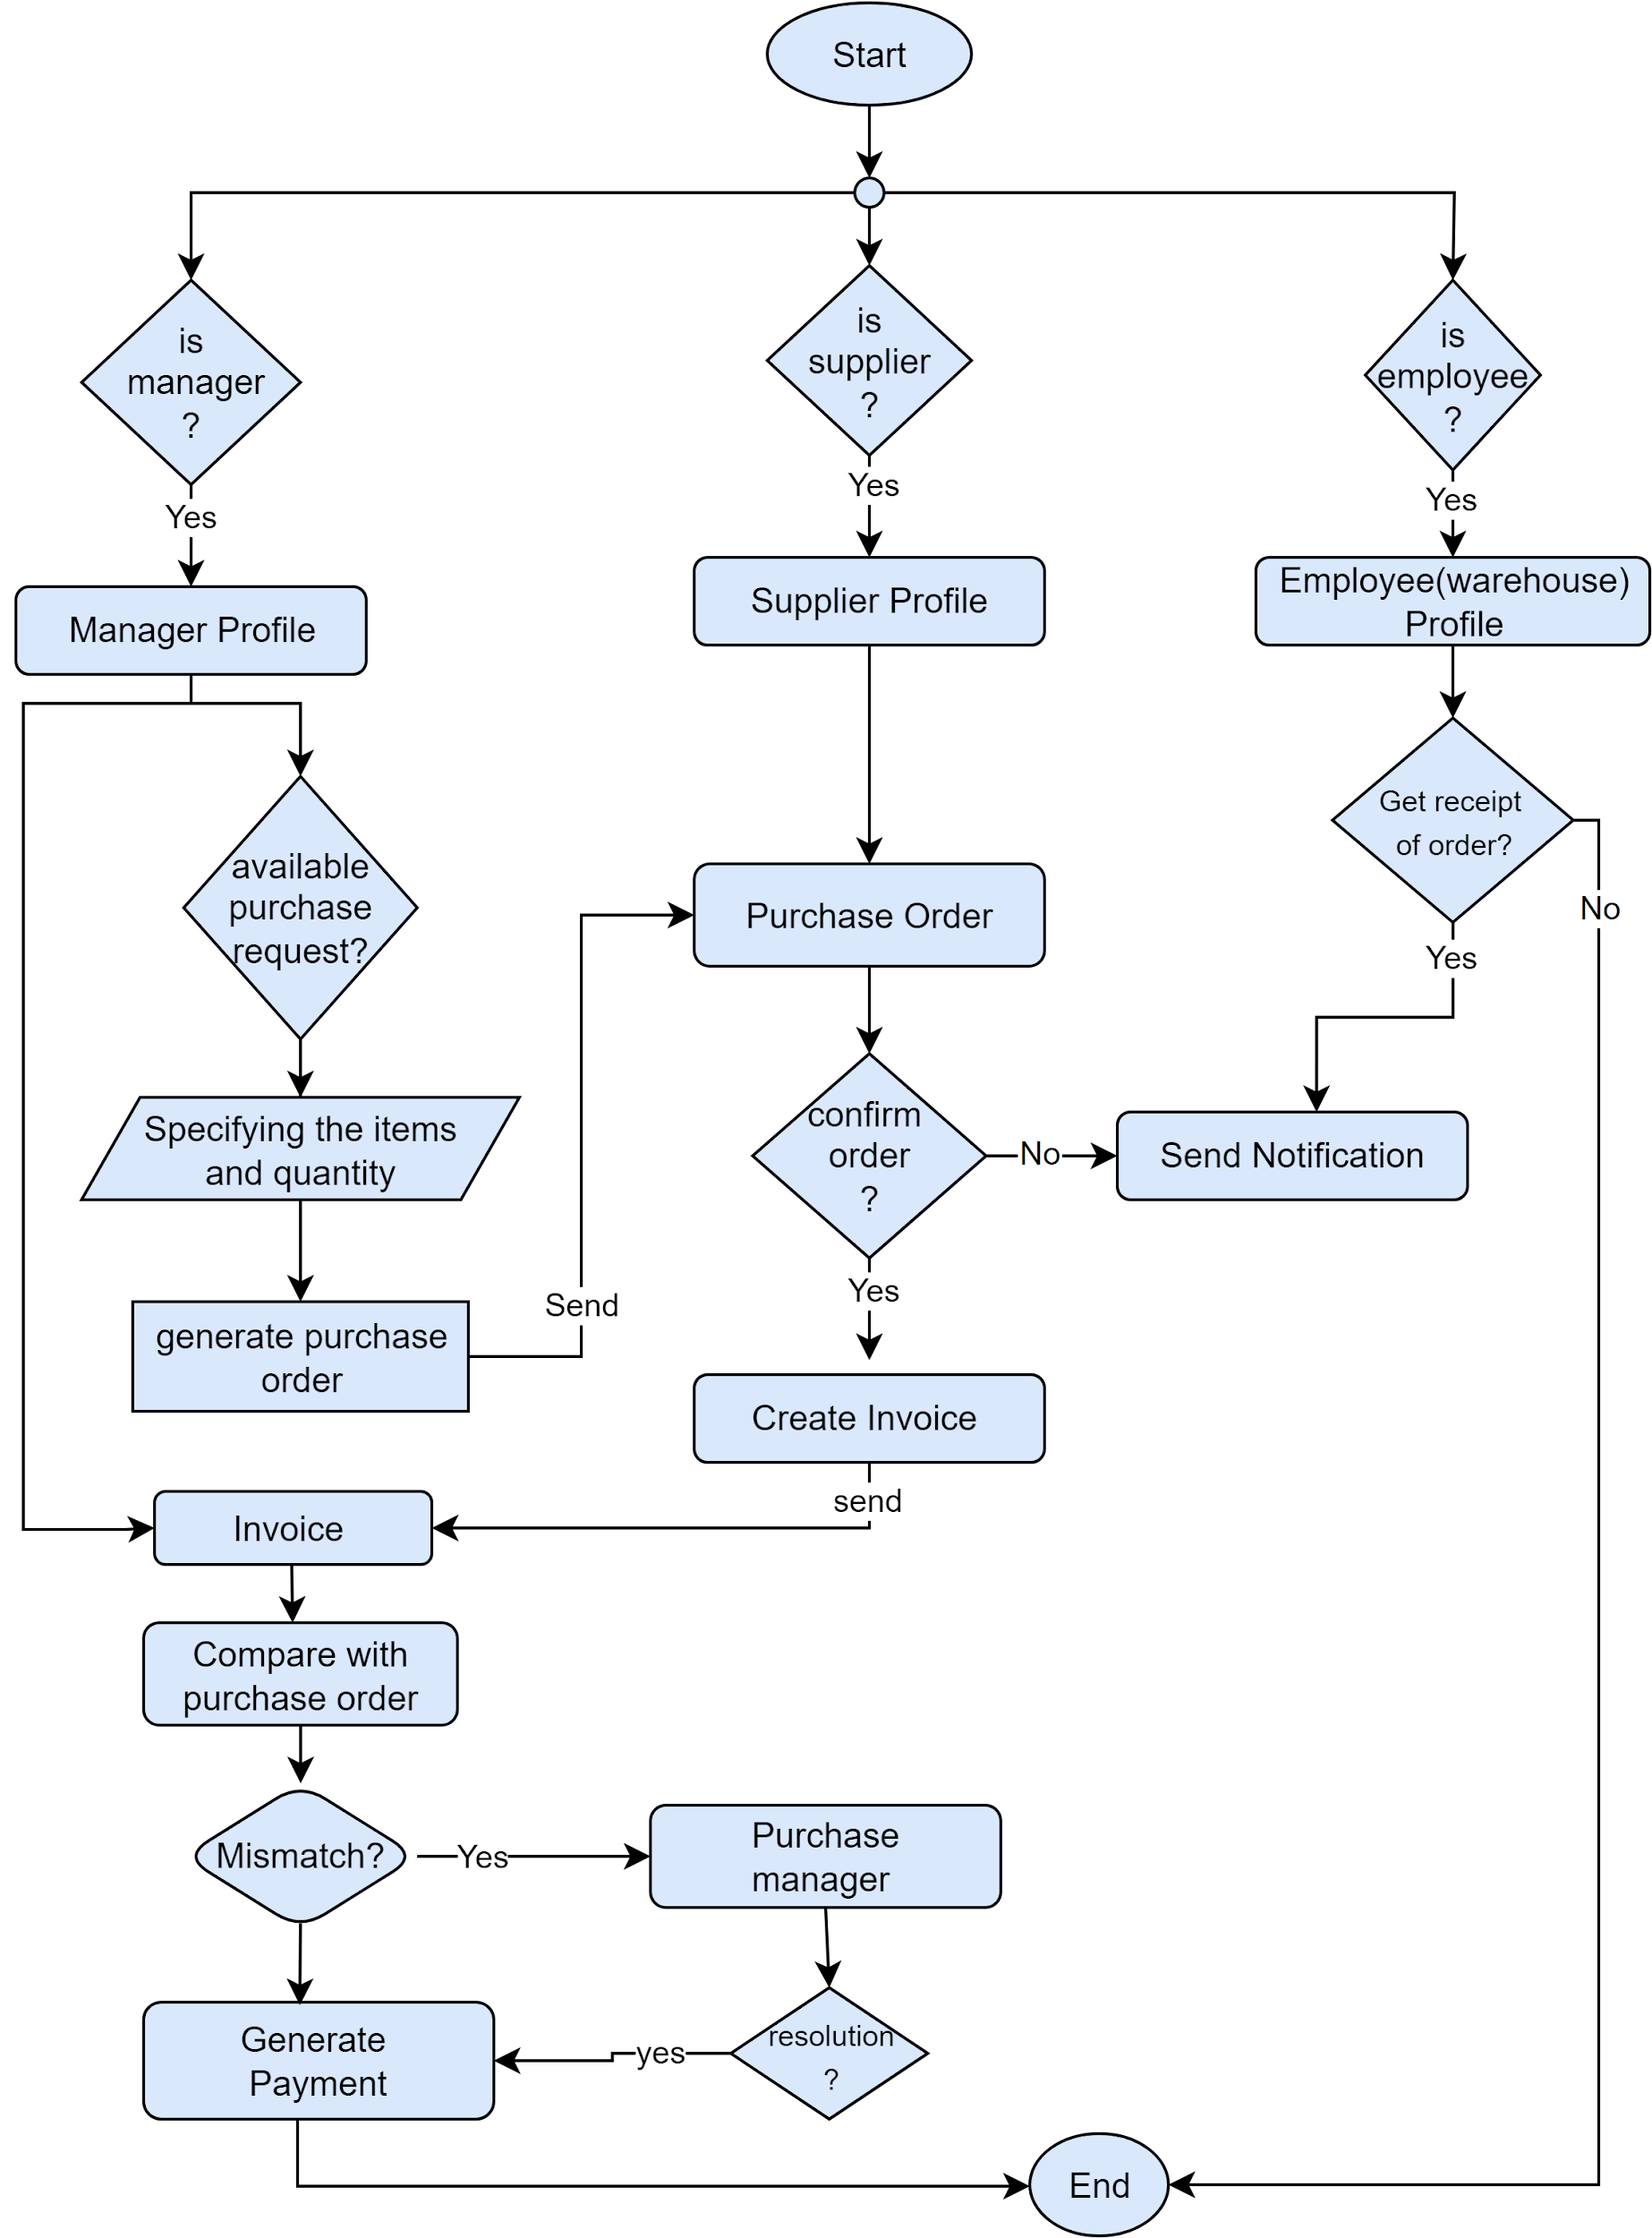](https://app.diagrams.net/?page-id=t1hoqtqNfKv9MO53Sqzk&scale=auto#G1KpwtGn2bAfCRoVHjpeDFZ8r3w3vtvnOJ)

*Figure 31 : Activity diagram level 1.3 Purchase Management System*

**Activity diagram ID: 15**

**Level 1.4**

**Name :**  Account Management System

**Reference**: Use case level 1.4 (Figure: Use case diagram level 1.4 : Account Management System)

[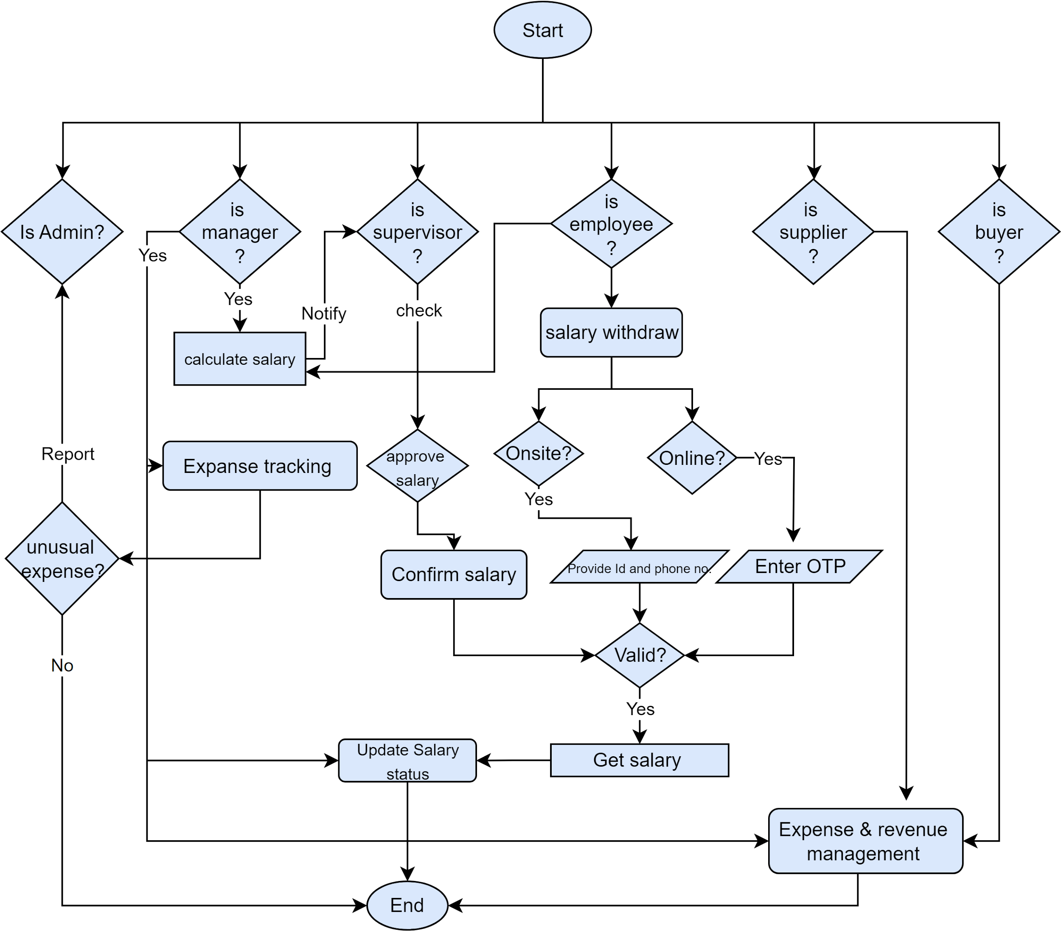](https://app.diagrams.net/?page-id=-qD0ZDVE6E8UFajrYdmB&scale=auto#G1FYblRjXpYlKaYYg4tCosKIUMmVKveqkf)

*Figure 32: Activity diagram level 1.4 : Account Management System*

**Activity diagram ID: 16**

**Level 1.5**

**Name :**  Warehouse Management System

**Reference**: Use case level 1.5 (Figure: Use case diagram level 1.5 : Warehouse Management System)

[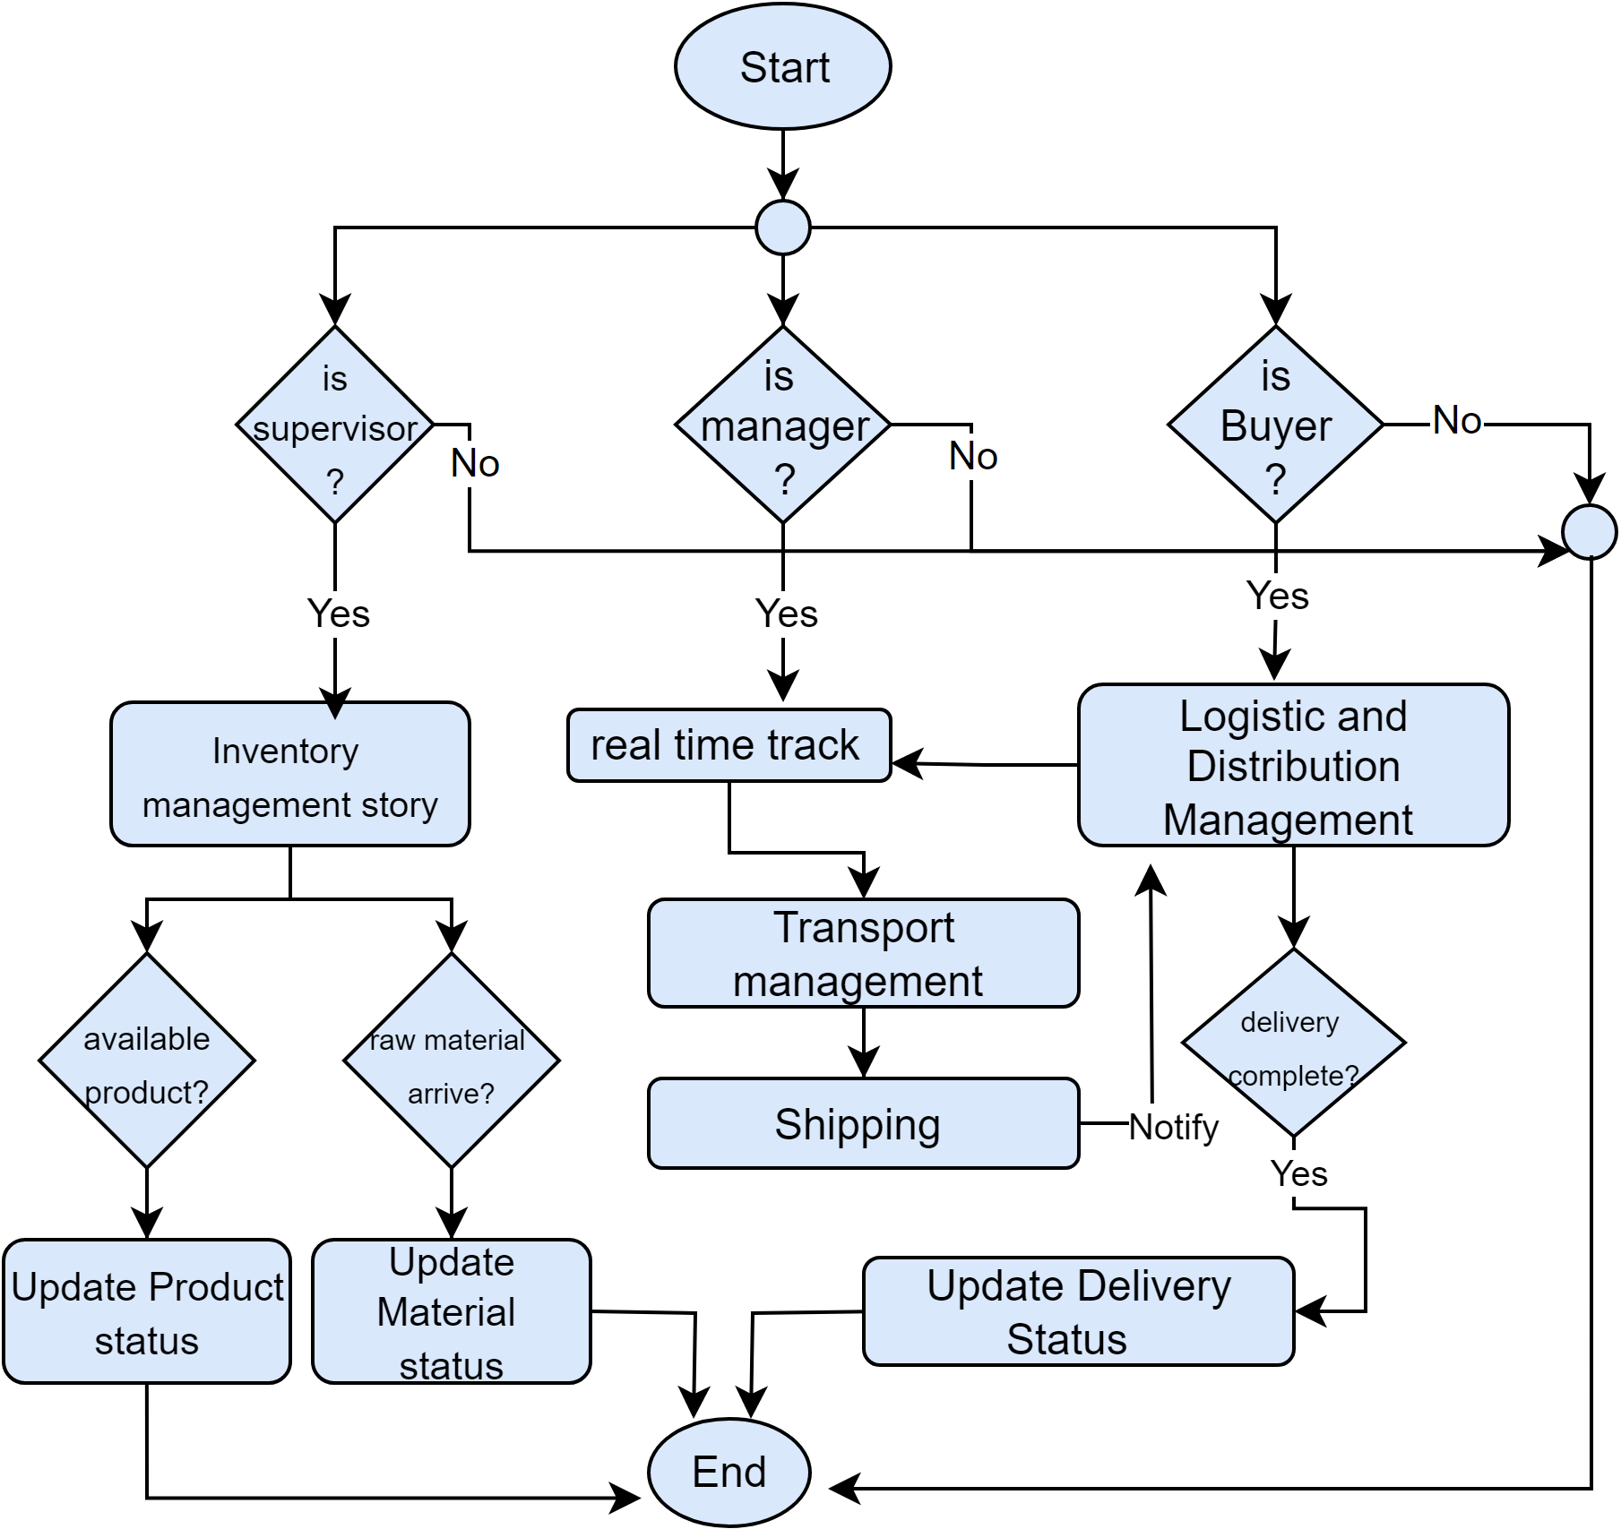](https://app.diagrams.net/?page-id=ycIsrod-mUHCrIFl0dBP&scale=auto#G10QNBdM43bSSXLS_FXXaWQKGLwgG5PoFU)

*Figure 33: Activity diagram level 1.5 : Warehouse Management System*

**Activity diagram ID: 17**

**Level 1.6**

**Name :** Production Negotiation and Buyer Interaction Management

**Reference**: Use case level 1.6 (Figure: Use case diagram level 1.6 : Production Negotiation and Buyer Interaction Management)

[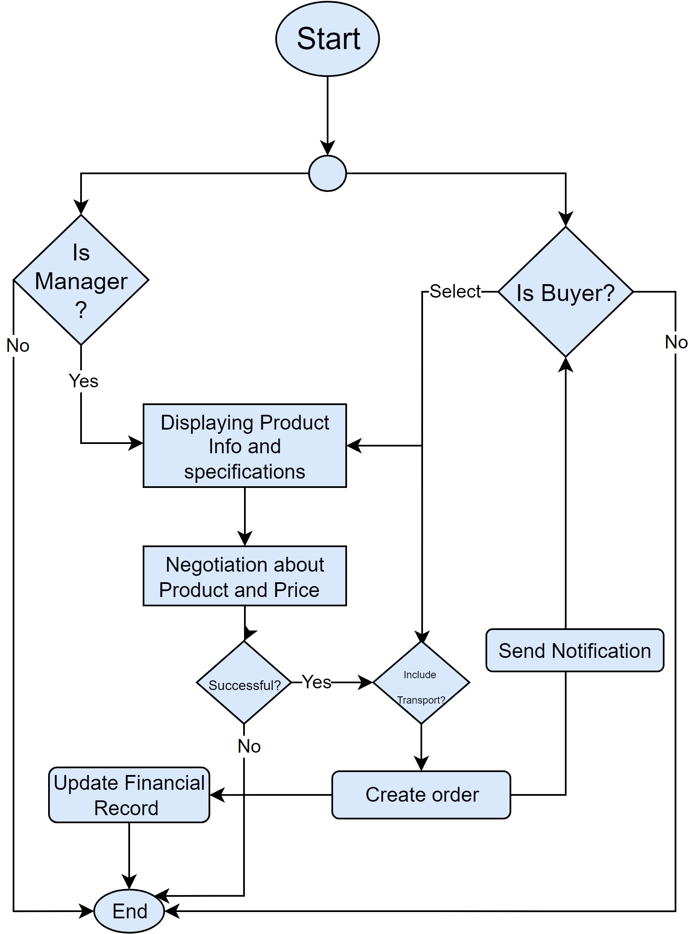](https://app.diagrams.net/?page-id=8lCnJPD3R-XN4jd-vHx5&scale=auto#G1_sDy1Um2W5PvzkUbOvkSGdkqAnj4XBeP)

*Figure 34: Activity diagram level 1.6 : Production Negotiation and Buyer Interaction Management*

**4.5 Swim lane diagrams**

A swimlane diagram is a type of flowchart. Like a flowchart, it diagrams a process from start to finish, but it also divides these steps into categories to help distinguish which departments or employees are responsible for each set of actions. It is based on the analogy of lanes in a pool, as it places process steps within the horizontal or vertical “swimlanes” of a particular department, work group or employee, thus ensuring clarity and accountability.

**Swim lane Diagram ID: 01**

**Level 1.1**

**Name** : Registration and AuthenticationSystem

**Reference** : Use case level 1.1 (Figure : use case diagram level 1.1 Registration and AuthenticationSystem) & Activity diagram ID : 01 (Figure : Activity diagram level 1.1 Registration and AuthenticationSystem)

[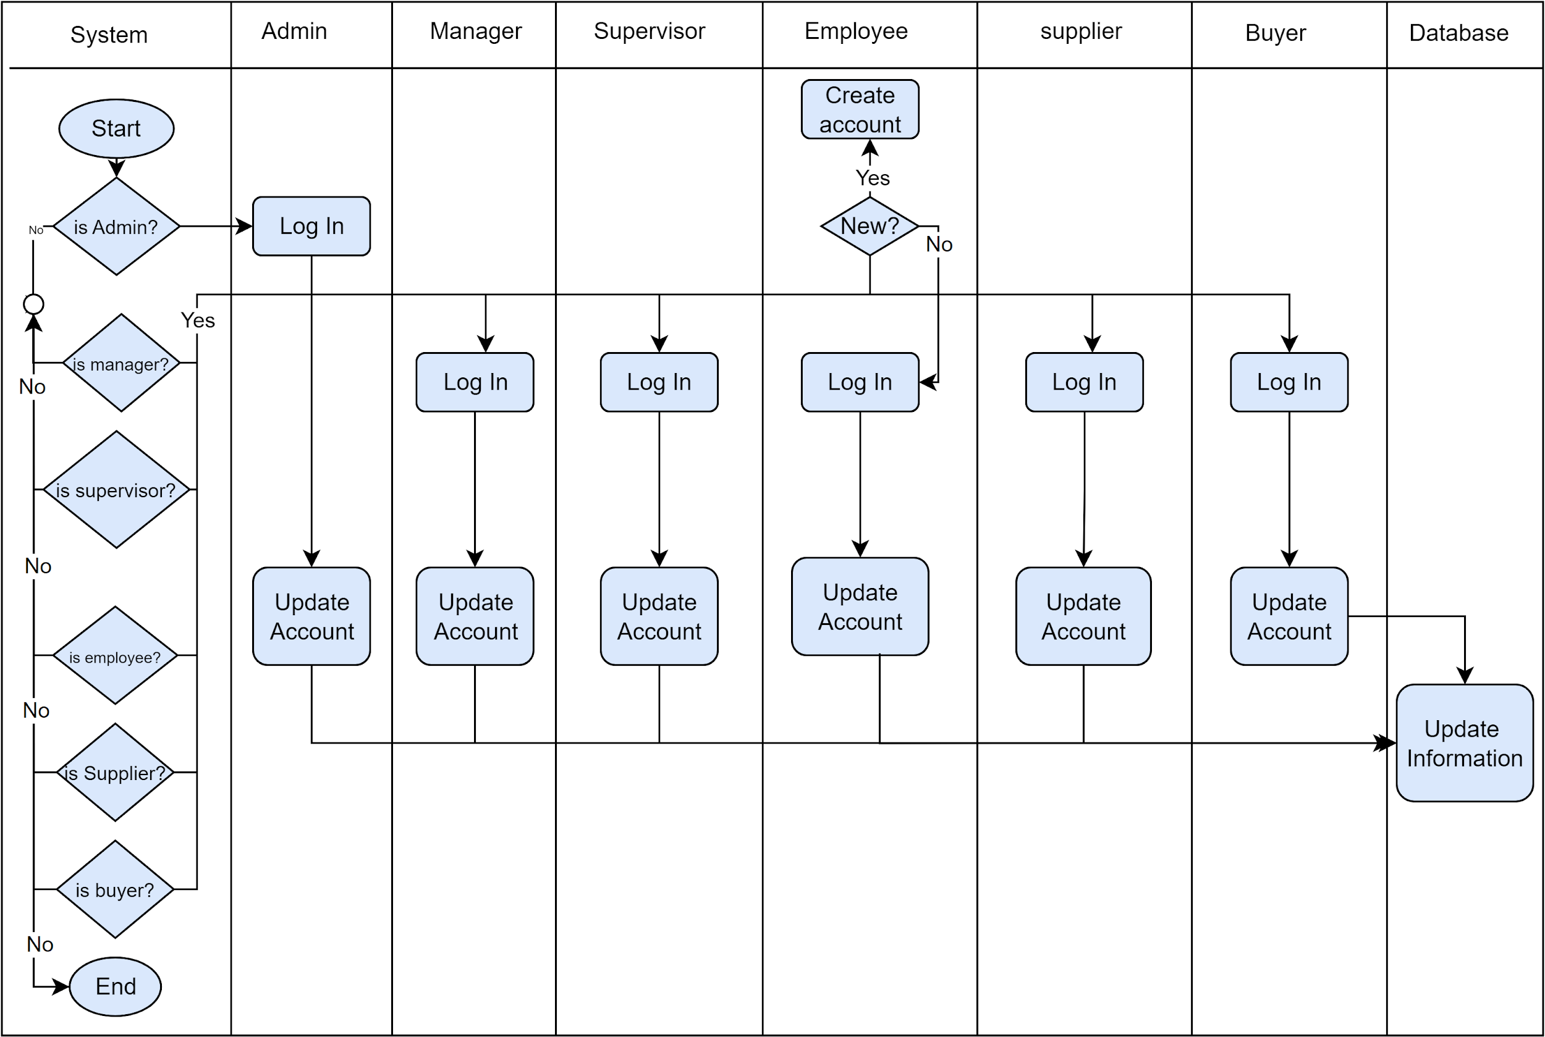](https://app.diagrams.net/?page-id=HonKn0GlZdrpNykT2NT8&scale=auto#G1WLhsL-hVqp1Yl6M6oxvS4wlYTt0LwSLC)

*Figure 35: Swimlane diagram level 1.1 Registration and Authentication**System*

**Swim lane Diagram ID: 02**

**Level 1.1.2**

**Name** :Create Account

**Reference** : Use case level 1.1 (Figure: Use case diagram level 1.1 : Registration and AuthenticationSystem) & Activity diagram ID : 02(Figure : Activity diagram level 1.1.2 Create Account)

[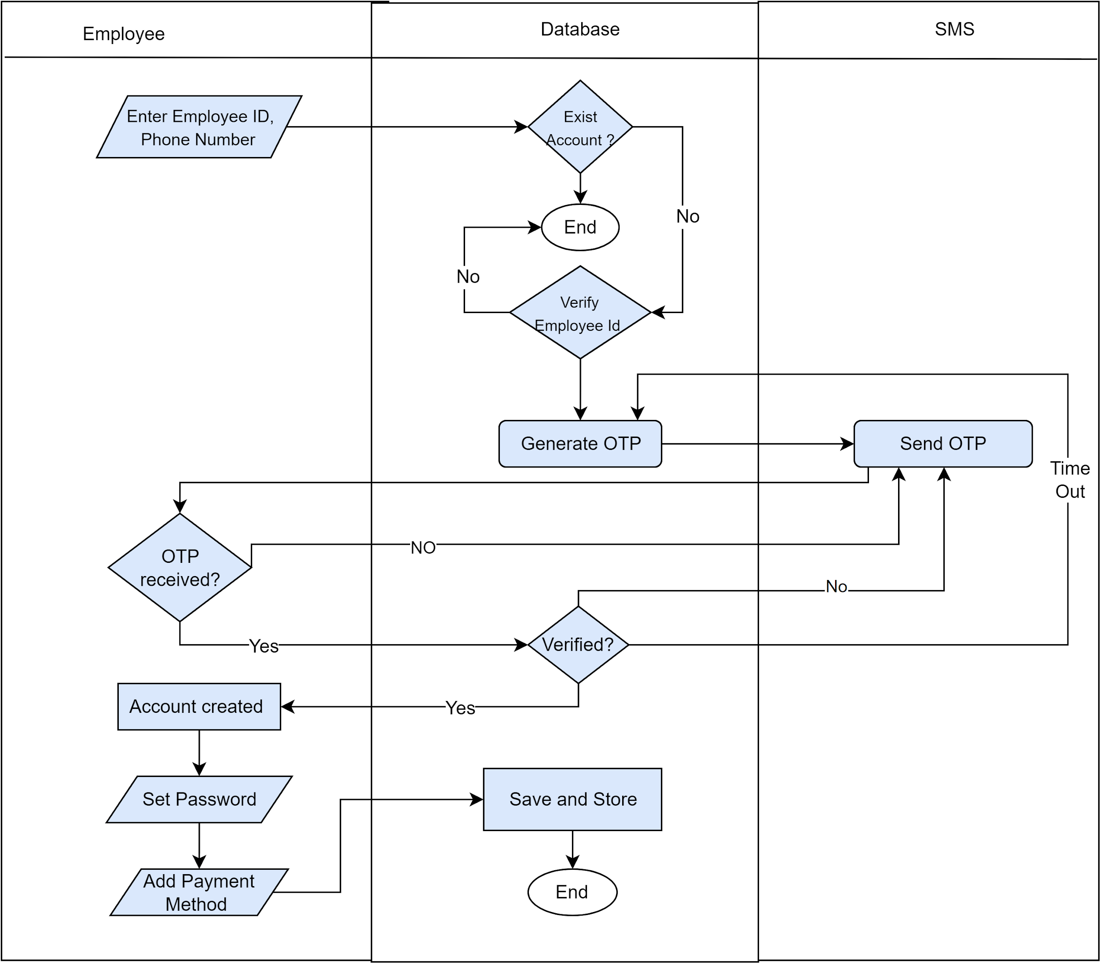](https://app.diagrams.net/?page-id=_KVXCClfKmX5hdjG43cq&scale=auto#G1GTFcP5j5ZAzWp-idiURwTd89THVXulRk)

*Figure 36 : Swimlane diagram level 1.1.2 Create Account*

**Swim lane diagram ID: 03**

**Level 1.1.3**

**Name :** Log in

**Reference**: Use case level 1.1 (Figure: Use case diagram level 1.1 : Registration and AuthenticationSystem) & Activity diagram ID : 04( Figure : Activity diagram level 1.1.3 log in )

[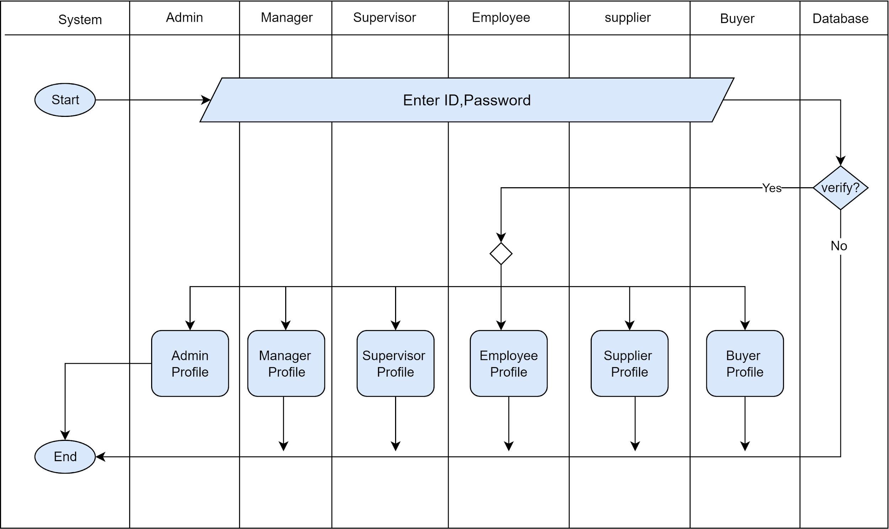](https://app.diagrams.net/?page-id=9QgYvWLEND_FybFjw94J&scale=auto#G1GTFcP5j5ZAzWp-idiURwTd89THVXulRk)

*Figure 37: Swimlane diagram level 1.1.3 log in*

**Swim lane diagram ID: 04**

**Level 1.1.1.1**

**Name :** Update Account information

**Reference**: Use case level 1.1.1 (Figure: Use case diagram level 1.1.1 : Update Account) & Activity diagram ID : 05 ( Figure : Activity diagram level 1.1.1.1 Update Account information )

[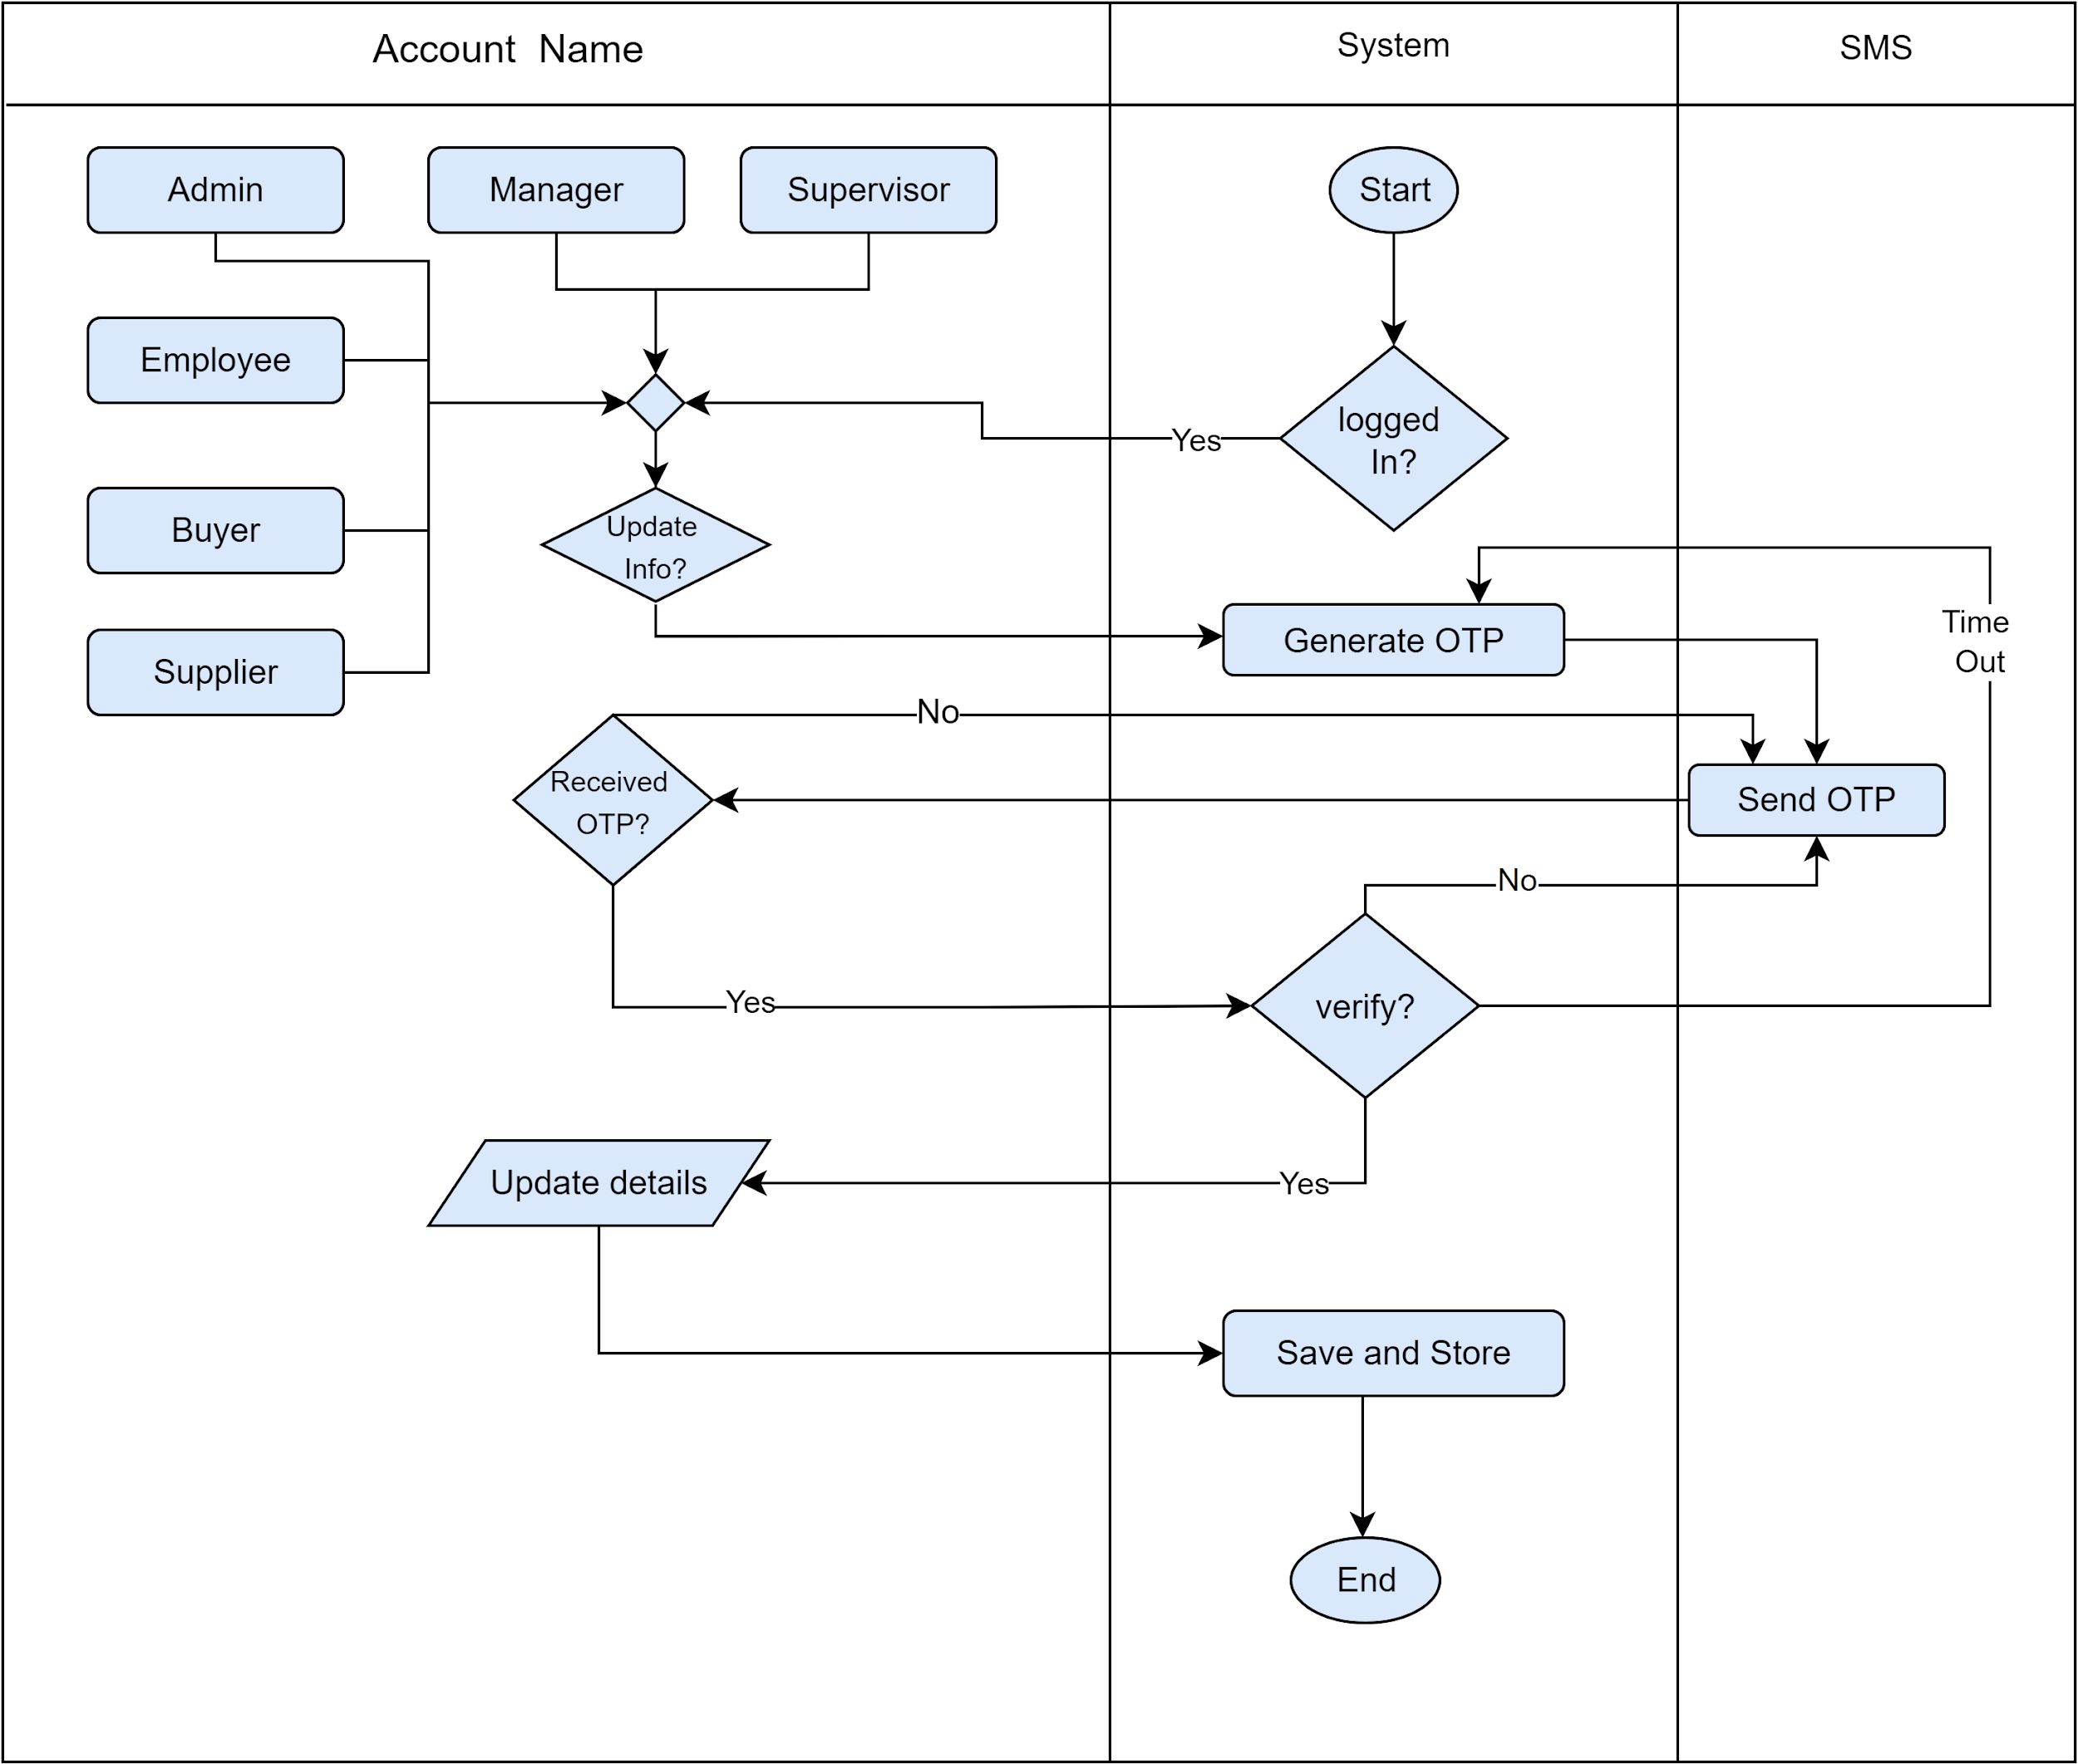](https://app.diagrams.net/?page-id=FQQh2cbC3B0JMclRgb3R&scale=auto#G1GTFcP5j5ZAzWp-idiURwTd89THVXulRk)

*Figure 38: Swimlane diagram level 1.1.1.1 Update Account information*

**Swim lane diagram ID: 05**

**Level 1.1.1.2**

**Name :** Update password

**Reference**: Use case level 1.1.1 (Figure: Use case diagram level 1.1.1 : Update Account) & Activity diagram ID : 06 ( Figure : Activity diagram level 1.1.1.2 Update Password )

[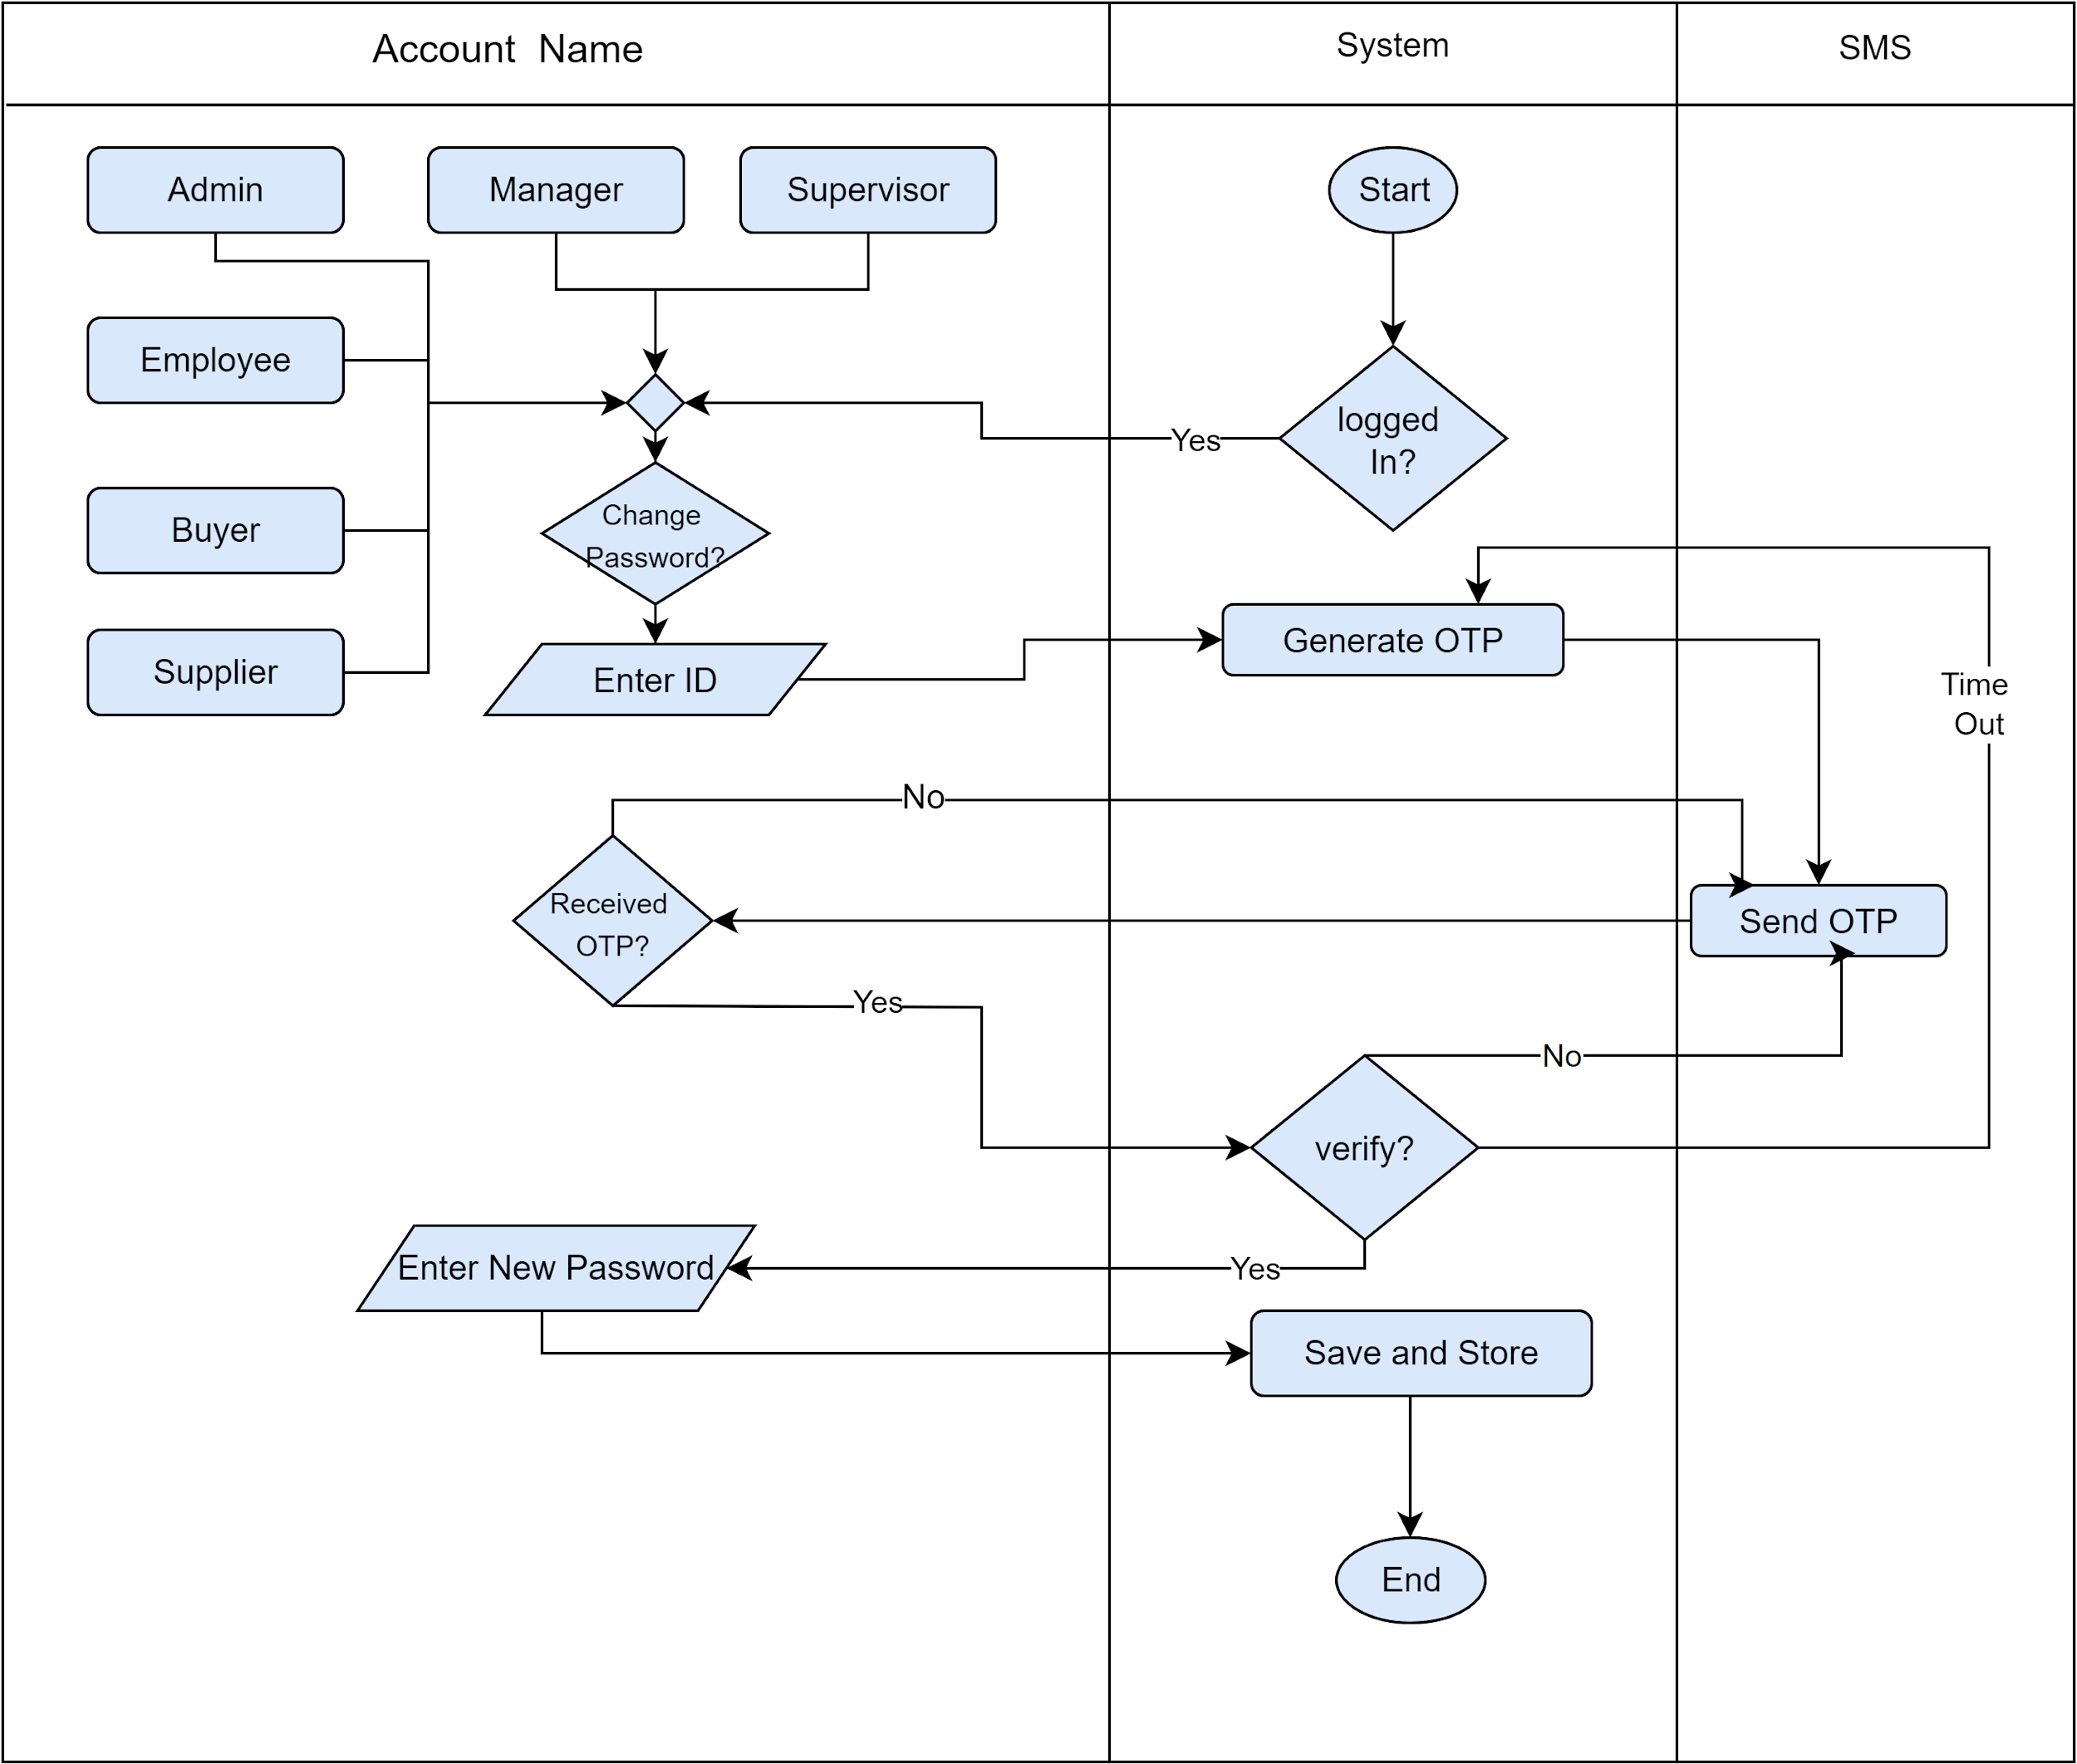](https://app.diagrams.net/?page-id=Y0wM1BSODWZ_dz111-mm&scale=auto#G1GTFcP5j5ZAzWp-idiURwTd89THVXulRk)

*Figure 39: Swimlane diagram level 1.1.1.2 Update Password*

**Swim lane diagram ID: 06**

**Level 1.1.1.3**

**Name :** Updating Employee Account

**Reference**: Use case level 1.1.1 (Figure: Use case diagram level 1.1.1 : Update Account) & Activity diagram ID : 07 ( Figure : Activity diagram level 1.1.1.3 Updating Employee Account )

[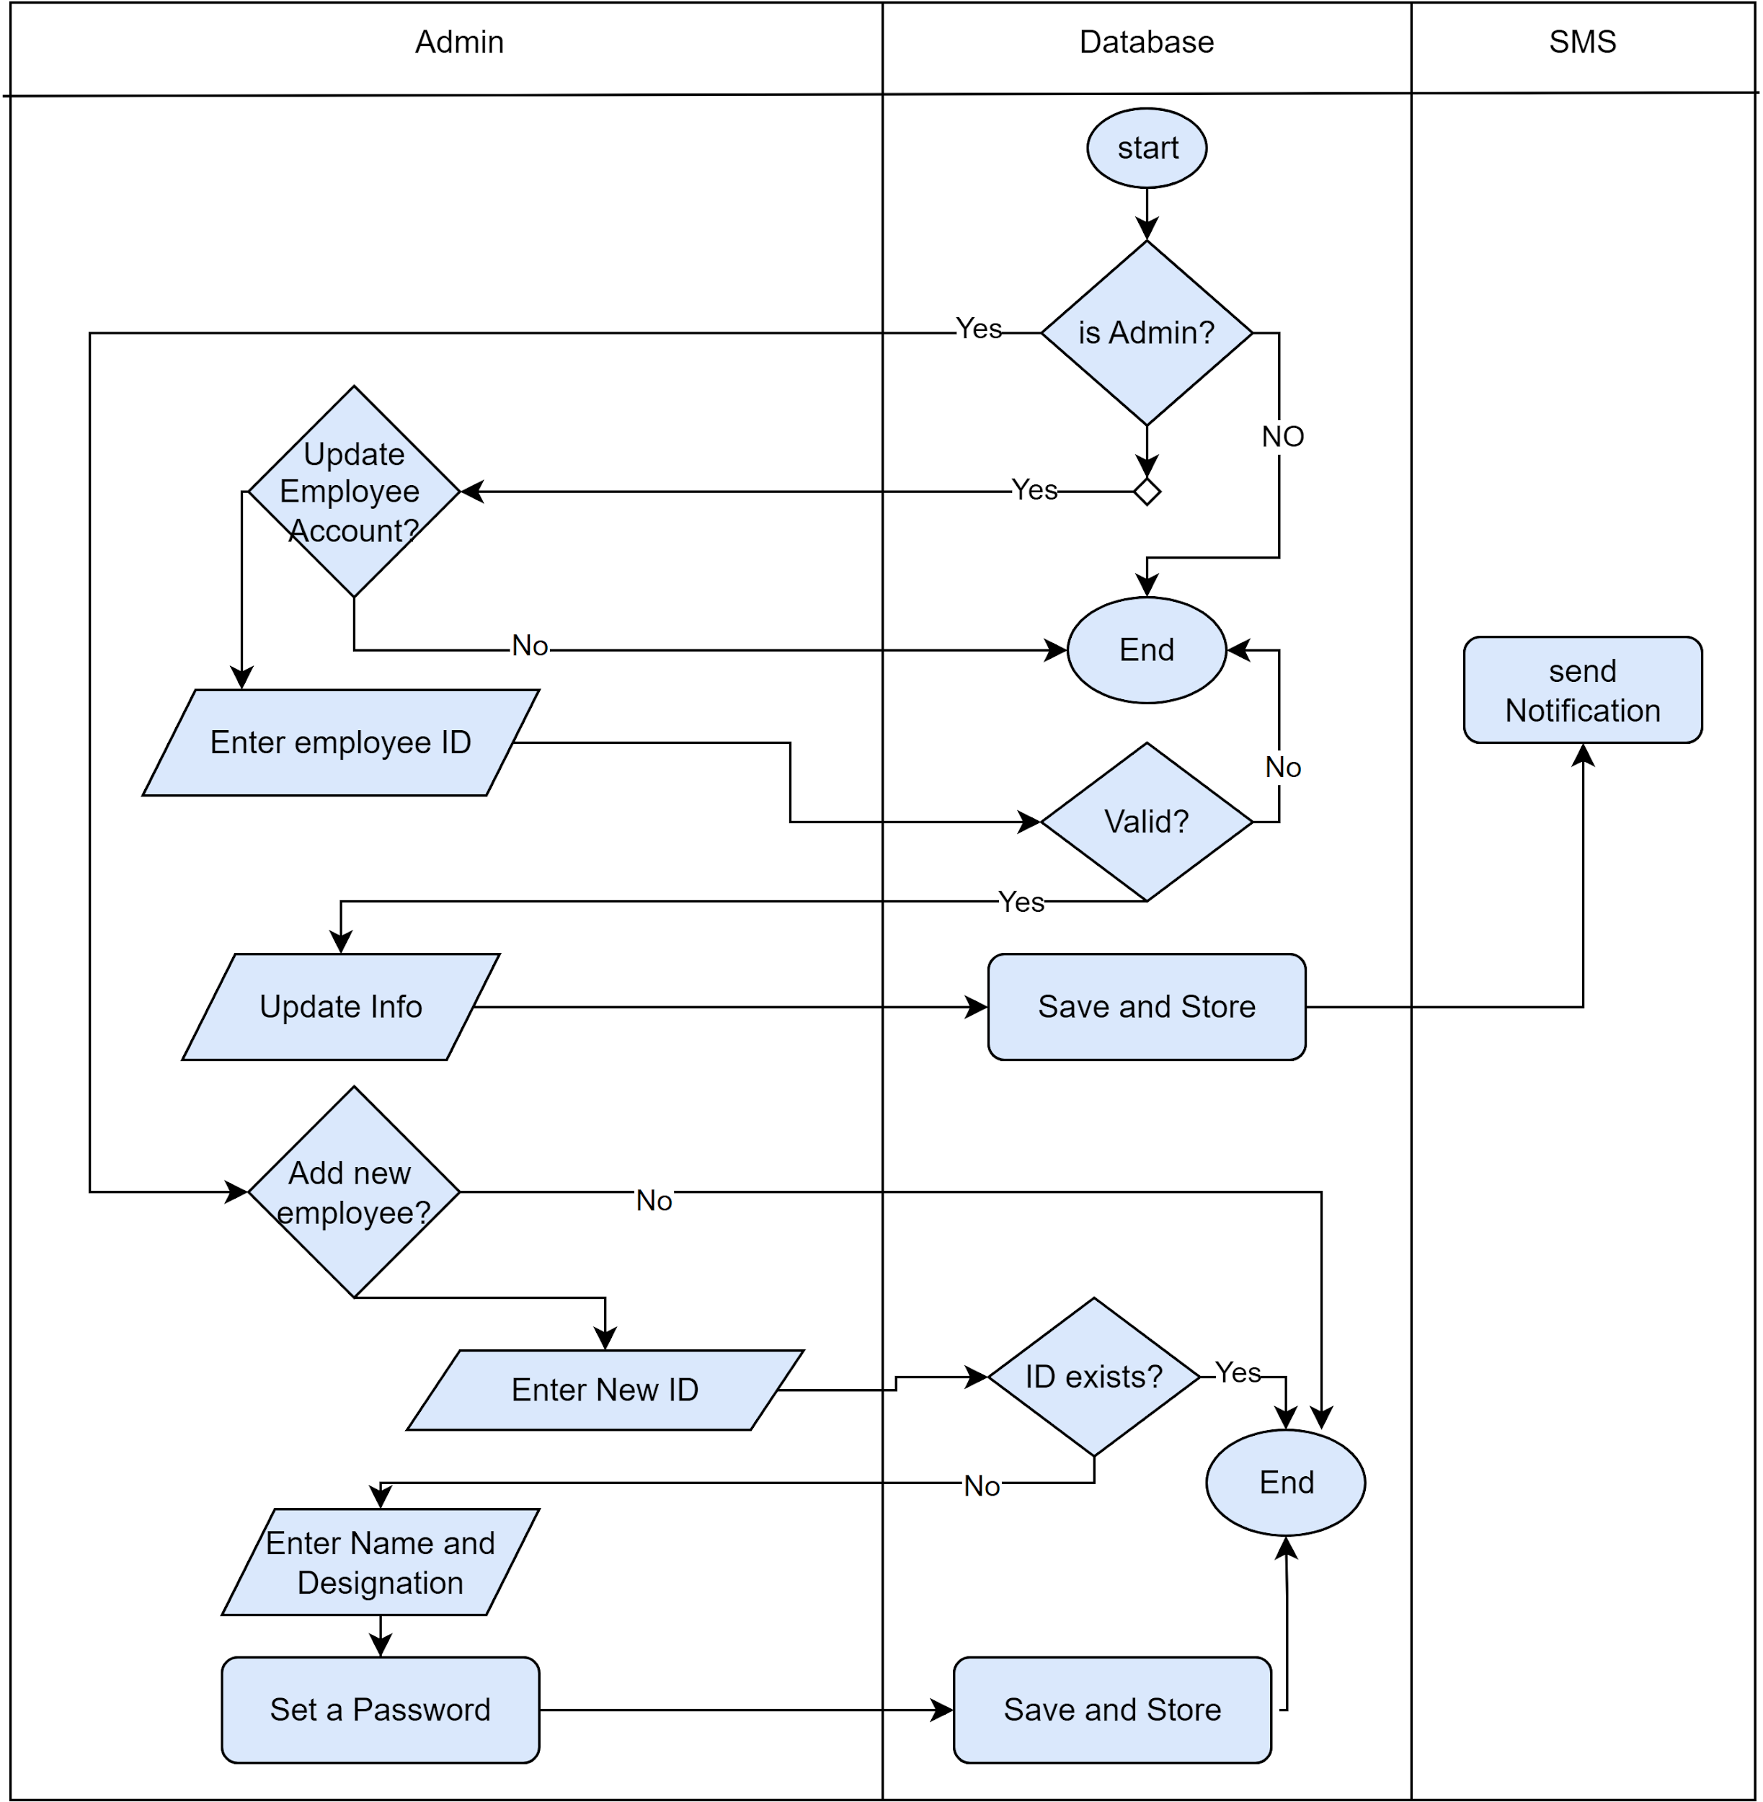](https://app.diagrams.net/?page-id=bWPF8qoc6wMLHAftl2AZ&scale=auto#G1GTFcP5j5ZAzWp-idiURwTd89THVXulRk)

*Figure 40: Swimlane diagram level 1.1.1.3 Updating Employee Account*

**Swim lane diagram ID: 07**

**Level 1.2.2.1**

**Name :** Leave

**Reference**: Use case level 1.2.2(Figure:Use case diagram level 1.2.2 : Application) & Activity diagram ID : 09 ( Figure : Activity diagram level 1.2.2.1 Leave )

[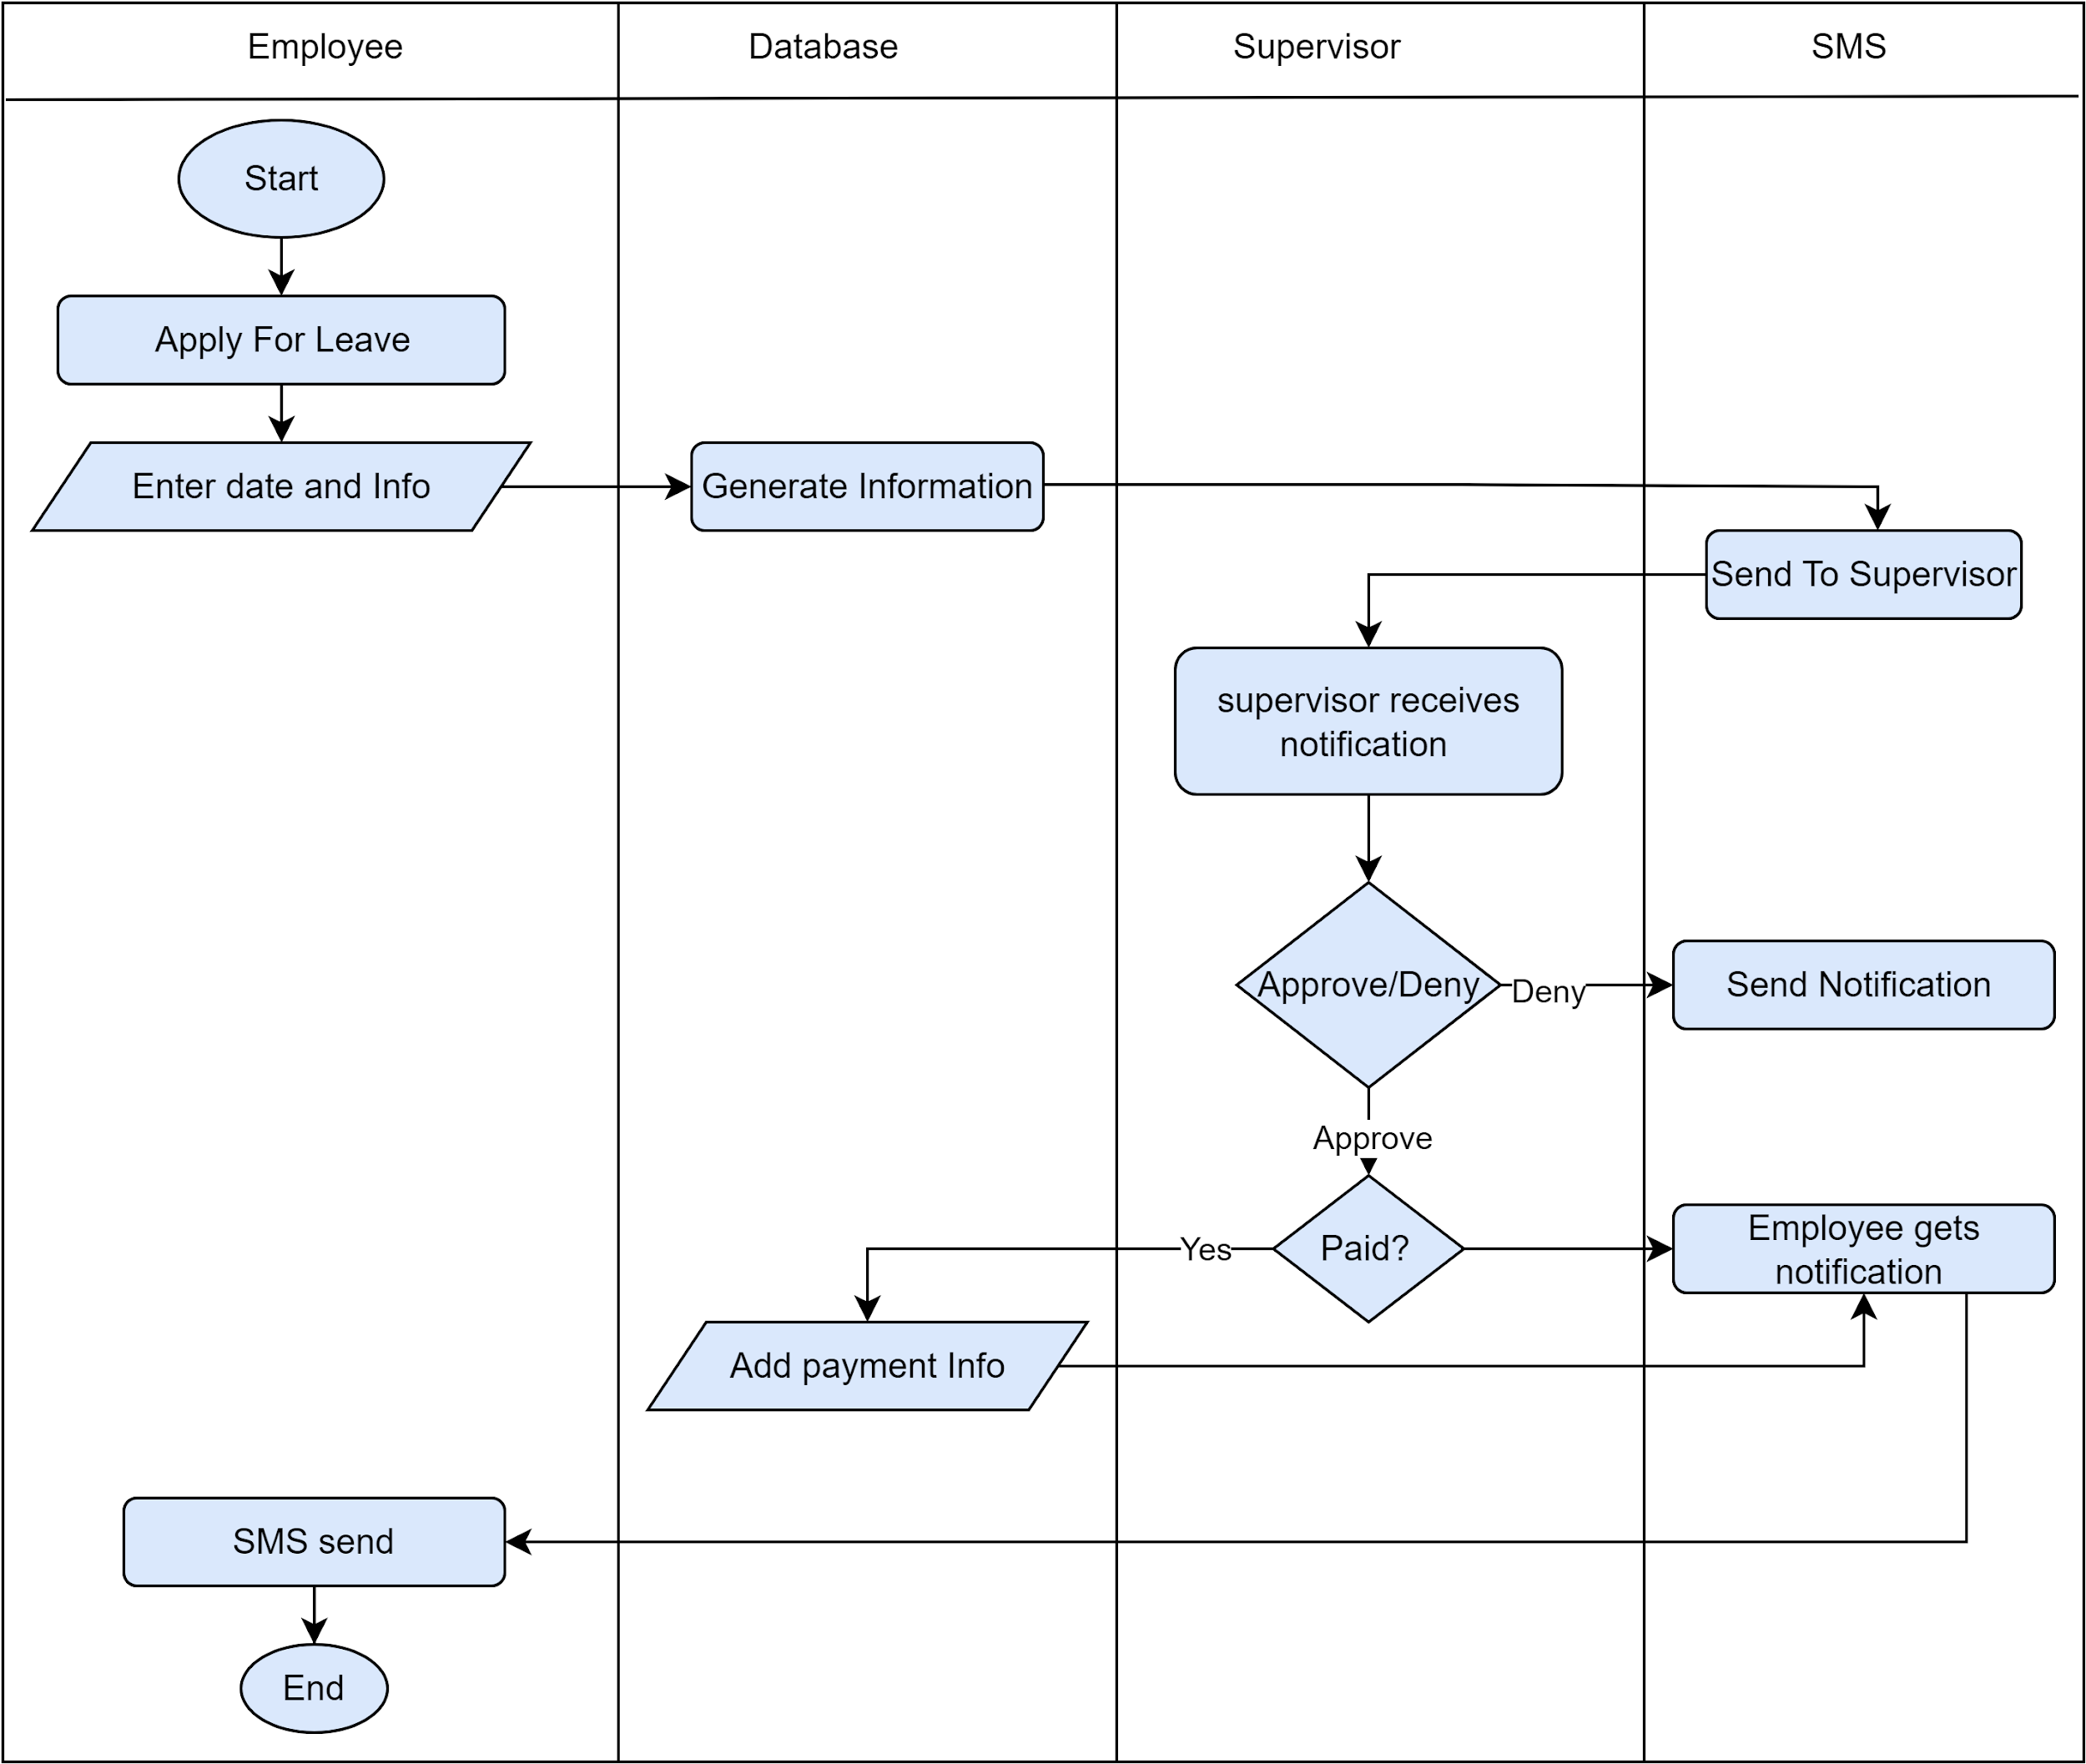](https://app.diagrams.net/?page-id=mawtL51N4T5zueo1_v-S&scale=auto#G1GTFcP5j5ZAzWp-idiURwTd89THVXulRk)

*Figure 41: Swimlane diagram level 1.2.2.1 Leave*

**Swim lane diagram ID: 08**

**Level 1.2.2.2**

**Name :** Overtime

**Reference**: Use case level 1.2.2(Figure:Use case diagram level 1.2.2: Application)

& Activity diagram ID : 10 ( Figure : Activity diagram level 1.2.2.2 Overtime )

[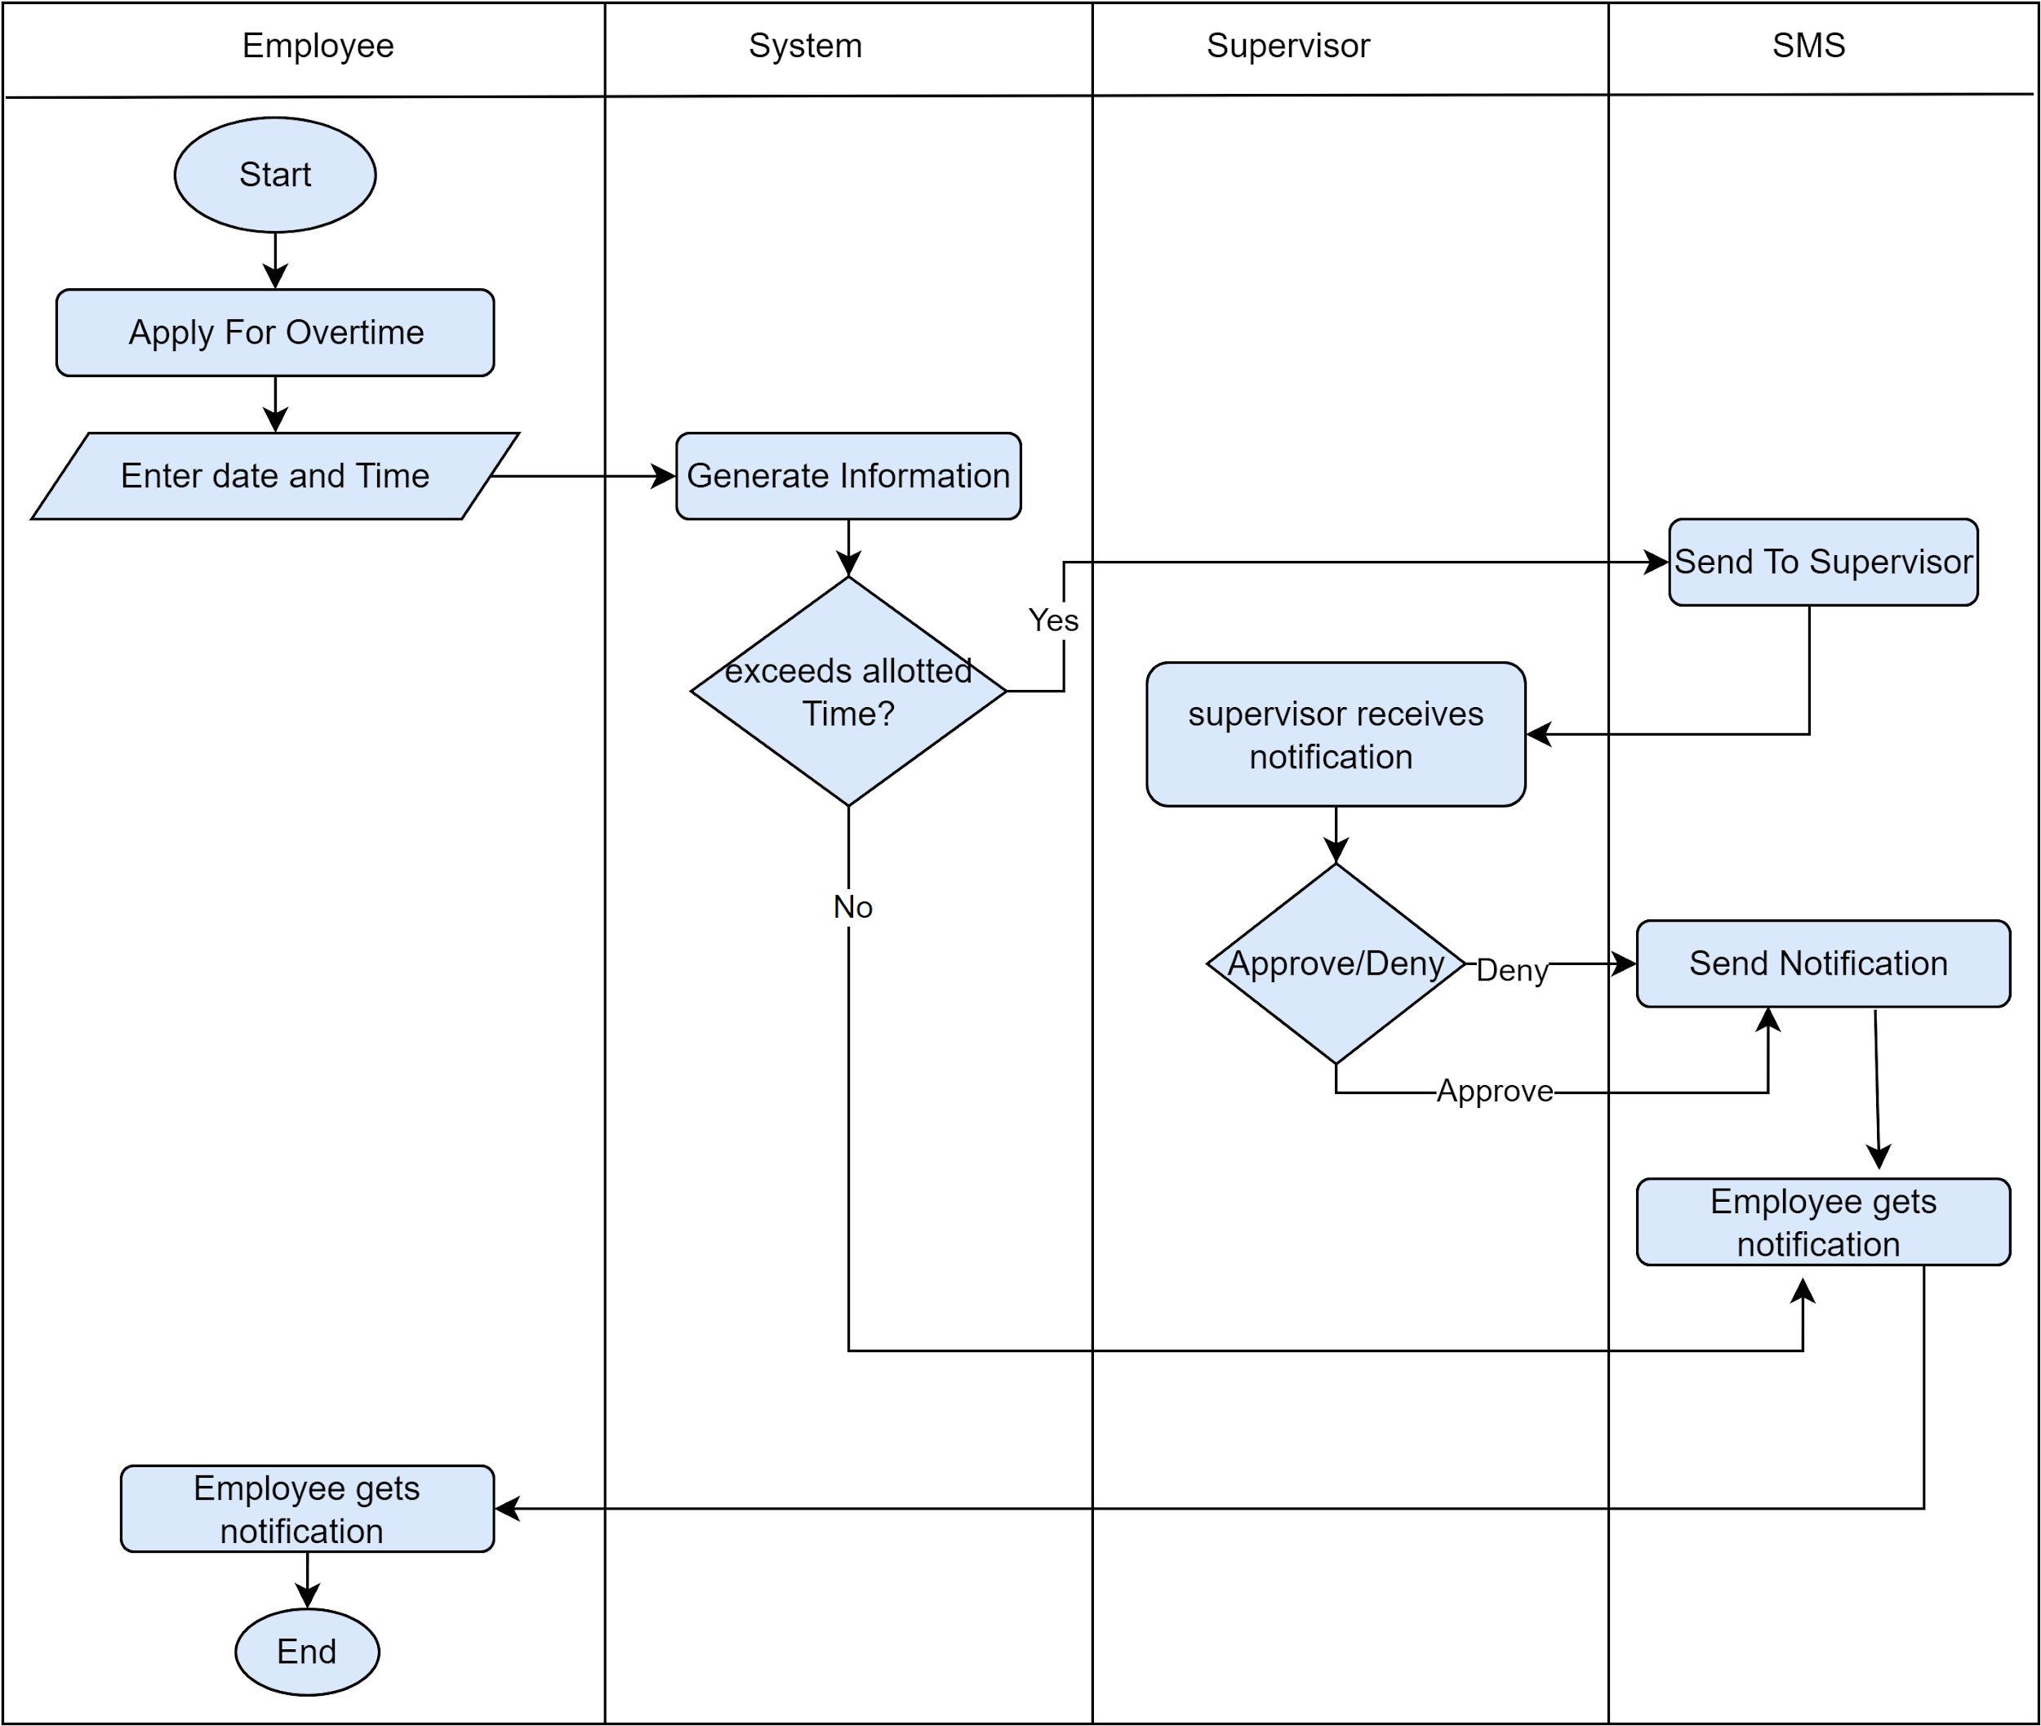](https://app.diagrams.net/?page-id=p3EUtho0W4fNCxe7YpX7&scale=auto#G1GTFcP5j5ZAzWp-idiURwTd89THVXulRk)

*Figure 42 : Swimlane diagram level 1.2.2.2 Overtime*

**Swim lane diagram ID: 09**

**Level 1.2.2.3**

**Name :** Insurance

**Reference**: Use case level 1.2.2(Figure:Use case diagram level 1.2.2 : Application)

& Activity diagram ID : 11 ( Figure : Activity diagram level 1.2.2.3 Insurance )

[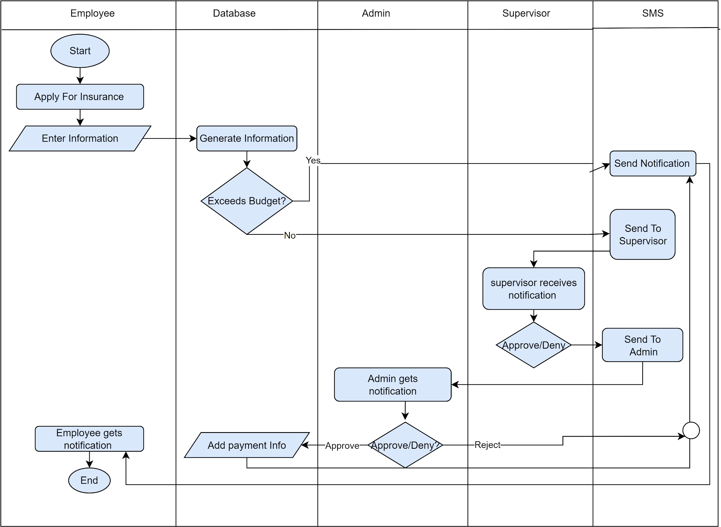](https://app.diagrams.net/?page-id=H19q3dxnNRDaIP6Z55lE&scale=auto#G1GTFcP5j5ZAzWp-idiURwTd89THVXulRk)

*Figure 43: Swimlane diagram level 1.2.2.3 Insurance*

**Swim lane diagram ID: 10**

**Level 1.3**

**Name :**  Purchase Management System

**Reference**: Use case level 1.3 (Figure: Use case diagram level 1.3 :Purchase Management System)& Activity diagram ID : 14 ( Figure : Activity diagram level 1.3 Purchase Management System )

[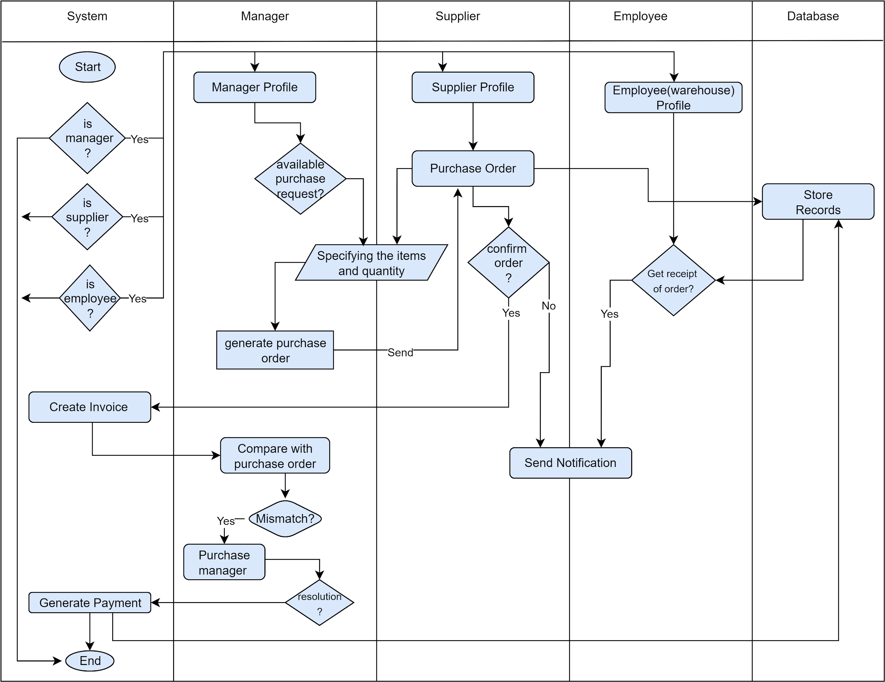](https://app.diagrams.net/?page-id=GGKC8ivxISPi15TkYfIL&scale=auto#G1GTFcP5j5ZAzWp-idiURwTd89THVXulRk)

*Figure 44 : Swimlane diagram level 1.3 Purchase Management System*

**Swim lane diagram ID: 11**

**Level 1.4**

**Name :**  Account Management System

**Reference**: Use case level 1.4 (Figure: Use case diagram level 1.4 :Account Management System)& Activity diagram ID : 15 ( Figure : Activity diagram level 1.4 Account Management System )

[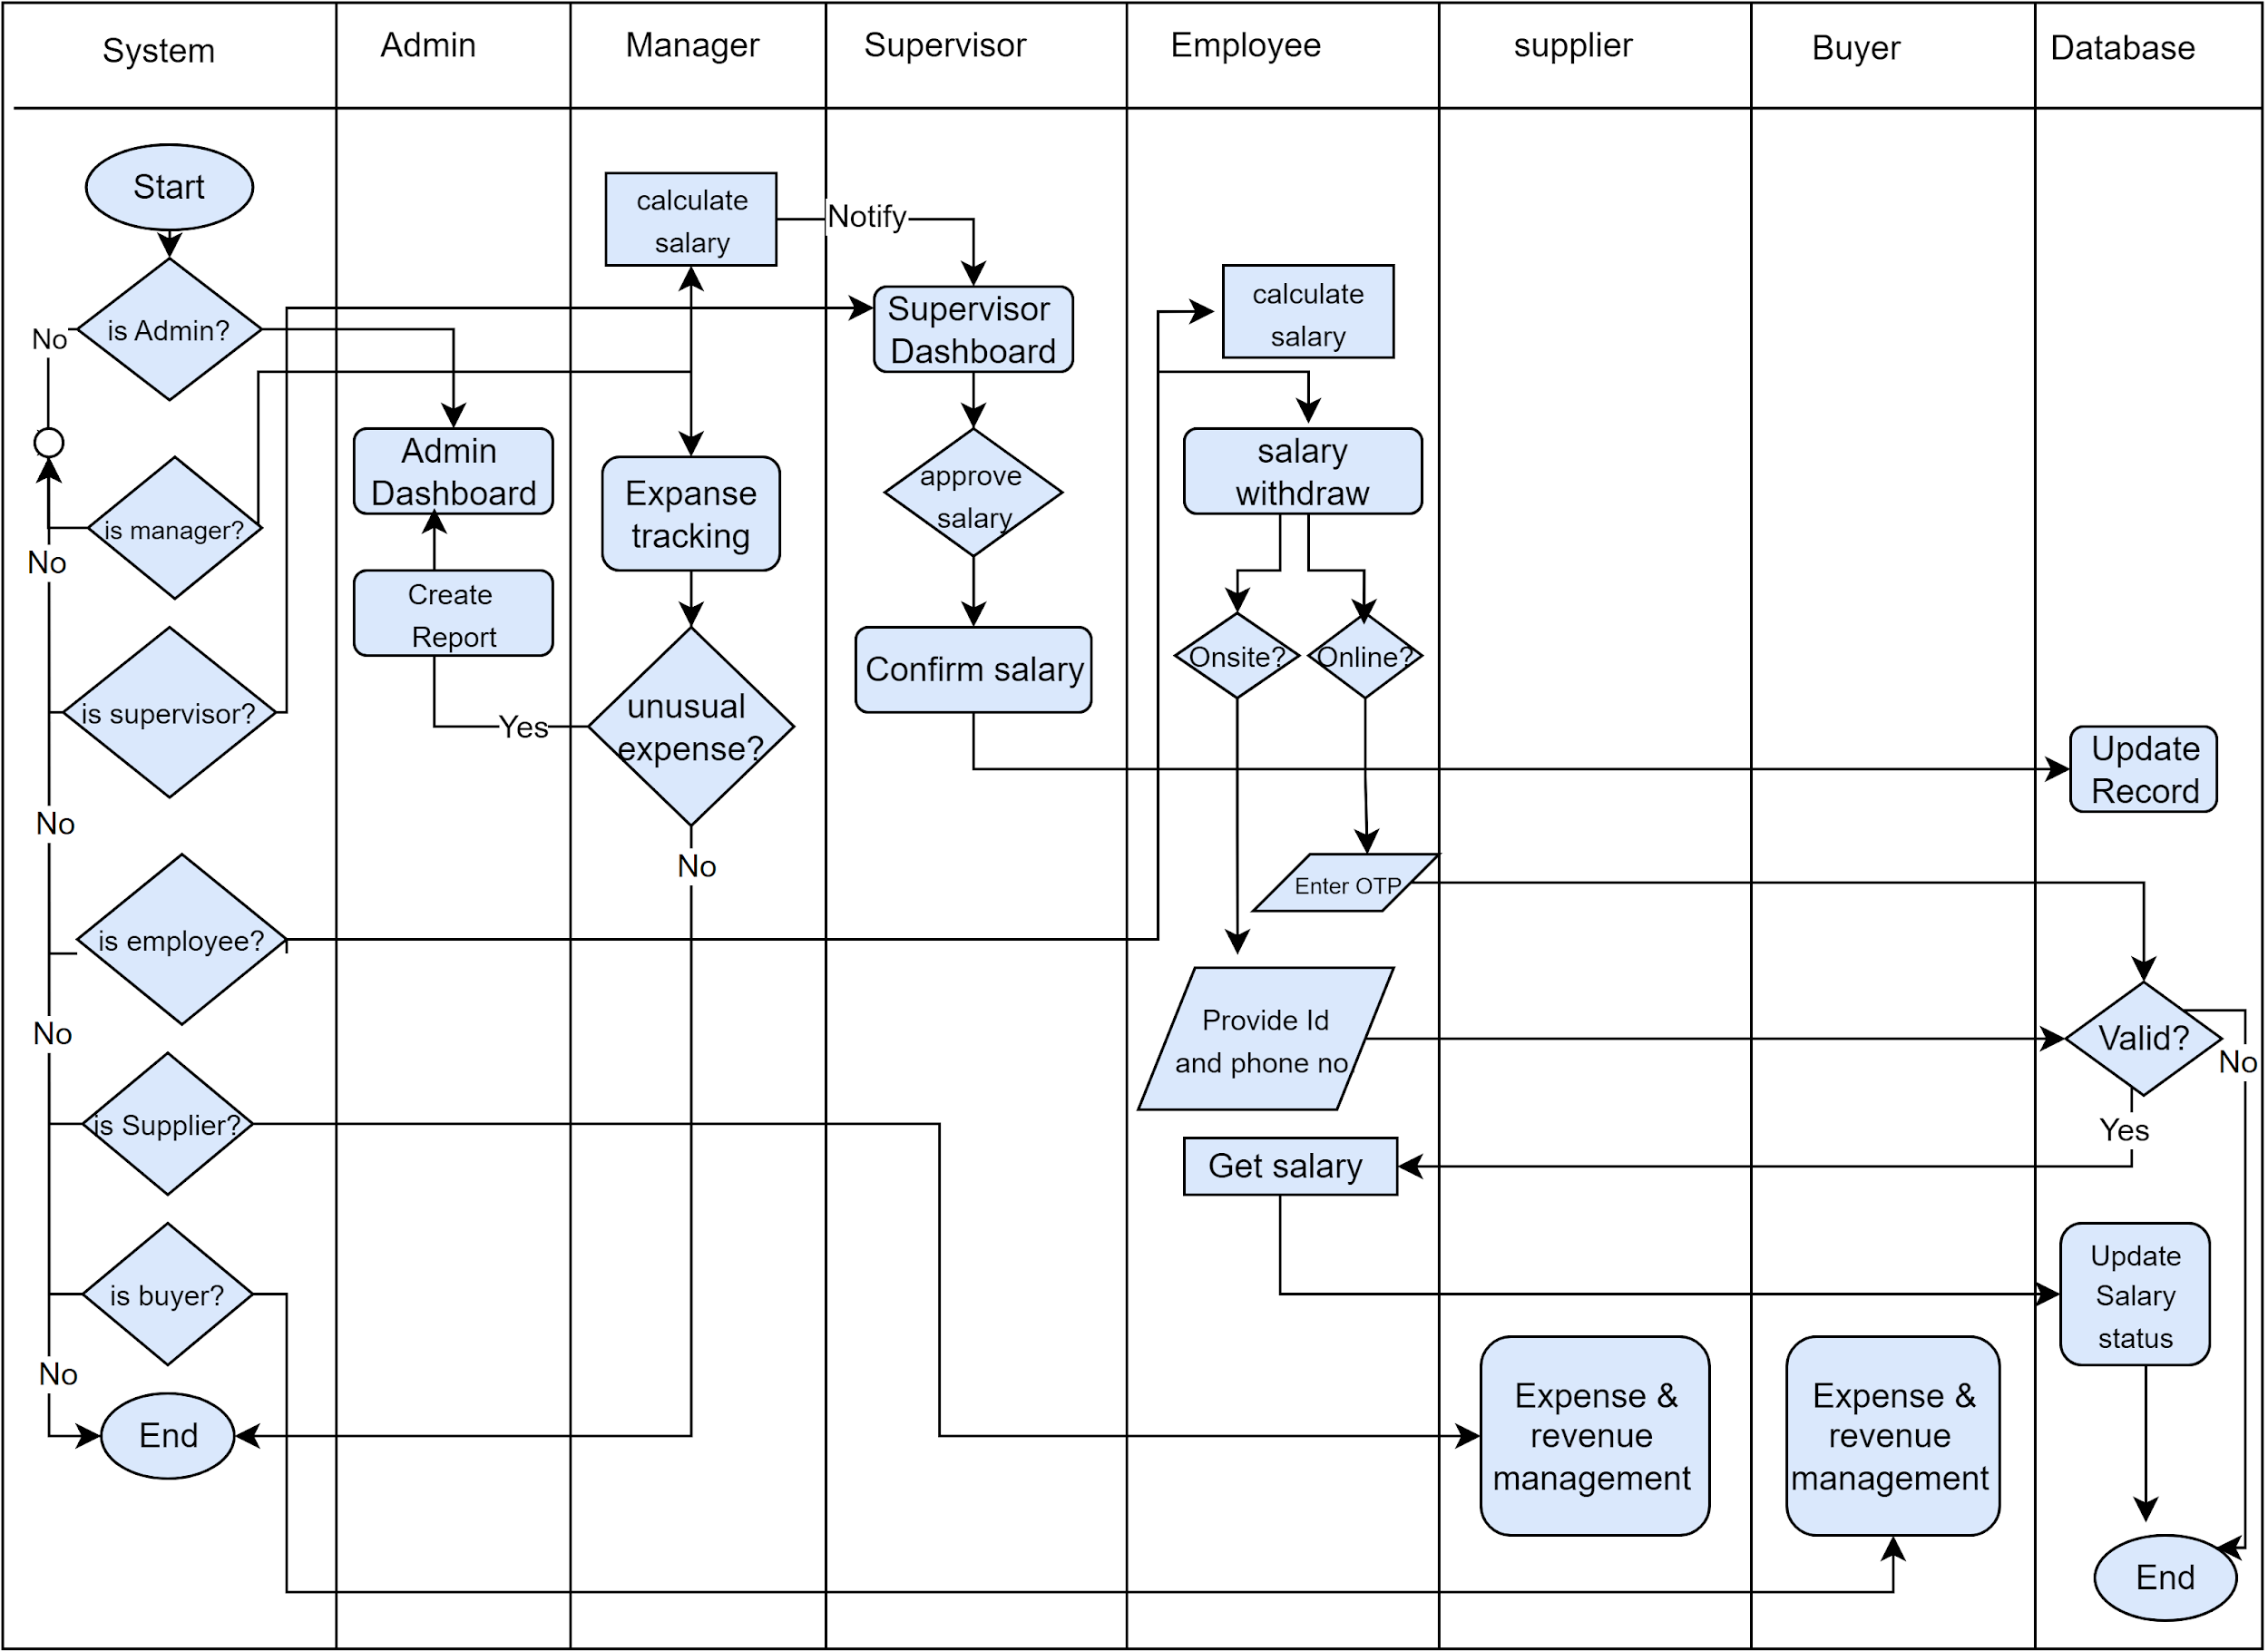](https://app.diagrams.net/?page-id=JLSHitLszAYVKwI6pFur&scale=auto#G1GTFcP5j5ZAzWp-idiURwTd89THVXulRk)

*Figure 45: Swimlane diagram level 1.4 : Account Management System*

**Swim lane diagram ID: 12**

**Level 1.5**

**Name :**  Warehouse Management System

**Reference**: Use case level 1.5 (Figure: Use case diagram level 1.5:Warehouse Management System)& Activity diagram ID : 16( Figure : Activity diagram level 1.5 Warehouse Management System )

[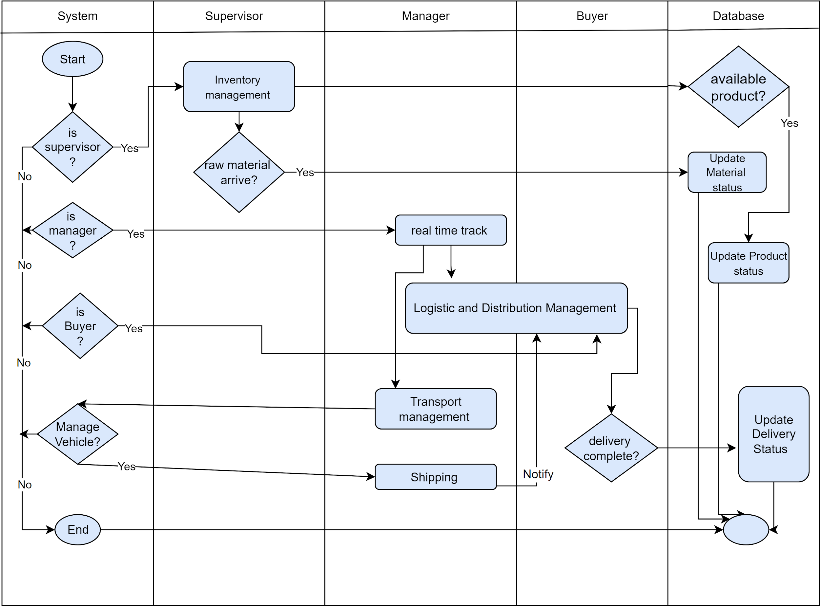](https://app.diagrams.net/?page-id=OUjIAvl-g1C0gT4ju1Y2&scale=auto#G1GTFcP5j5ZAzWp-idiURwTd89THVXulRk)

*Figure 46: Swimlane diagram level 1.5 : Warehouse Management System*

**Swim lane diagram ID: 13**

**Level 1.6**

**Name :** Production Negotiation and Buyer Interaction Management

**Reference**: Use case level 1.6 (Figure: Use case diagram level 1.6 : Production Negotiation and Buyer Interaction Management) & Activity diagram ID :17 (Figure:Activity diagram level 1.6 Production Negotiation and Buyer Interaction Management )

[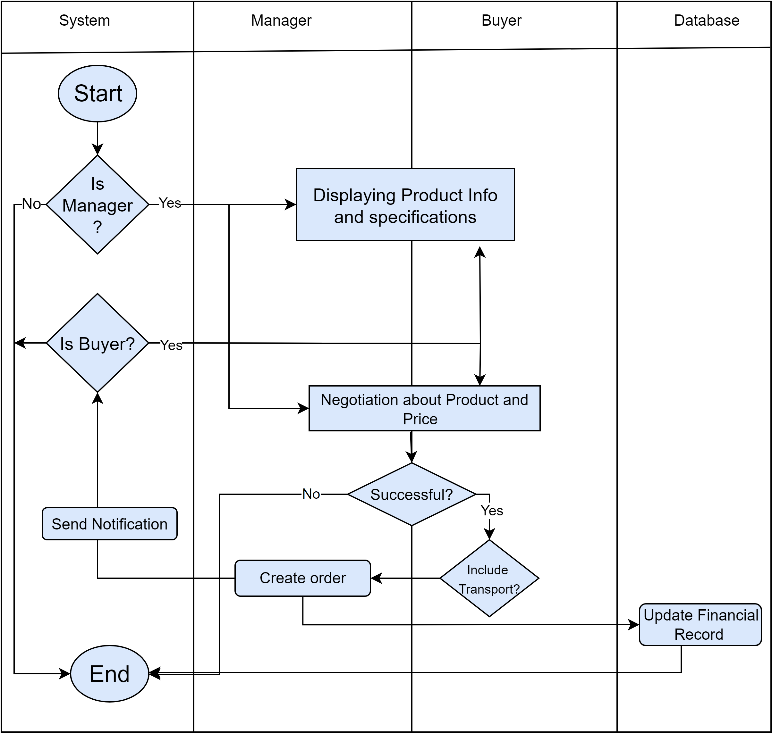](https://app.diagrams.net/?page-id=7S9IzFuPJBz6q9adi0bm&scale=auto#G1GTFcP5j5ZAzWp-idiURwTd89THVXulRk)*Figure 47: Swimlane diagram level 1.6 : Production Negotiation and Buyer Interaction Management*

**5. Data Based Modeling**

**5.1 Noun Listing**

| SI | Nouns | Attribute | Problem/Solution space |
| --- | --- | --- | --- |
|  | Modules |  | P |
|  | Subsystem |  | P |
|  | System Admin | 8,9,11,14,15,16,56,66,72,155,181,189 | S |
|  | Login |  | S |
|  | Creation |  | S |
|  | Process |  | P |
|  | Employee | 8,9,37,38,39,43,45,54,64,66 | S |
|  | Employee ID |  | S |
|  | Phone number |  | S |
|  | Information |  | S |
|  | Database | 7,122,124,185,186,205 | S |
|  | Accuracy |  | P |
|  | Validation | 14 | S |
|  | OTP |  | S |
|  | Email | 16 | S |
|  | Password |  | S |
|  | Accounts | 19,20,124,140,142,143,145,203 | S |
|  | Method |  | P |
|  | Bank |  | S |
|  | Bkash |  | S |
|  | Connection |  | P |
|  | Authentication | 15,16 | S |
|  | Credentials |  | S |
|  | Details |  | P |
|  | Users | 26,27,34,35,37 | S |
|  | Supervisor | 8,9,15,16,37,38,39,43,45,54,66,119 | S |
|  | Purchase Manager | 8,9,15,16,17,37,39,43,54,66,108,114,119 | S |
|  | Ready-made |  | P |
|  | Action |  | P |
|  | Access |  | P |
|  | Privileges |  | P |
|  | Role |  | P |
|  | Option |  | P |
|  | Verification |  | P |
|  | Modification |  | P |
|  | Interface |  | S |
|  | Data fields | 17,38,39 | S |
|  | Address |  | S |
|  | User photo |  | S |
|  | Generation |  | P |
|  | Rights |  | P |
|  | Requisite |  | P |
|  | Designation |  | S |
|  | Place |  | P |
|  | Shift |  | S |
|  | Changes |  | P |
|  | Management |  | P |
|  | Resource |  | S |
|  | Human |  | S |
|  | Wages |  | S |
|  | Problems |  | P |
|  | Count |  | P |
|  | Issues |  | P |
|  | Attendance | 57,58,63 | S |
|  | Application | 71,72,73,75 | S |
|  | Notices |  | S |
|  | Work day |  | S |
|  | card |  | S |
|  | Machine |  | S |
|  | Start |  | P |
|  | End |  | P |
|  | Garment |  | P |
|  | Hours |  | S |
|  | Day |  | S |
|  | Date |  | S |
|  | Salary |  | S |
|  | Calculation |  | P |
|  | Request |  | P |
|  | Four |  | P |
|  | Submodule |  | P |
|  | Leave | 76,77,78,79,80 | S |
|  | Overtime |  | S |
|  | Insurance | 84 | S |
|  | Help |  | P |
|  | Support | 88,167 | S |
|  | Reason |  | S |
|  | Festival |  | S |
|  | Medical |  | S |
|  | Annual |  | S |
|  | Maternity leave |  | S |
|  | Notification |  | S |
|  | Approval |  | S |
|  | Policies |  | P |
|  | Documentation |  | S |
|  | Updates |  | S |
|  | Assistance |  | P |
|  | Categories |  | P |
|  | Harassment |  | P |
|  | Dashboard | 10,56,81,90 | S |
|  | Messages |  | S |
|  | Terms |  | P |
|  | Administrator | 8,9,15,16,38,39 | S |
|  | Communication |  | S |
|  | policy |  | P |
|  | Dissemination |  | P |
|  | Announcement |  | P |
|  | Purchase | 101 | S |
|  | Segmentation |  | P |
|  | Procurement |  | S |
|  | buyers | 8,9,15,16,38,39 | S |
|  | Goods |  | P |
|  | Receipt |  | S |
|  | Confirmation |  | S |
|  | Warehouse | 63,173,174,175,176,177 | S |
|  | Invoice |  | S |
|  | Performance |  | S |
|  | Analytics |  | S |
|  | Decision Making |  | S |
|  | Evaluation |  | S |
|  | Need |  | P |
|  | Inventory | 7,63,173,174,175,176,177 | S |
|  | Items |  | P |
|  | Quantity |  | S |
|  | Order |  | S |
|  | Supplier | 8,9,15,16,38,39,119 | S |
|  | fulfillment |  | P |
|  | Levels |  | P |
|  | Event |  | P |
|  | Department |  | P |
|  | discrepancy |  | S |
|  | Resolution |  | S |
|  | Records |  | S |
|  | Time period |  | S |
|  | transaction | 8,100,115,127 | S |
|  | factors |  | S |
|  | Delivery |  | S |
|  | Product | 128,143,173,174,189,180,192,193 | S |
|  | Quality |  | S |
|  | adherence |  | P |
|  | Terms |  | P |
|  | Relationship |  | P |
|  | Formulation |  | P |
|  | Future |  | P |
|  | Strategy |  | P |
|  | decision |  | P |
|  | Aspects |  | P |
|  | Functionalities |  | P |
|  | Tracking |  | S |
|  | Reporting |  | S |
|  | Online |  | S |
|  | Month |  | P |
|  | Onsite |  | S |
|  | Expense | 138,139 | S |
|  | Individual |  | P |
|  | Bonus |  | S |
|  | Accessible |  | P |
|  | Summary |  | P |
|  | Final |  | P |
|  | Balance |  | P |
|  | Banking |  | S |
|  | Rocket |  | S |
|  | Nagad |  | S |
|  | Numbers |  | P |
|  | Transfer |  | P |
|  | amount |  | S |
|  | Withdrawal |  | S |
|  | Approach |  | P |
|  | Means |  | P |
|  | Case |  | P |
|  | Security |  | P |
|  | Status |  | S |
|  | Purpose |  | P |
|  | Insights |  | P |
|  | Analysis |  | S |
|  | Expenditures |  | S |
|  | Organization |  | P |
|  | Financial Help |  | S |
|  | Allocation |  | S |
|  | Tools |  | P |
|  | Planning |  | S |
|  | owner |  | P |
|  | Materials |  | P |
|  | Type |  | S |
|  | PO number |  | S |
|  | Origin |  | S |
|  | Arrival |  | S |
|  | Departure |  | S |
|  | Destination |  | S |
|  | Remaining |  | P |
|  | Amount |  | S |
|  | Reports |  | S |
|  | Usage |  | P |
|  | Storage |  | S |
|  | week |  | P |
|  | Visualization |  | S |
|  | Queries |  | S |
|  | Transportation | 127,175,176,177,178,189,192,204 | S |
|  | logistics |  | P |
|  | Vehicles |  | S |
|  | Logistic Distribution | 106,113,191,192,193,202,203,204 | S |
|  | Demand |  | S |
|  | Location |  | S |
|  | Delivery Schedule |  | S |
|  | Shipment |  | S |
|  | Transparency |  | P |
|  | Satisfaction |  | S |
| 197. | Logistic Manager | 17,187,188,190,201 | S |
| 198. | Transport request |  | S |
| 199. | Sales |  | S |
| 200. | Income |  | S |
| 201. | GPS |  | S |
| 202. | User ID |  | S |
| 206. | traffic |  | S |
| 207. | SMS | 14 | S |
| 208. | Experience |  | P |
| 209. | Coordination |  | S |
| 210. | Production Manager | 8,9,15,16,17,37,93,209,211 | S |
| 211. | Negotiation |  | S |
| 212. | Showcasing |  | S |
| 213. | Specification |  | S |
| 214. | Collaborative |  | S |
| 215. | Consideration |  | S |
| 216. | Account Manager | 8,9,15,16,17,37,39 | S |

**5.2 Potential to be data object**

| SI | Data Object | Attribute |
| --- | --- | --- |
| 1. | Employee | Employee ID ,Email,Password,Phone number,Designation,Working days,Working hours,Shift,Salary,Attendance,Address,User Photo |
| 2. | Supervisor | Employee ID,Email,Password,Phone Number,Address,Salary,User Photo,Designation,Department |
| 3. | Purchase Manager | Employee ID,Email,Password,Phone Number,Salary,Address,User Photo,Designation,PO number |
| 4. | Supplier | Supplier ID, Email,Password,PhoneNumber,Address,User Photo |
| 5. | Buyer | Buyer ID, Email, Password, PhoneNumber, Address, User Photo |
| 6. | Administrator | Employee ID,Email,Password,Phone Number,Address,User Photo |
| 7. | Account Manager | Employee ID,Email,Password,Phone Number,Salary,Address,User Photo,Designation |
| 8. | Accounts | Employee ID, Account Number,phone number,salary,OTP,payment method,Revenue ID,Expense ID |
| 9. | Database | Employee_ID,Supplier ID,Buyer ID,Records |
| 10. | Logistic Distribution | PO Number, Product type,Delivery Schedule,Location,vehicle,GPS |
| 11. | Logistic Manager | Employee ID,Email,Password,Phone Number,Salary,Address,User Photo,Designation |
| 12 | Product | Supplier ID,PO Number,Product name,Product type Transaction ID |
| 13. | Product Manager | Employee ID,Email,Password,Phone Number,Salary,Address,User Photo,Designation |
| 14. | Transportation | PO Number, Product type,Arrival,Departure,vehicle,GPS |
| 15. | Help & Support | Employee ID,Reason,Documents,Harassment,Insurance |
| 16. | DashBoard | Employee ID,Notices,Messages,Information |
| 17. | Warehouse | PO Number, Product type, Quantity,Department,Arrival,Departure, Date |
| 18. | Application | Employee ID,Leave,Insurance |

**Analysis:**

In the given scenario, it appears that the roles of Purchase Manager, Production Manager, Accounts Manager, and Logistic Manager share common attributes. Therefore, it is suggested to merge these roles into a more generic role called "Manager," with the addition of a new attribute called "Department" to differentiate between the specific functions within the organization.Additionally, it is observed that Transportation and Logistic Distribution perform similar operations. Hence, it is proposed to merge these functions into a single entity named "Logistic Distribution" for better clarity and efficiency in managing these processes.Furthermore, it is mentioned that employees can submit applications to managers for assistance and support. It is noted that the "Help and Support" object is already under the "Application" category. To enhance clarity and organization, it is recommended to modify the structure by placing the "Help and Support" object directly under the "Application" category, streamlining the hierarchy.

**5.3 Final Data Object list**

| SI | Data Object | Attribute |
| --- | --- | --- |
| 1. | Employee | Employee ID ,Email,Password,Phone number,Department,Working days,Working hours,Shift,Salary,Attendance,Address,User Photo |
| 2. | Supervisor | Employee ID,Email,Password,Phone Number,Address,Salary,User Photo,Designation,Department |
| 3. | Manager | Employee ID,Email,Password,Phone Number,Salary,Address,User Photo,Designation,Department |
| 4. | Supplier | Supplier ID, Email,Password,PhoneNumber,Address |
| 5. | Buyer | Buyer ID, Email, Password, PhoneNumber, Address |
| 6. | Administrator | Administrator ID,Email,Password,Phone Number,Address,User Photo |
| 7. | Accounts | Employee ID, Account Number,phone number,salary,OTP,payment method,Revenue ID,  Expense ID |
| 8. | Database | Employee_ID,Supplier ID,Buyer ID, Records |
| 9. | Logistic Distribution | PO Number, Employee_ID,Product name,Delivery Schedule,Location,vehicle |
| 11. | Application | Employee ID,Reason,Documents |
| 12. | Dashboard | Employee ID,Notices,Messages |
| 13. | Warehouse | PO Number, Product type, Quantity,Department,Arrival,Departure, Date |
| 14. | System Admin | Employee_id, Supplier_id, Buyer_id,insurance_amount,  OTP,final_salary,working_hour  report |

**5.4 Relations Between Data and Objects**

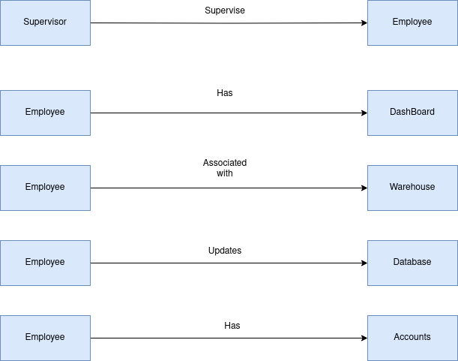

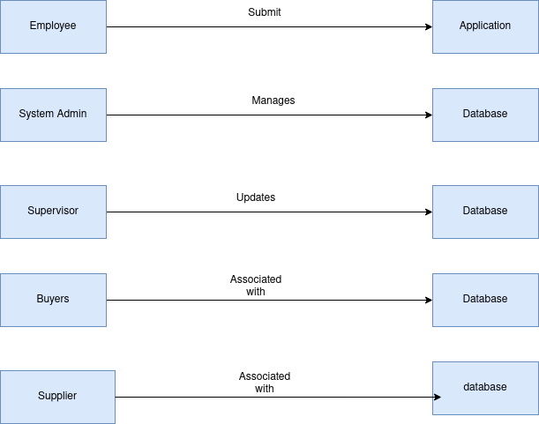

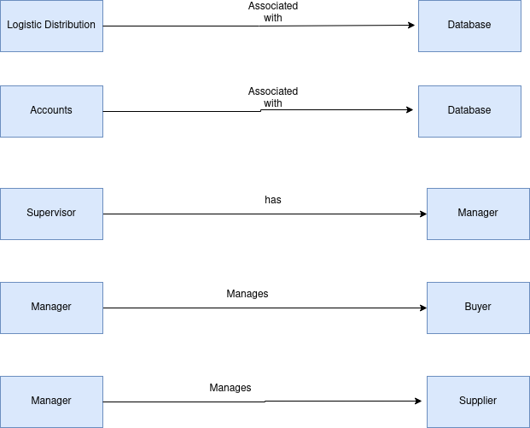

**5.6 ER DIAGRAM**

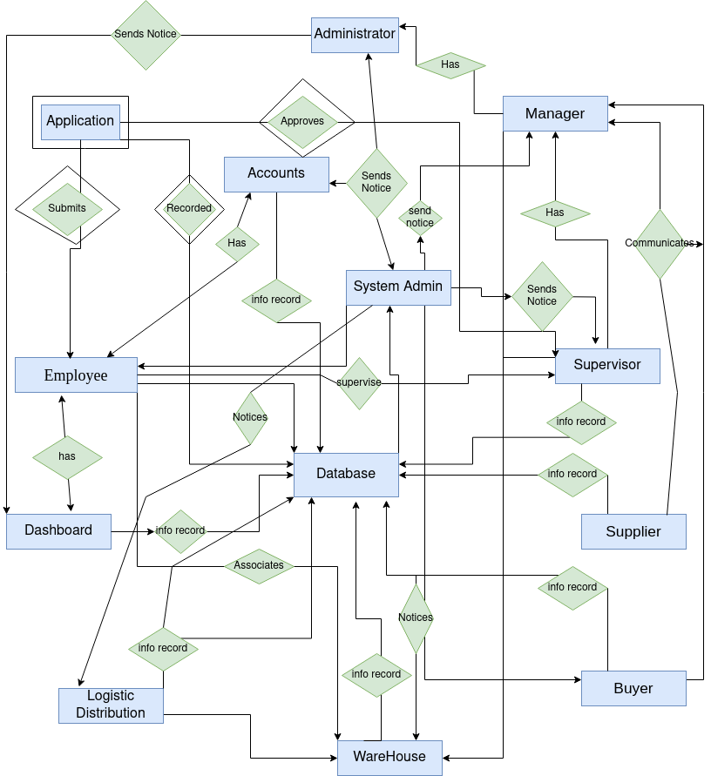

**5.7 Schema**

| Employee | |
| --- | --- |
| Attribute | Data type |
| -Employee ID  -Email  -Password  -Phone number  -Designation  -Working days  -Working hours  -Shift  -Salary  -Attendance  -Address  -User Photo | -Number  -String  -String  -Number  -String  -Number  -Number  -String  -Number  -Number  -String  -PNG/JPG |

| Supervisor | |
| --- | --- |
| Attribute | Data type |
| -Employee ID  -Email  -Password  -Phone number  -Designation  -Department  -Working days  -Shift  -Salary  -Attendance  -Address  -User Photo | -Number  -String  -String  -Number  -String  -String  -Number  -String  -Number  -Number  -String  -PNG/JPG |

| Manager | |
| --- | --- |
| Attribute | Data type |
| -Employee ID  -Email  -Password  -Phone number  -Designation  -Department  -Working days  -Shift  -Salary  -Attendance  -Address  -User Photo | -Number  -String  -String  -Number  -String  -String  -Number  -String  -Number  -Number  -String  -PNG/JPG |

| Supplier | |
| --- | --- |
| Attribute | Data type |
| -Supplier ID  -Email  -Password  -Phone number  -Address | -Number  -String  -String  -Number  -String |

| Buyer | |
| --- | --- |
| Attribute | Data type |
| -Buyer ID  -Email  -Password  -Phone number  -Address | -Number  -String  -String  -Number  -String |

| Administrator | |
| --- | --- |
| Attribute | Data type |
| -Supplier ID  -Email  -Password  -Phone number  -Address  -User Photo | -Number  -String  -String  -Number  -String  -PNG/JPG |

| Accounts | |
| --- | --- |
| Attribute | Data type |
| -Employee ID  -Account number  -salary  -OTP  -payment_method  -Revenue ID,  -Expense ID | -Number  -Number  -Number  -Number  -String  -Number  -Number |

| Database | |
| --- | --- |
| Attribute | Data type |
| -UserID  -Record  -User information | -Number  -String  -String |

| Logistic Distribution | |
| --- | --- |
| Attribute | Data type |
| -PO Number  -Product name  -Delivery Schedule  -Location  -vehicle | -Number  -String  -Number  -String  -String |

| Application | |
| --- | --- |
| Attribute | Data type |
| -Employee ID  -Reason  -Documents | -Number  -String  -String |

| DashBoard | |
| --- | --- |
| Attribute | Data type |
| -Employee ID  -Notice  -Message | -Number  -String  -String |

| Warehouse | |
| --- | --- |
| Attribute | Data type |
| -PO Number  - Product type -Quantity  -Department  -Arrival  -Departure  - Date | -Number  -String  -Number  -String  -String  -String  -String |

**6. Class-based Modeling**

The objects that the system will manipulate, the operations (also known as methods or services) applied to manipulate these objects, relationships (some hierarchical) between the objects, and interactions among the defined classes—all are represented by class-based modeling. Classes, objects, attributes, operations, Class-Responsibility-Collaborator (CRC) models, collaboration diagrams, and packages constitute components of a class-based model.

**6.1 List of verbs**

| **SI** | **Verbs** | **SI** | **Verbs** | **SI** | **Verbs** |
| --- | --- | --- | --- | --- | --- |
| 1 | Will | 13 | is | 25 | Gains |
| 2 | are | 14 | Promote | 26 | Has |
| 3 | Create | 15 | Input | 27 | Edit |
| 4 | Update | 16 | Secure | 28 | Involve |
| 5 | Begin | 17 | Complete | 30 | Replace |
| 6 | Verify | 18 | Commence | 31 | Requisite |
| 7 | Generate | 19 | Check | 32 | Reflect |
| 8 | Sent | 20 | Ensure | 33 | Manage |
| 9 | Validate | 21 | Tailor | 34 | Solve |
| 10 | Grant | 22 | Seek | 35 | Face |
| 11 | Setup | 23 | Prompts | 36 | Take |
| 12 | Store | 24 | Dispatch | 37 | Calculate |
| 38 | can | 62 | Makes | 88 |  |
| 39 | Empower | 63 | Continue | 89 | assign |
| 40 | Apply | 64 | Reconsider | 90 | implement |
| 41 | Receive | 67 | Play | 91 | enhance |
| 42 | Approval | 68 | Integrate | 92 | add |
| 43 | Submit | 69 | Incompass | 93 | orchestrates |
| 44 | Allow | 70 | Compute | 94 | facilitate |
| 45 | Enable | 71 | Conduct | 95 | gain |
| 46 | Disseminate | 72 | Contain | 96 | track |
| 47 | Reach | 73 | Provide | 97 | focus |
| 48 | Streamlines | 74 | Manage | 98 | optimize |
| 49 | Facilitate | 75 | Enhance | 99 | establish |
| 50 | Initiate | 76 | Share | 100 | serves |
| 51 | Purchase | 77 | Enter | 101 | engage |
| 52 | Review | 78 | Opt | 102 | showcase |
| 53 | Convert | 79 | Need | 103 | streamlines |
| 54 | Notify | 80 | Record | 104 | sold |
| 55 | Forward | 81 | Loges | 105 | capture |
| 56 | Utilize | 82 | offer | 106 | remain |
| 57 | Confirm | 83 | modify | 107 | triggering |
| 58 | Communicate | 84 | make |  |  |
| 59 | Proceed | 85 | receive |  |  |
| 60 | Process | 86 | dispatch |  |  |
| 61 | Elapsed | 87 | includes |  |  |

**6.2 General Classification**

**1. External entities** (e.g., other systems, devices, people) that produce or consume information to be used

by a computer-based system.

**2. Things** (e.g., reports, displays, letters, signals) that are part of the information domain for the problem.

**3. Occurrences or events** (e.g., a property transfer or the completion of a series of robot movements) that

occur within the context of system operation.

**4. Roles** (e.g., manager, engineer, salesperson) played by people who interact with the system.

**5. Organizational units** (e.g., division, group, team) that are relevant to an application.

**6. Places** (e.g., manufacturing floor or loading dock) that establish the context of the problem and the overall function of the system.

**7. Structures** (e.g., sensors, four-wheeled vehicles, or computers) that define a class of objects or related classes of objects.

| **Noun** | **G.C** |
| --- | --- |
| **Account** | 2,3,5 |
| Login | 3,4 |
| **Employee** | 4,5,7 |
| Employee ID | 2 |
| Phone number | 3 |
| Information | 3 |
| OTP | 3 |
| **Admin** | 4,5,7 |
| Password | 2 |
| **Account Management** | 4,5,7 |
| Bank | 2 |
| Bkash | 2 |
| Authentication | 3 |
| **Supervisor** | 4,5,7 |
| **Purchase Manager** | 4,5,7 |
| Role | 4 |
| Verification | 2 |
| Modification | 2 |
| Address | 2 |
| User photo | 2 |
| Designation | 4 |
| Shift | 2 |
| Resource | 2,3 |
| Attendance | 2 |
| **Application** | 3,4,6 |
| Notices | 2 |
| Work day | 2 |
| **Card Machine** | 1,3,4 |
| Hours | 2 |
| Delivery Date | 2 |
| Salary | 2 |
| Calculation | 2 |
| Request | 3 |
| Payment |  |
| Leave | 3,4 |
| Overtime | 3,4 |
| Insurance | 3,4 |
| Help & Support | 3,4 |
| Reason | 3 |
| **Notification** | 1,4,7 |
| Approval | 3 |
| Documentation | 3 |
| **System Admin** | 2,4,5,7 |
| Updates | 3 |
| Harassment | 2 |
| **Dashboard** | 4,5,7 |
| Messages | 2 |
| **Administration** | 4,5,7 |
| Communication | 3 |
| Purchase | 2 |
| **buyers** | 1,4,7 |
| Goods | 2 |
| Receipt | 2 |
| **Warehouse** | 4,5,7 |
| Invoice | 2 |
| Performance | 3 |
| Analytics | 3 |
| Decision Making | 4 |
| Evaluation | 2 |
| **Inventory** | 4,5,7 |
| Items | 2 |
| Quantity | 2 |
| Order | 2 |
| fulfillment | 3 |
| Event | 3 |
| **Salary** | 2,3,4 |
| Department | 7 |
| Records | 2 |
| Time period | 2 |
| transaction | 3 |
| **Supplier** | 1,4,7 |
| Delivery | 3 |
| Product | 2 |
| Quality | 2 |
| decision | 4 |
| Tracking | 2 |
| Reporting | 2 |
| Online | 2 |
| **Database** | 1,4,6 |
| Onsite | 2 |
| Expense | 2,3,7 |
| Bonus | 2 |
| Summary |  |
| Final | 2 |
| **Account Manager** | 4,5,7 |
| Balance | 2 |
| Banking | 1 |
| Rocket | 1 |
| Nagad | 1 |
| Numbers | 2 |
| **Income** | 2,3,4 |
| Transfer | 2 |
| amount | 3 |
| Withdrawal | 3 |
| Security | 3 |
| Analysis | 3 |
| **Logistic Manager** | 4,5,7 |
| **Expenditures** | 2,3,4 |
| Financial Help | 4 |
| Planning | 4 |
| Materials | 2 |
| Type | 2 |
| PO number | 2 |
| Origin | 6 |
| **SMS** | 1,4,7 |
| Arrival | 6 |
| Departure | 6 |
| Destination | 6 |
| Amount | 3 |
| Reports | 2 |
| Queries | 2 |
| Transportation | 6 |
| Vehicles | 2 |
| Logistic Distribution | 5 |
| **Email** | 1,4,7 |
| Demand | 2 |
| Delivery Schedule | 6 |
| Transparency | 2 |
| Satisfaction | 2 |
| Transport request | 2 |
| Income | 2 |
| **GPS** | 1,3,7 |
| User ID | 2 |
| Experience | 3 |
| Coordination | 3 |
| **Production Manager** | 1,4,7 |
| Negotiation | 4 |
| Showcasing | 4 |
| Specification | 2 |
| Collaborative | 4 |
| Consideration | 4 |

**6.3 Potential to be Class**

1. Account
2. Employee
3. Salary
4. Database
5. Administrator
6. Account Manager
7. Supervisor
8. Purchase Manager
9. Buyer
10. GPS
11. System Admin
12. Email
13. SMS
14. Application
15. Card Machine
16. Notification
17. Dashboard
18. Administration
19. Warehouse
20. Inventory
21. Supplier
22. Logistic Manager
23. Production Manager
24. Expenditures
25. Income

**6.4 Selection Criteria**

**1. Retained information:** The potential class will be useful during analysis only if information about it must be remembered so that the system can function.

**2. Needed services:** The potential class must have a set of identifiable operations that can change the value of its attributes in some way.

**3. Multiple attributes:** During requirement analysis, the focus should be on “major” information; a class with a single attribute may, in fact, be useful during design, but is probably better represented as an attribute of another class during the analysis activity.

**4. Common attributes:** A set of attributes can be defined for the potential class and these attributes apply to all instances of the class.

**5. Common operations:** A set of operations can be defined for the potential class and these operations apply to all instances of the class.

**6. Essential requirements:** External entities that appear in the problem space and produce or consume information essential to the operation of any solution for the system will almost always be defined as classes in the requirements model.

| **SI** | **Noun** | **S.C** |
| --- | --- | --- |
| 1. | Account | 1,2,3,4,5 |
| 2. | Employee | 1,2,3,4,5 |
| 3. | Database | 1,6 |
| 4. | Administrator | 1,2,3,4,5 |
| 5. | Account Manager | 1,2,3,4,5 |
| 6. | Supervisor | 1,2,3,4,5 |
| 7. | Purchase Manager | 1,2,3,4,5 |
| 8. | Income | 1,3,4 |
| 9. | Supplier | 1,2,3,4,5 |
| 10. | GPS | 6 |
| 11. | Email | 6 |
| 12. | SMS | 6 |
| 13. | Dashboard | 1,2,3,4,5 |
| 14. | Salary | 1,3,4 |
| 15. | Expenditure | 1,3,4 |
| 16. | Application | 3,4 |
| 17. | Administration | 1,2 |
| 18. | Logistic Manager | 1,2,3,4,5 |
| 19. | Card Machine | 6 |
| 20. | Warehouse | 1,2,3,4,5 |
| 21. | Inventory | 1,2,3,4,5 |
| 22. | Logistic Manager | 1,2,3,4,5 |
| 23. | System Admin | 2,3,4,5 |
| 24. | Buyer | 1,2,3,4,5 |
| 25. | Notification | 2,3,4,5 |

**6.5 Selected Classes**

1. Account
2. Employee
3. Database
4. Administrator
5. Account Manager
6. Supervisor
7. Purchase Manager
8. Buyer
9. GPS
10. System Admin
11. Email
12. SMS
13. Card Machine
14. Notification
15. Dashboard
16. Warehouse
17. Income
18. Inventory
19. Supplier
20. Logistic Manager
21. Production Manager
22. Salary
23. Expenditure

**Analysis**

* Here, 'Accounts' encompasses activities like registration, login, and profile updates. Hence, we may define the class as 'Registration' rather than 'Account.'
* The attributes of the Account Manager, Purchase Manager, Logistic Manager, and Production Manager are the same, involving the common task of managing their respective departments. However, the working functionalities vary according to the departments. Therefore, we can create a superclass called 'Manager' and include these four types of managers within it. Subsequently, we define a class named 'Manager,' with subclasses such as Account Manager, Purchase Manager, Logistic Manager, and Production Manager.
* In the Expenditure class, the total expenses are calculated, while the Income class records the total earnings. Subsequently, all transactions are aggregated in the Accounts class. Employees receive their salary from the company accounts. Considering that transactions constitute the primary function, we can consolidate these classes into an 'Account Management' class.

**After analysis**

1. Registration
2. Employee
3. Database
4. Administrator
5. Supervisor
6. Manager
7. Buyer
8. Account Management
9. GPS
10. System Admin
11. Email
12. SMS
13. Card Machine
14. Notification
15. Dashboard
16. Warehouse
17. Inventory
18. Supplier

**Further Analysis**

* 'Inventory' functions as a sub-module of 'Warehouse ', therefore, we can remove the 'Inventory' class.
* Considering that 'SMS' and 'Email' both are external systems, we can amalgamate them into a single class named 'SMS & Email System'.
* Notifications are displayed on the Dashboard, so there's no necessity to create a separate 'Notification' class. The 'Dashboard' class already showcases these notifications.
* The Card Machine has a singular responsibility of recording attendance. Hence, I've transferred this responsibility to the Employee class. Consequently, there's no requirement for a separate Card Machine class.

**6.6 Finally Selected Classes**

1. Registration
2. Administrator
3. Manager
4. Supervisor
5. Employee
6. Supplier
7. Buyer
8. Warehouse
9. Account Management
10. GPS
11. Dashboard
12. Database
13. System Admin
14. Email & SMS System

**6.7 Class Cards**

1. **Registration**

| Registration | |
| --- | --- |
| **Attribute** | **Method** |
| userType  userID  email  password  Name  address  designation  department  contactNumber  confirmationStatus | +generate_ID(userType)  +selectUserType()  +sendConfirmationEmail()  +sendOTP()  +updateContactNumber()  +getUserDetails()  +authenticateUser()  +updateLoginAttempts()  +grantAdminPrivileges()  +passwordRecovery()  +logout() |
| **Responsibilities** | **Collaborator class** |
| 1.User registration | Admin,Manager,Supervisor,Employee,Buyer,Supplier |
| 2.User authentication & login | Admin,Manager,Supervisor,Employee,Buyer,Supplier |
| 3.Password Recovery | Admin,Manager,Supervisor,Employee,Buyer,Supplier |

1. **Administrator:**

| Administrator | |
| --- | --- |
| **Attribute** | **Method** |
| -Administrator_ID  -Email  -Password  -Phone Number  -Address  -Photo | +change_employee_info()  + set_maximum_overtime_hour()  + set_insurance_amount()  + view_information()  + insert_information()  +delete_account()  +provide_employee_id()  +send_salary()  +launch_dashboard()  +get_employee_id() |
| **Responsibilities** | **Collaborator class** |
| 1.View information | System Admin,Database |
| 2.Send salary | Account Management |
| 3.Set Overtime hour | Employee,Database |
| 4.Set insurance amount | Database |

1. **Manager**

| Manager | |
| --- | --- |
| **Attribute** | **Method** |
| Employee ID  Email  Password  Phone Number  Salary  Address  Photo  Designation  Department | +launch_dashboard()  +Responsibility()  +verify_provided_info()  +approve_request()  +review_invoice()  +communicate()  +review_analysis_report()  +initiate_salary_calc()  +log_expense()  +transport_request()  +showcase_product_details()  +negotiation()  +generate_sale_record() |
| **Responsibilities** | **Collaborator** |
| 1.Approve Supervisor’s applications | Supervisor |
| 2.Send notices | Dashboard |
| 3.Oversees the work of supervisor | Database |
| 4.Negotiation with buyers,suppliers | Buyers,Supplier |
| 5.Generate sale report | Dashboard,Database |

**Sub-Classes:**

| Account Manager | |
| --- | --- |
| **Attribute** | **Method** |
| Employee ID  Designation  Department | +Responsibility() |
| **Responsibilities** | **Collaborator** |
| 1. Manages Account system | Account Management |

| Production Manager | |
| --- | --- |
| **Attribute** | **Method** |
| Employee ID  Designation  Department | +Responsibility() |
| **Responsibilities** | **Collaborator** |
| 1.Manages Production system | Warehouse |

| Purchase Manager | |
| --- | --- |
| **Attribute** | **Method** |
| Employee ID  Designation  Department | +Responsibility() |
| **Responsibilities** | **Collaborator** |
| 1.Manages Purchase system | Buyer,Supplier |

| Logistic Manager | |
| --- | --- |
| **Attribute** | **Method** |
| Employee ID  Designation  Department | +Responsibility() |
| **Responsibilities** | **Collaborator** |
| 1.Manages Logistic system | Warehouse |

1. **Supervisor**

| Supervisor | |
| --- | --- |
| **Attribute** | **Method** |
| Employee ID  Email  Password  Phone Number  Department  Designation  Address  Salary  Photo | +launch_dashboard()  +verify_provided_info()  +insurance_approval()  +send_notice()  +confirm_accuracy()  +provide_onsite_salary()  +update()_inventory() |
| **Responsibilities** | **Collaborator** |
| 1.Approve Employee’s applications | Employee |
| 2.Send Notices | Dashboard |
| 3.Confirm accuracy | Database |
| 4.Provide onsite salary and update status | Account Management,Database |
| 5.Update material information | Warehouse,Database |

1. **Employee**

| Employee | |
| --- | --- |
| **Attribute** | **Method** |
| Employee ID  Email  Password  Phone number  Designation  Working days  Working hours  Shift  Salary  Address  Photo | +launch_dashboard()  +submit_application_request()  +eave_overtime_application()  +claim_insurance()  +seek_assistace()  +conduct_online_transaction()  +initiate_on_site_payment()  +card_for_attendance() |
| **Responsibilities** | **Collaborator** |
| 1. Applying for leave,insurance,help & support | Supervisor |
| 2.Receive Salary | Account Management |
| 3.Receive product from supplier and update status | Database |

1. **Supplier**

| Supplier | |
| --- | --- |
| **Attribute** | **Method** |
| Supplier ID  Email  Password  PhoneNumber  Address | +launch_dashboard()  +submit_invoice()  +receive_bill() |
| **Responsibilities** | **Collaborator** |
| 1.Receive bills for supplies | Account Management |
| 2.Submit invoice | System Admin |

1. **Buyer**

| Buyer | |
| --- | --- |
| **Attribute** | **Method** |
| Buyer ID  Email  Password  PhoneNumber  Address | +launch_dashboard()  +get_notified()  +pay_bill()  +order_product() |
| **Responsibilities** | **Collaborator** |
| 1.Order Product | System Admin |
| 2.Pay bill | Account Management,Database |

1. **Database**

| Database | |
| --- | --- |
| **Attribute** | **Method** |
| User ID  User information  Records | +verify_provided_info()  +store_information()  +record_attendance()  +update_delivery_status()  +store_work_hour_report() |
| **Responsibilities** | **Collaborator** |
| 1. Creating employee, Buyer, Supplier, information table, inventory table etc. | Admin,Supervisor,System Admin |
| 2. Updating changed employee information, payment status, warehouse information etc | Admin,Supervisor,System Admin |
| 3. Providing records of employee information, inventory etc. | System Admin |

**9.Account Management**

| Account Management | |
| --- | --- |
| **Attribute** | **Method** |
| Employee_ID  Designation  Buyer_ID  Revenue ID  Supplier_ID  Expense ID  Account Number  phone number  Salary  payment method | +pay_salary()  +receive_revenue()  +pay_supplier_expense() |
| **Responsibilities** | **Collaborator** |
| 1.Paying salary to Employees | Employee,Database |
| 2.Receive payment from Buyers | Buyers,Database,Supplier |
| 3.Give payment to supplier | Supplier,Database |
| 4.Others withdrawal or expenses | Admin,Warehouse |

**10.Warehouse**

| Warehouse | |
| --- | --- |
| **Attribute** | **Method** |
| PO_Number  Department  Arrival_Product  moved_product  Date_of_departure | +materials_arriaval()  +check_quality()  +assign_vehicle()  +select_department()  +provide_location()  +product_shortage()  +select_product_type()  +add_information_of_incoming_product()  +add_information_of_moved_product() |
| **Responsibilities** | **Collaborator** |
| 1.Setting PO number of product | Supervisor |
| 2.Adding information of incoming products to database | Supervisor,Database |
| 3. Adding information of moving products to database | Supervisor,Database |

**11.Dashboard**

| Dashboard | |
| --- | --- |
| **Attribute** | **Method** |
| User_Photo  User_ID  User_name  Phone_Number | +receive_notification()  +notify_purchase_request()  +notify_salary_preview()  +company_notices() |
| **Responsibilities** | **Collaborator** |
| 1.Showing all notices | Admin,Manager,Supervisor,Database |
| 2.Informing about products running low | Warehouse,Database,System Admin |
| 3.Showing total salary | Database |
| 4.Notifying leave decision,overtime decision,insurance decision | System Admin |

**12. GPS**

|  | |
| --- | --- |
| **Attribute** | **Method** |
| Vehicle_ID  Transaction_ID | +track_location()  +notification() |
| **Responsibilities** | **Collaborator** |
| 1.Track Product Location | Dashboard,Buyer |

**13.System Admin**

| System Admin | |
| --- | --- |
| **Attribute** | **Method** |
| Employee_id  Supplier_id  Buyer_id  overtime  insurance_amount  OTP  final_salary  working_hour  report | +calculates_work_hour()  +generate_purchase_order()  +generate_performance_report()  +send_transaction_noti()  +generate_financial_report()  +verify_employee_info()  +notify_in_dashboard()  +update_online_payment_history()  +update_offline_payment_history()  +provide_overtime_information()  +update_overtime_information()  +provide_leave_info()  +update_leave_info()  +provide_insurance_info()  +update_insurance_info()  +calculate_salary()  +transaction_doc()  +salary_accessible()  +calculate_remaining_product()  +link_employee()  +dataAnalysis() |
| **Responsibilities** | **Collaborator** |
| 1.Verifying employee id and phone number for creating account | Database |
| 2. generating OTP | Email/SMS system |
| 3. Sending notifications in Dashboard | Dashboard |
| 4. Verifying employee id and password for login | Database |
| 5. Calculating working hours of an employee | Database |
| 6. Providing additional info related to overtime, leave etc. Application, Database | Database |
| 7. Updating application status | Database |
| 8. Calculating remaining amount product stored in inventory | Database,Warehouse |
| 9. Calculating final salary | Database,Account Management |
| 10. Generating inventory report at the end of the month/week | Database,Warehouse |
| 11.Analyzing the supplier data | Database |

**14. Email & SMS System:**

| Email & SMS System | |
| --- | --- |
| **Attribute** | **Method** |
| Email  SMS  sender’s email address  receiver’s email address  sender’s phone number  receiver’s phone number | +sendEmail()  +receiveEmail()  +sendSMS()  +receiveSMS()  +send_OTP |
| **Responsibilities** | **Collaborator** |
| 1.Send & receive Email | Employee,Supervisor,Manager,Admin,Buyer,Supplier,dashboard |
| 2.Send & receive SMS | Employee,Supervisor,Manager,Admin,Buyer,Supplier,dashboard |

**6.8 CRC Diagram**

**Diagram:01**

**Name:Registration**

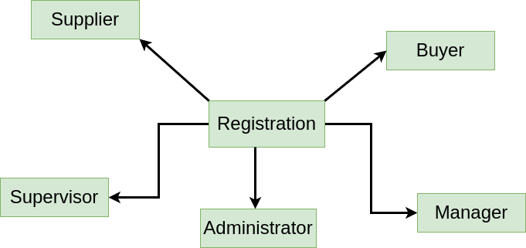

**Figure 48 : CRC diagram for Registration class**

**Diagram:02**

**Name:Administrator**

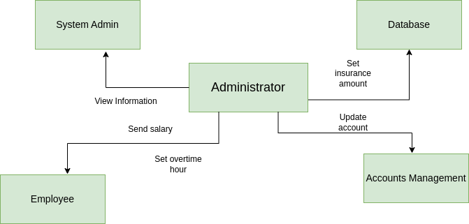

**Figure 49 : CRC diagram for Administration class**

**Diagram:03**

**Name:Manager**

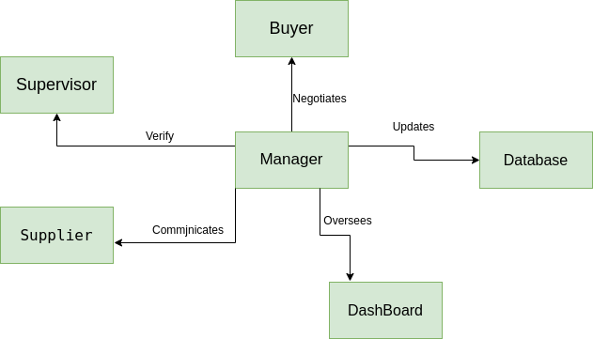

**Figure : CRC diagram for Manager class**

**Diagram:04**

**Name:Supervisor**

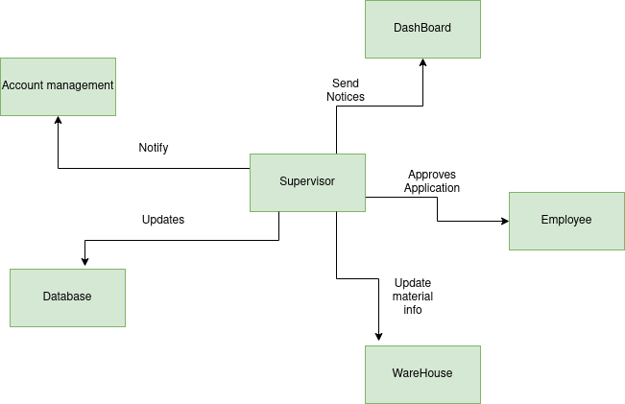

**Figure 50 : CRC diagram for Supervisor class**

**Diagram:05**

**Name:Employee**

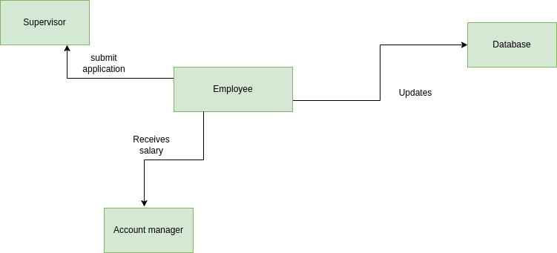

**Figure 51 : CRC diagram for Employee class**

**Diagram:06**

**Name:Supplier**

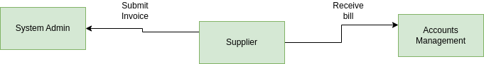

**Figure 52 : CRC diagram for Supplier class**

**Diagram:07**

**Name:Buyer**

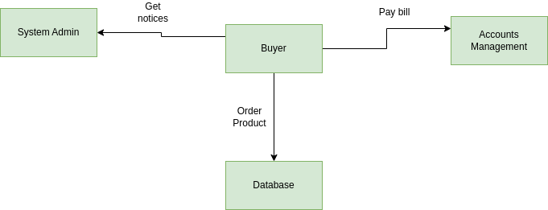

**Figure 53 : CRC diagram for Buyer class**

**Diagram:08**

**Name:Database**

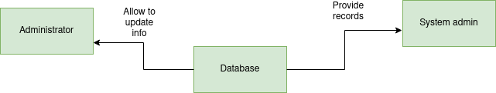

**Figure 54 : CRC diagram for Database class**

**Diagram:09**

**Name:Accounts Management**

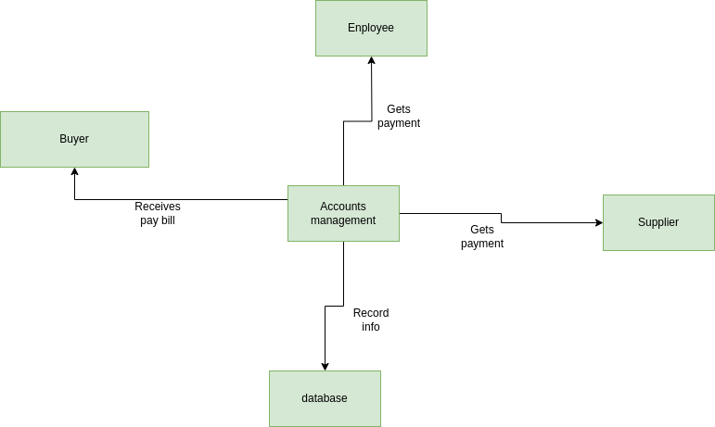

**Figure 55 : CRC diagram for Accounts Management class**

**Diagram:10**

**Name:WareHouse**

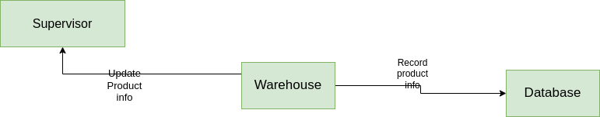

**Figure 56 : CRC diagram for Warehouse class**

**Diagram:11**

**Name:Dashboard**

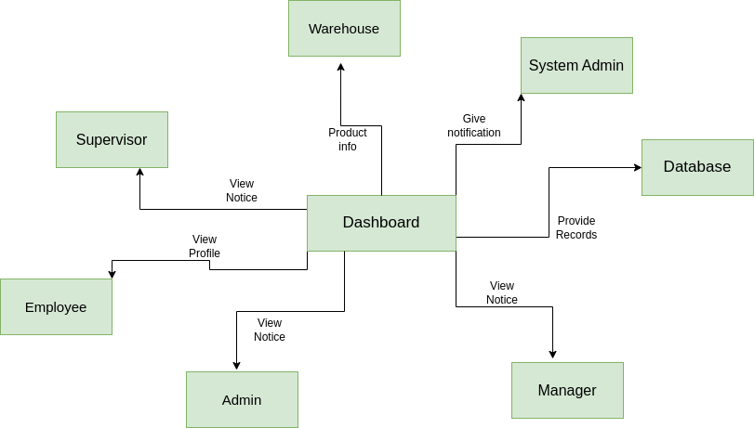

**Figure 57 : CRC diagram for Dashboard class**

**Diagram:12**

**Name:GPS**

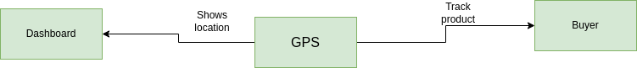

**Figure 58 : CRC diagram for GPS class**

**Diagram:13**

**Name:System Admin**

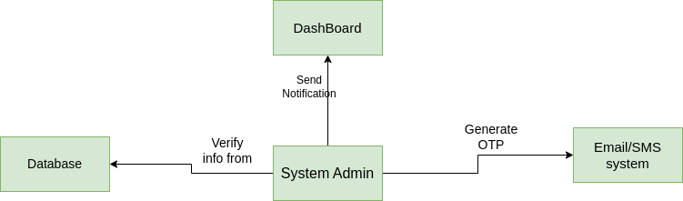

**Figure 59 : CRC diagram for System Admin class**

**Diagram:14**

**Name: Email & SMS System**

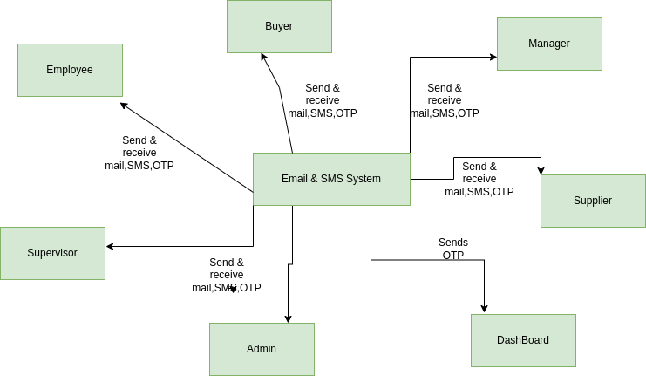

**CRC diagram for Email & SMS System**

**7. Behavioral Modeling**

The Behavior Modeling indicates how the system will behave to external events or stimuli. It is represented as a function of time and event, It describes interactions between objects. It shows how individual objects collaborate to achieve the behavior of the system as a whole. In UML

behavior of a system is shown with the help of use case diagram, sequence diagram and activity diagram.

To create behavioral model following things can be considered-

● Evaluation of all use-cases to fully understand the sequence of interaction within the system.

● Identification of events that drive the interaction sequence and understand how these events

relate to specific classes.

● Creating sequence for each use case.

● Building a state diagram for the system.

● Reviewing the behavioral model to verify accuracy and consistency

**7.1 Event Identification**

In the event identification table, events are mentioned in the leftmost column. The initiator class of the event and collaborator classes are mentioned in the following two columns and special cases for each event are mentioned in the rightmost column, if there are any such special cases.

| **SL** | **Initiator** | **Event Name** | **Collaborator** | **Related Method** |
| --- | --- | --- | --- | --- |
|  | Employee | Create Account | Registration | +register() |
|  | Administrator, Employee, Supervisor, Manager, Supplier, Buyer | Launch Dashboard | System Admin, Dashboard | +launch_dashboard() |
|  | Employee | Provide Info | Dashboard | +getEmployeeID()  +getEmailAddress()  +getPhoneNumber() |
|  | Database | Verify Provided Info | System Admin | +verify_provided_info() |
|  | System Admin | Validation request | SMS/Email, Employee | +send_OTP_request() |
|  | System Admin | Grant Access | Database, Employee | grant_access() |
|  | Employee | Set and store Password | System Admin, Database | set_pwd() |
|  | Employee | Set Account Management Method | System Admin, Database, Account Management | set_Account Management_method() |
|  | Administrator, manager, supervisor, employee, Supplier, Buyer | Login to system | Database,Registration, SMS | get_employee_id(), get_pwd(), get_email(), get_phone_no(),  send_OTP() |
|  | Administrator, manager, supervisor, employee, Supplier, Buyer | Authenticate Valid User | Registration, Database | +verify_provided_info() |
|  | Administrator, manager, supervisor, employee, Supplier, Buyer | Modify Account info | System Admin | modify_account_info() |
|  | Database | Update Account Info | SMS, Administrator, manager, supervisor, employee, Supplier, Buyer | send_OTP(),  verify_OTP(),  update_info() |
|  | Database | Record Attendance | Employee, Database | get_attendance(),  record_attendance(), store_attendance_record() |
|  | System Admin | Calculates Working Hour | Database | calculates_work_hour(), store_work_hour_report() |
|  | Employee | Submit application request | Supervisor | submit_application_request() |
|  | Employee | leave and overtime application | Supervisor | leave_overtime_application() |
|  | Dashboard | Receives notification | Supervisor, SMS | receive_notification() |
|  | Employee | Claim Insurance | Supervisor | claim_insurance() |
|  | Supervisor | Insurance approval | Administrator, Database | insurance_approval() |
|  | Employee | Seek assistance | Administrator, Supervisor, Dashboard | seek_assistace() |
|  | Administrator | Disseminate Notice | Employee, Dashboard, System Admin, SMS | send_notice() |
|  | System Admin | Initiate purchase request | Database | initiate_purchase_request() |
|  | Dashboard | Notifies purchase manager | Manager | notify_purchase_request() |
|  | Manager | Approve Purchase request | Database, System Admin | approve_request() |
|  | System Admin | Generate purchase order | Database | generate_purchase_order() |
|  | System Admin | Forward purchase order to suppliers | Dashboard, SMS/Email, Supplier | send_purchase_order() |
|  | Supplier | Supplier Submit invoice | System Admin, Database | submit_invoice() |
|  | Manager | Review Invoice | Dashboard | review_invoice() |
|  | Manager | Communicate for purchase resolution | Manager | communicate() |
|  | System Admin | Generate Supplier performance | Database | generate_performance_report() |
|  | Manager | Review analysis report | Database | review_analysis_report() |
|  | Manager | Initiate salary calculate process | System Admin | initiate_salary_calc() |
|  | System  Admin | Compute Salary | Database | calc_salary() |
|  | Dashboard | Notify to preview salary accuracy | Supervisor,  Database | notify_salary_preview() |
|  | Supervisor | Confirm salary accuracy | System admin | confirm_accuracy() |
|  | System admin | Salary accessible | Employee, Dashboard | set_salary_accessible() |
|  | Employee | Conduct Online transaction | Account Management, Dashboard | conduct_online_transaction() |
|  | System Admin | Transaction documentation | SMS, Dashboard, Database, Employee | transaction_doc(), get_transaaction_noti() |
|  | Employee | Initiate on-site Account Management | Supervisor, System admin, Database | initiate_on_site_Account Management() |
|  | SMS/Email | Get Send OTP request | Employee | generate_OTP() |
|  | Supervisor | Enter OTP in Account Management | Account Management, Database | enter_OTP() |
|  | System admin | Verify Onsite Account Management | Supervisor, employee | verifies_onsite_Account Management() |
|  | Supervisor | Provide salary | Employee, Account Management | provide_onsite_salary() |
|  | Manager | Log expenses | System, database | log_expense() |
|  | Account Management | Pay Employee salary | Employee | pay_salary() |
|  | System admin | Generate financial reports | Manager, Database, Dashboard | generate_financial_report() |
|  | Account Management | Pay supplier expense | Manager, supplier, Dashboard, Account Management | pay_supplier_expense() |
|  | Account Management | Receive revenues | Buyers, Managers, Dashboard, Account Management | receive_revenue() |
|  | Warehouse | Arrival of materials | System, database | materials_arriaval() |
|  | Supervisor | Update material info | Database, System admin | update_material_info() |
|  | Supervisor | Moving material records | System, Database | update()_inventory() |
|  | Manager | Initiate transport request | System | transport_request() |
|  | System admin | Assign vehicle | Database, Warehouse | assign_vehicle() |
|  | Database | Update delivery status | GPS, Dashboard, SMS | update_delivery_status() |
|  | GPS | Automated location tracking | Dashboard, SMS, Buyers | track_location() |
|  | Manager | Showcase product details | Buyers, Database | showcase_product_details() |
|  | Manager | Negotiation | Buyers | negotiation() |
|  | Manager | Sales record and notification | Dashboard, Database | generate_sale_record() |
|  | Buyer | Sales Notification | Dashboard | get_notified() |
|  | Buyer | Pay bills for products | Account Management | pay_bill() |
|  | Supplier | Receive bills for supplies | Account Management | receive_bill() |
|  | SMS/Email | Send OTP | Dashboard | send_OTP() |

**7. 2 State Transition diagrams**

State Transition Diagram represents active states for each class of events (triggers). For this we identified all the events, their initiators and collaborators. In the State Transition Diagram the states are shown in boxed texts, and the transition is represented by arrows. It is also called State Chart or Graph. It is useful in identifying valid transitions.

**ID: 01**

**Name: Registration**

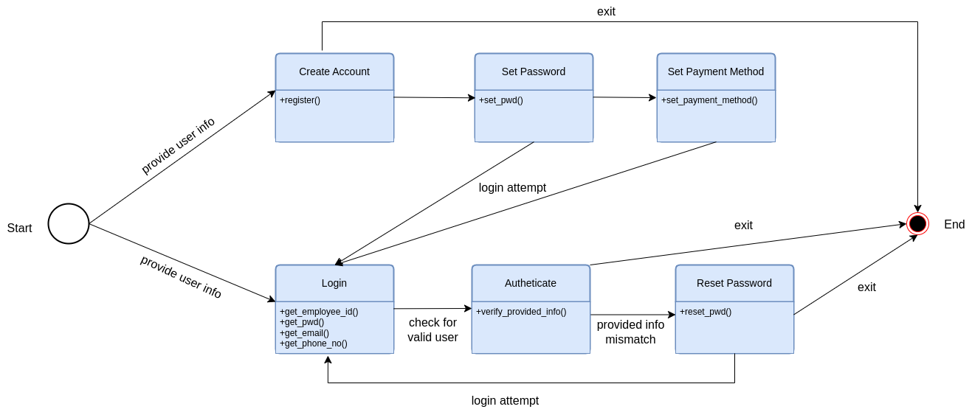

*Fig 60 : State transition diagram: Registration*

**ID: 02**

**Name: Employee**

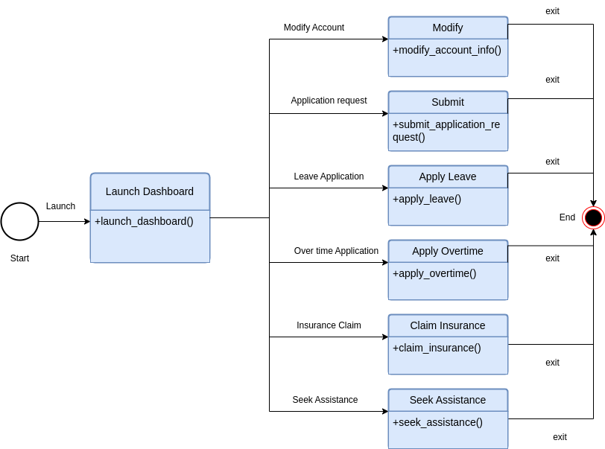

*Fig 61 : State transition diagram: Employee*

**ID: 03**

**Name: Manager**

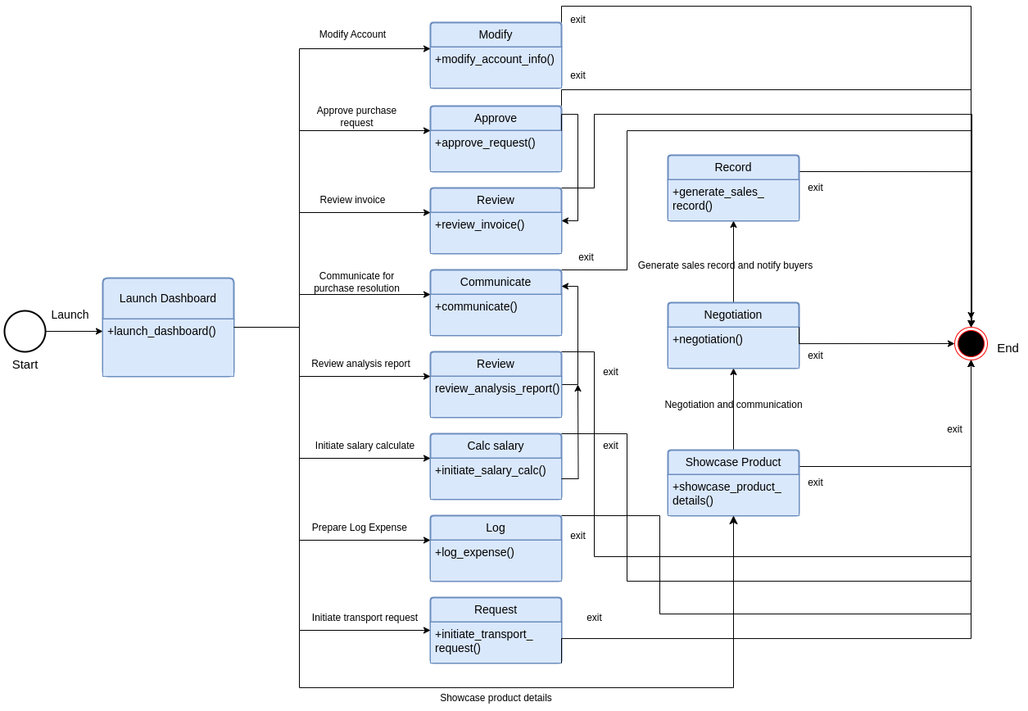

*Fig 62 : State transition diagram: Manager*

**ID: 04**

**Name: Supervisor**

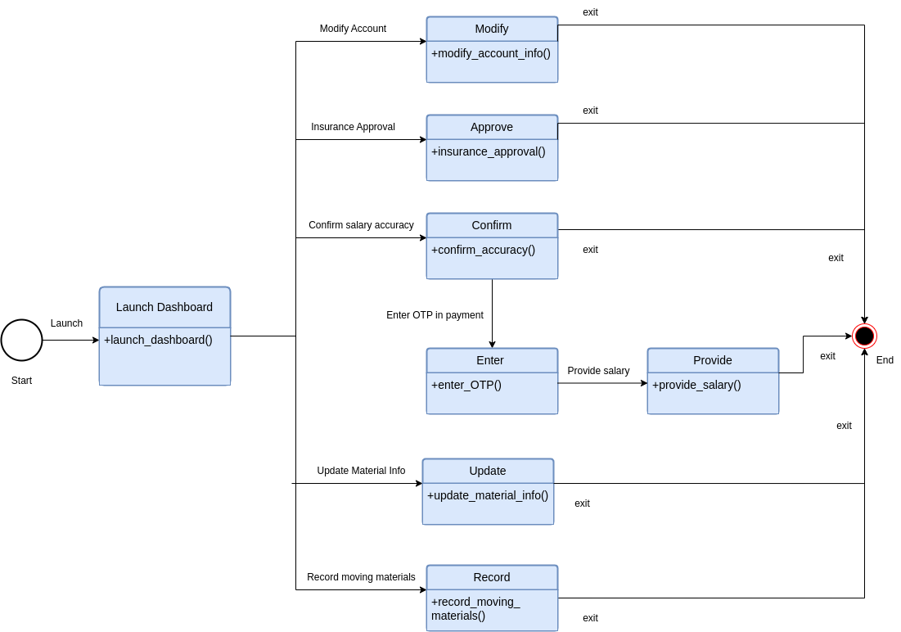

*Fig 63 : State transition diagram: Supervisor*

**ID: 05**

**Name: Administrator**

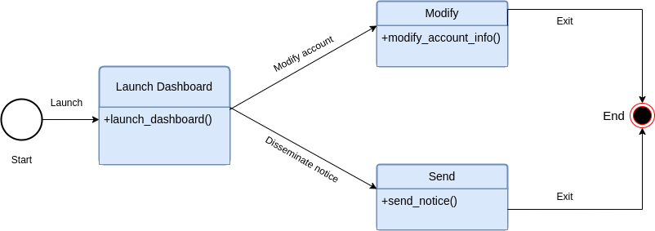

*Fig 64 : State transition diagram: Administrator*

**ID: 06**

**Name: Supplier**

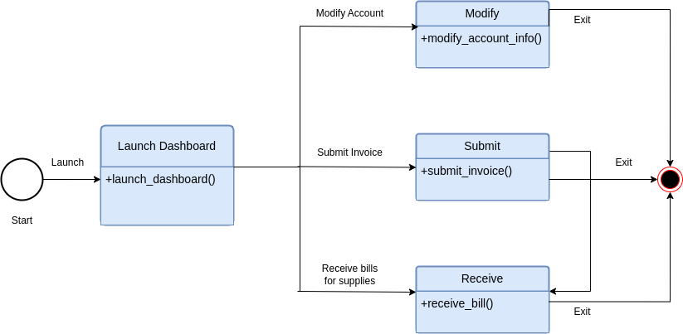

*Fig 65 : State transition diagram: Supplier*

**ID: 07**

**Name: Buyer**

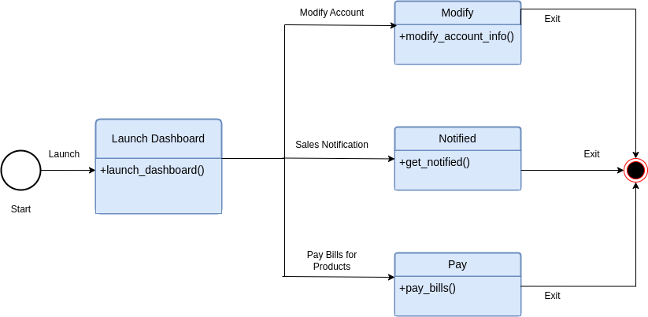

*Fig 66 : State transition diagram: Buyer*

**ID: 08**

**Name: Account Management**

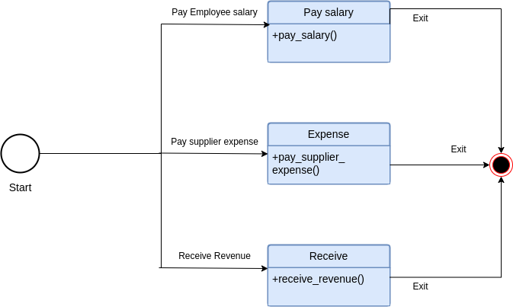

*Fig 67 : State transition diagram: Account Management*

**ID: 09**

**Name: SMS/Email**

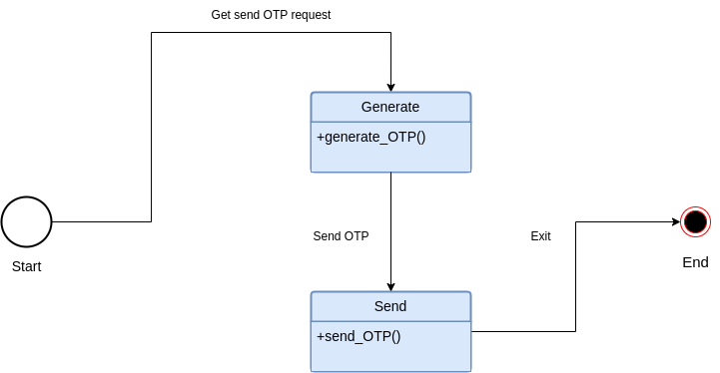

*Fig : State transition diagram: SMS/Email*

**ID: 10**

**Name: Database**

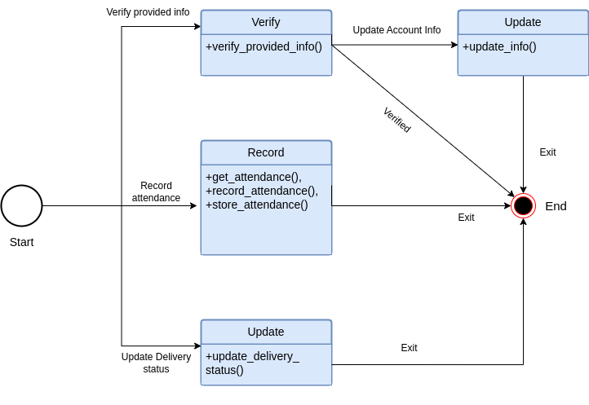

*Fig 68 : State transition diagram: Database*

**ID: 11**

**Name: Dashboard**

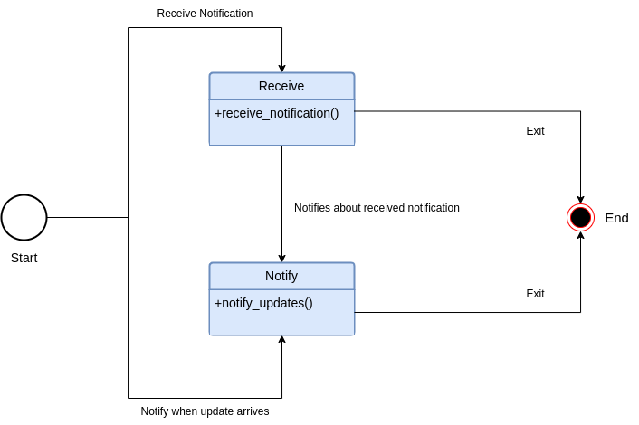

*Fig 69 : State transition diagram: Dashboard*

**ID: 12**

**Name: GPS**

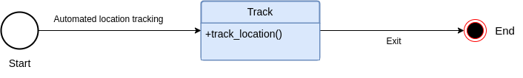

*Fig 70 : State transition diagram: GPS*

**ID: 13**

**Name: Warehouse**

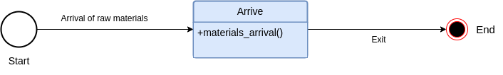

*Fig 71 : State transition diagram: Warehouse*

**ID: 14**

**Name: System Admin**

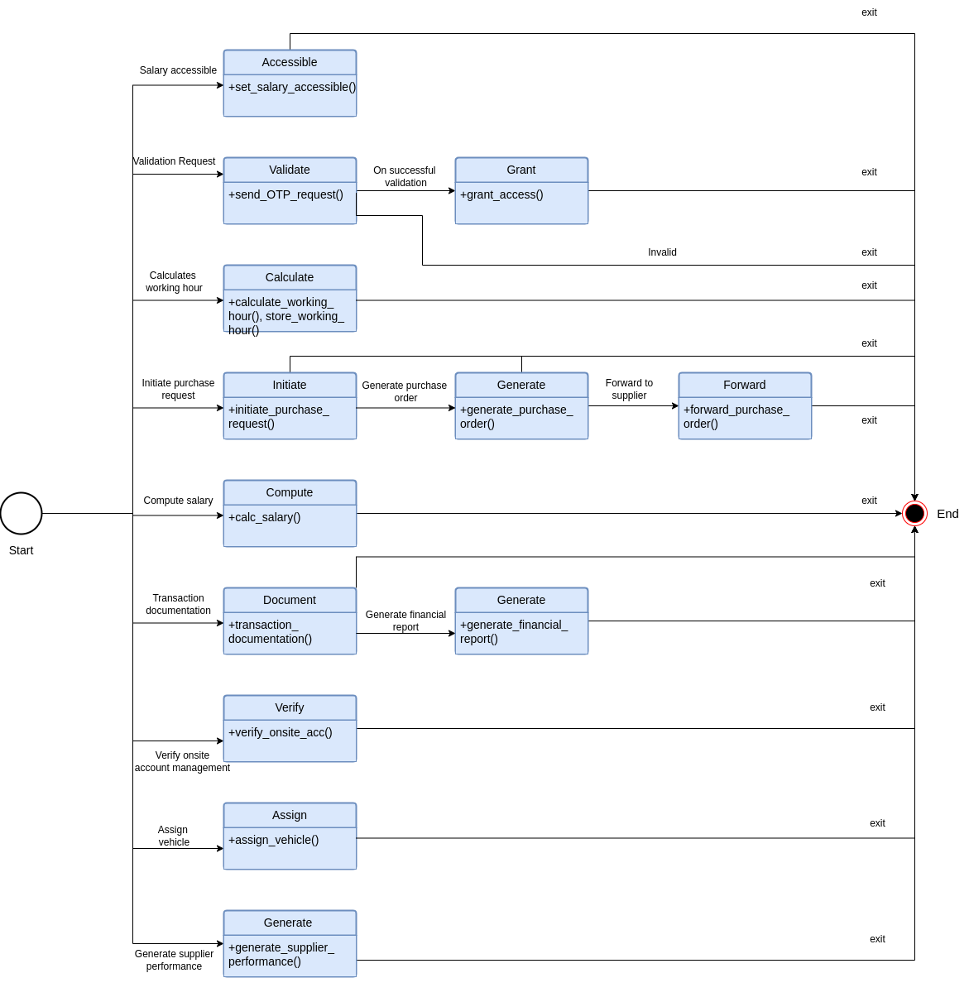

*Fig 72 : State transition diagram: System Admin*

**8. Sequence Diagram**

Sequence Diagrams are interaction diagrams that detail how operations are carried out. They capture the interaction between objects in the context of a collaboration. Sequence Diagrams are time focused and they show the order of the interaction visually by using the vertical axis of the diagram to represent time, what messages are sent and when.

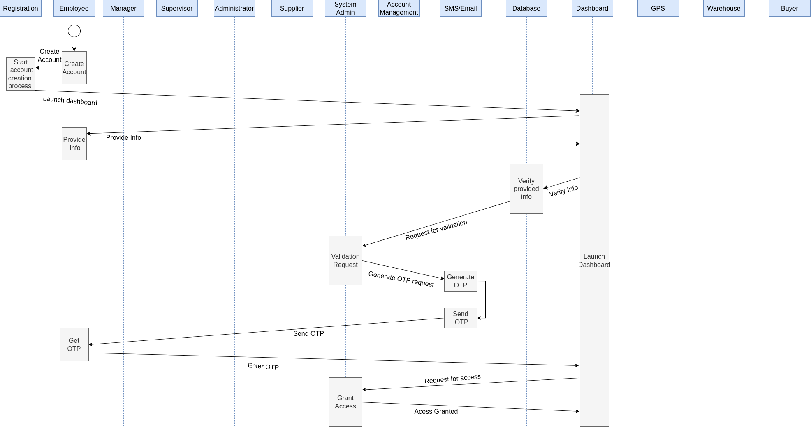

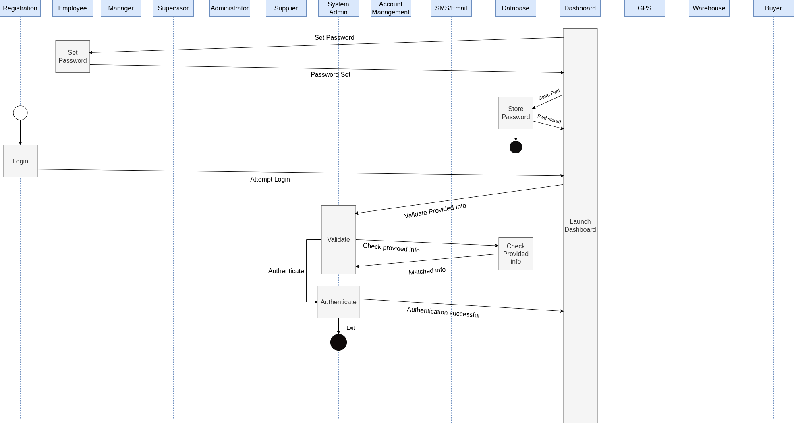

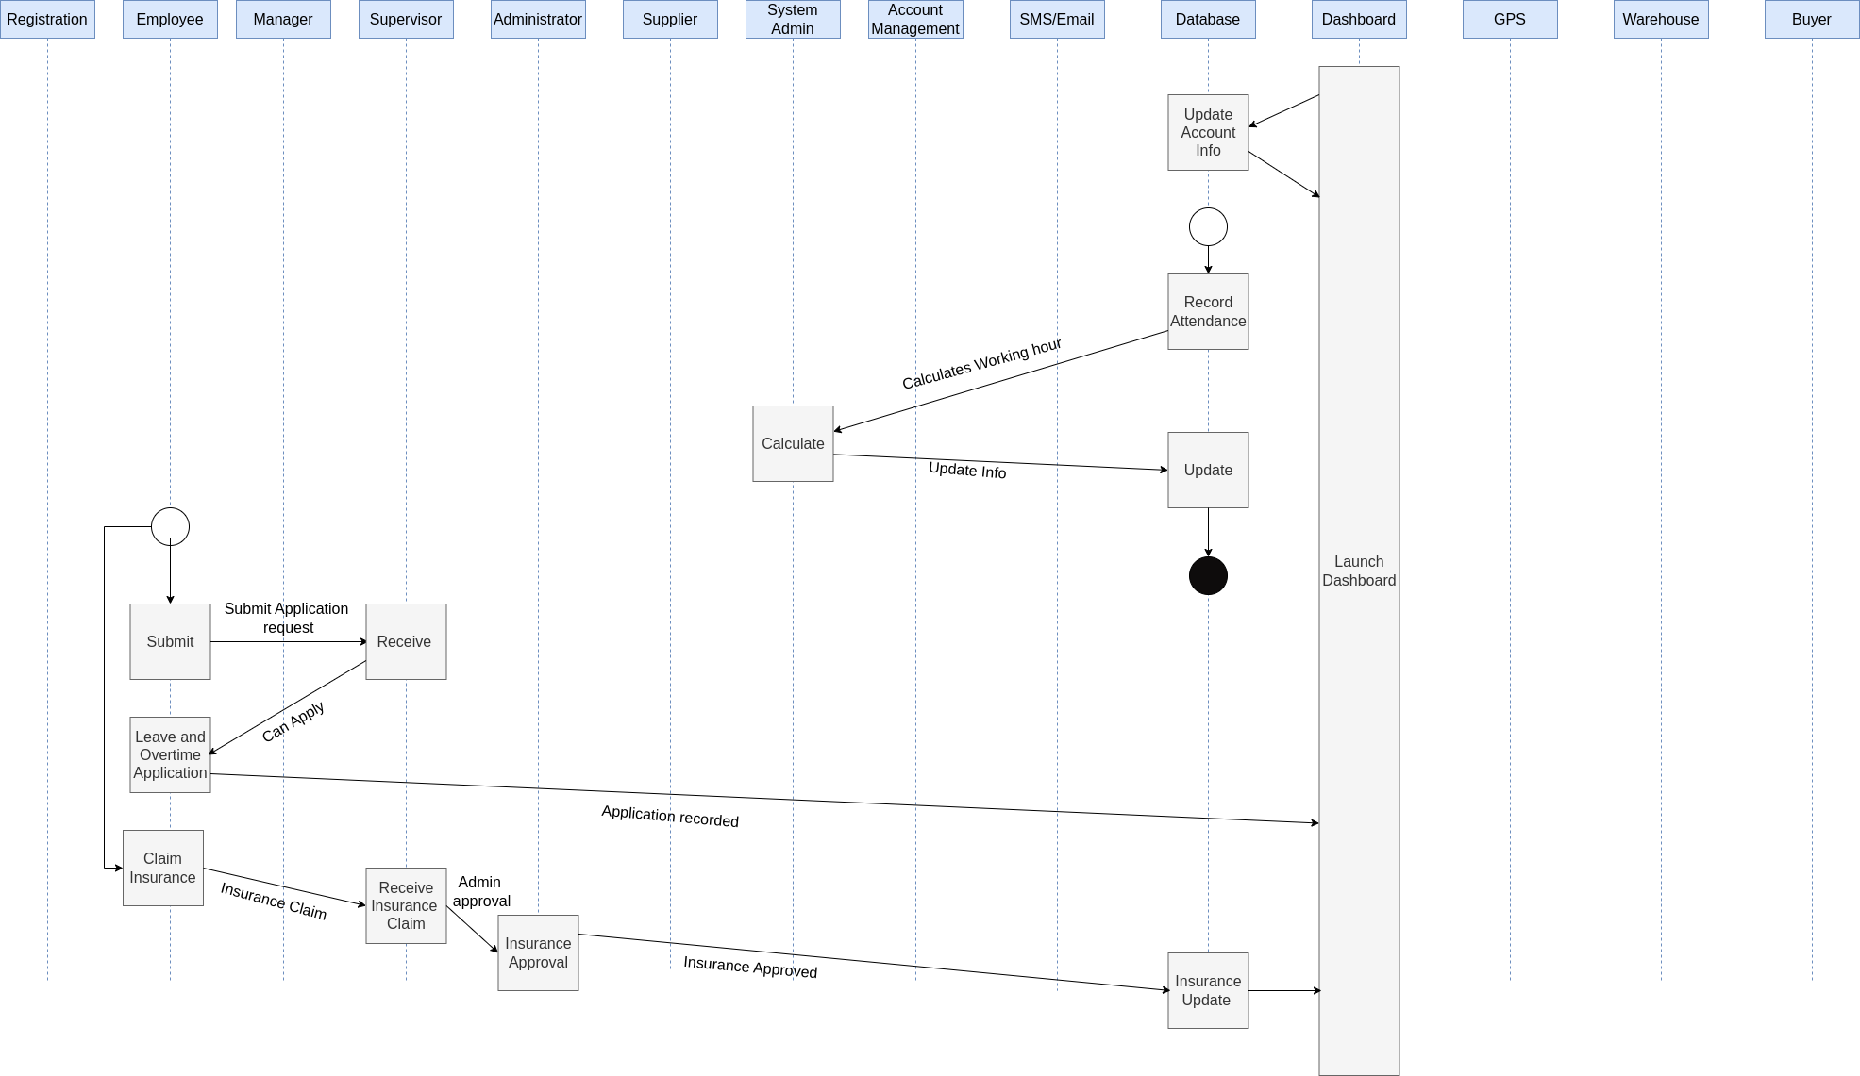

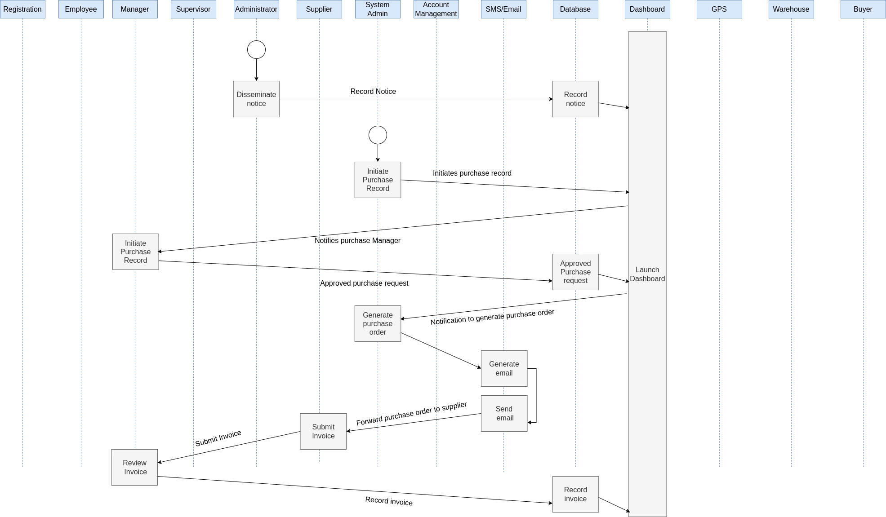

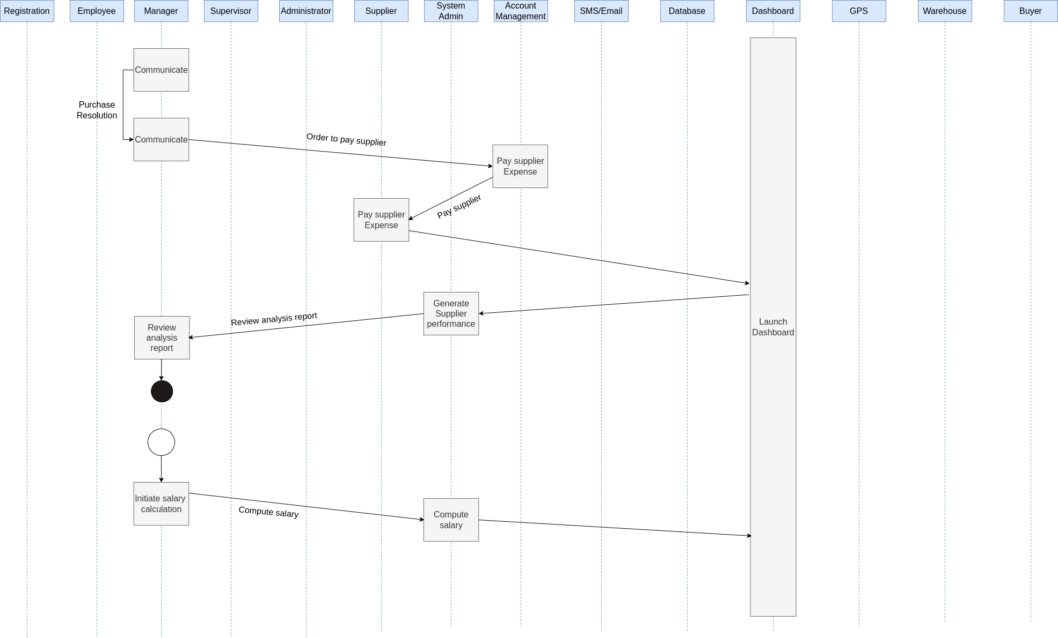

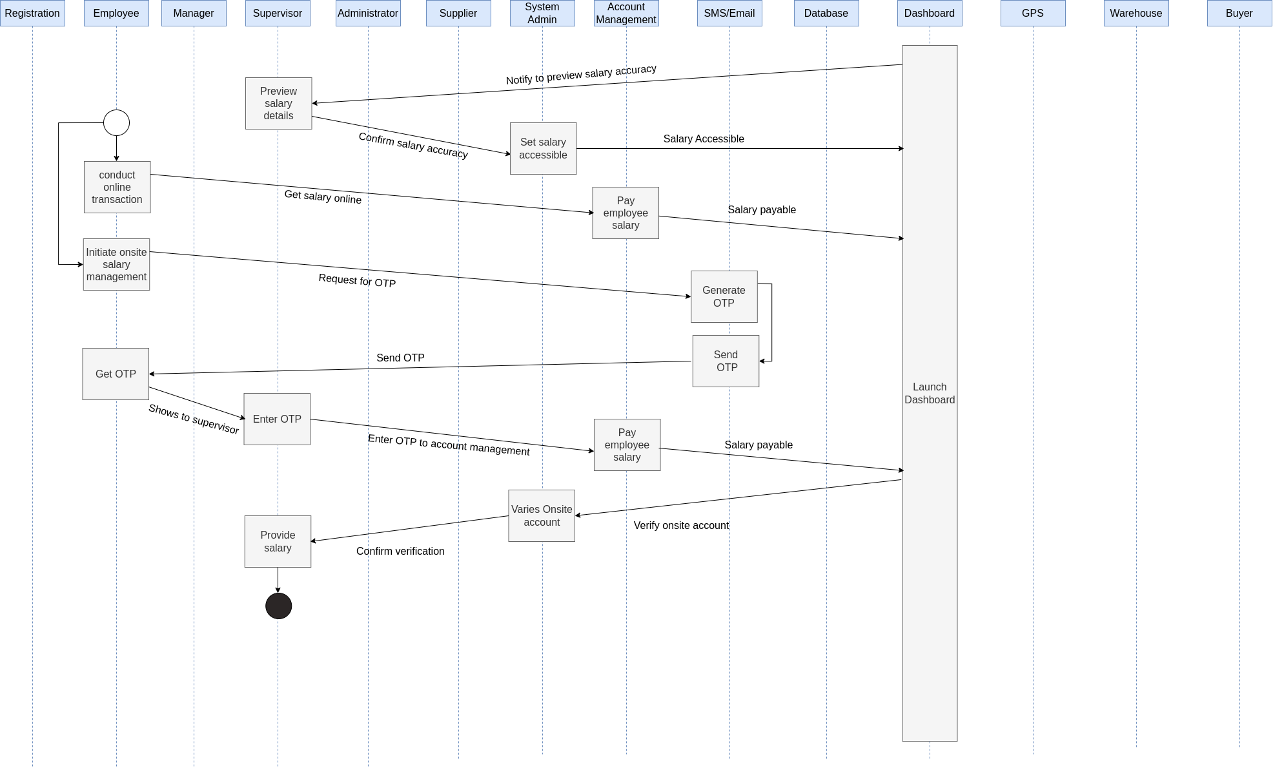

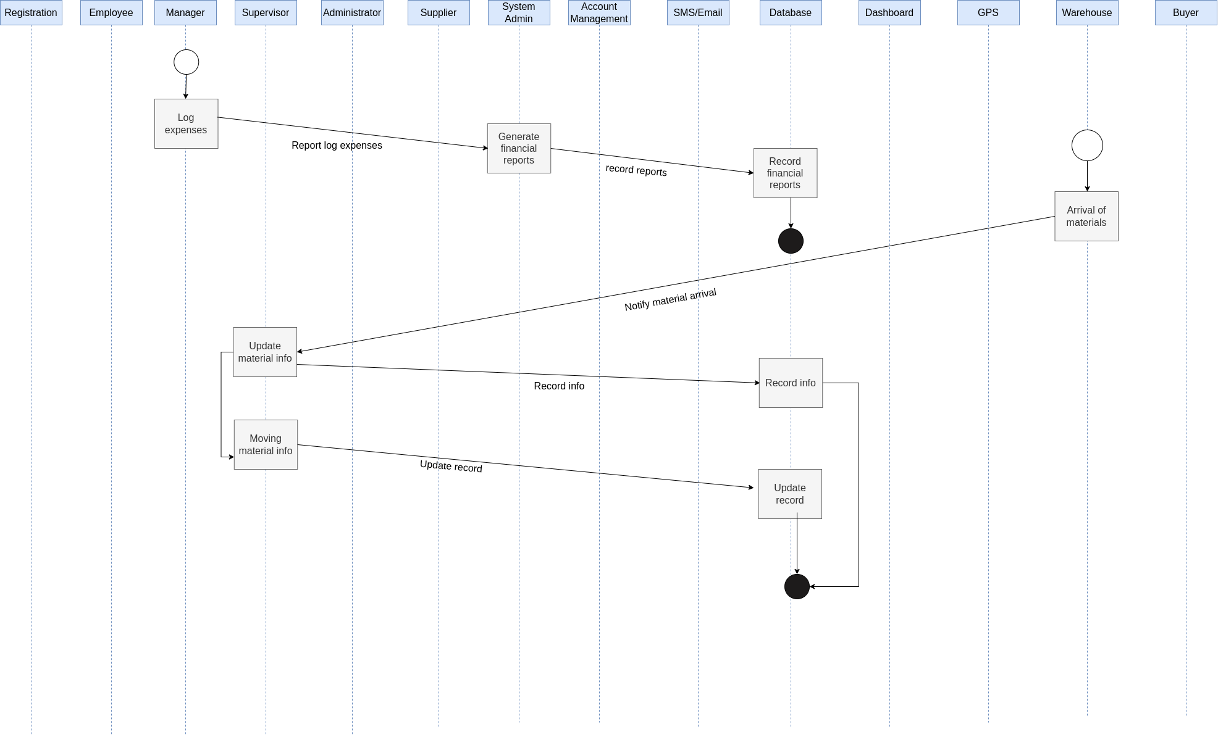

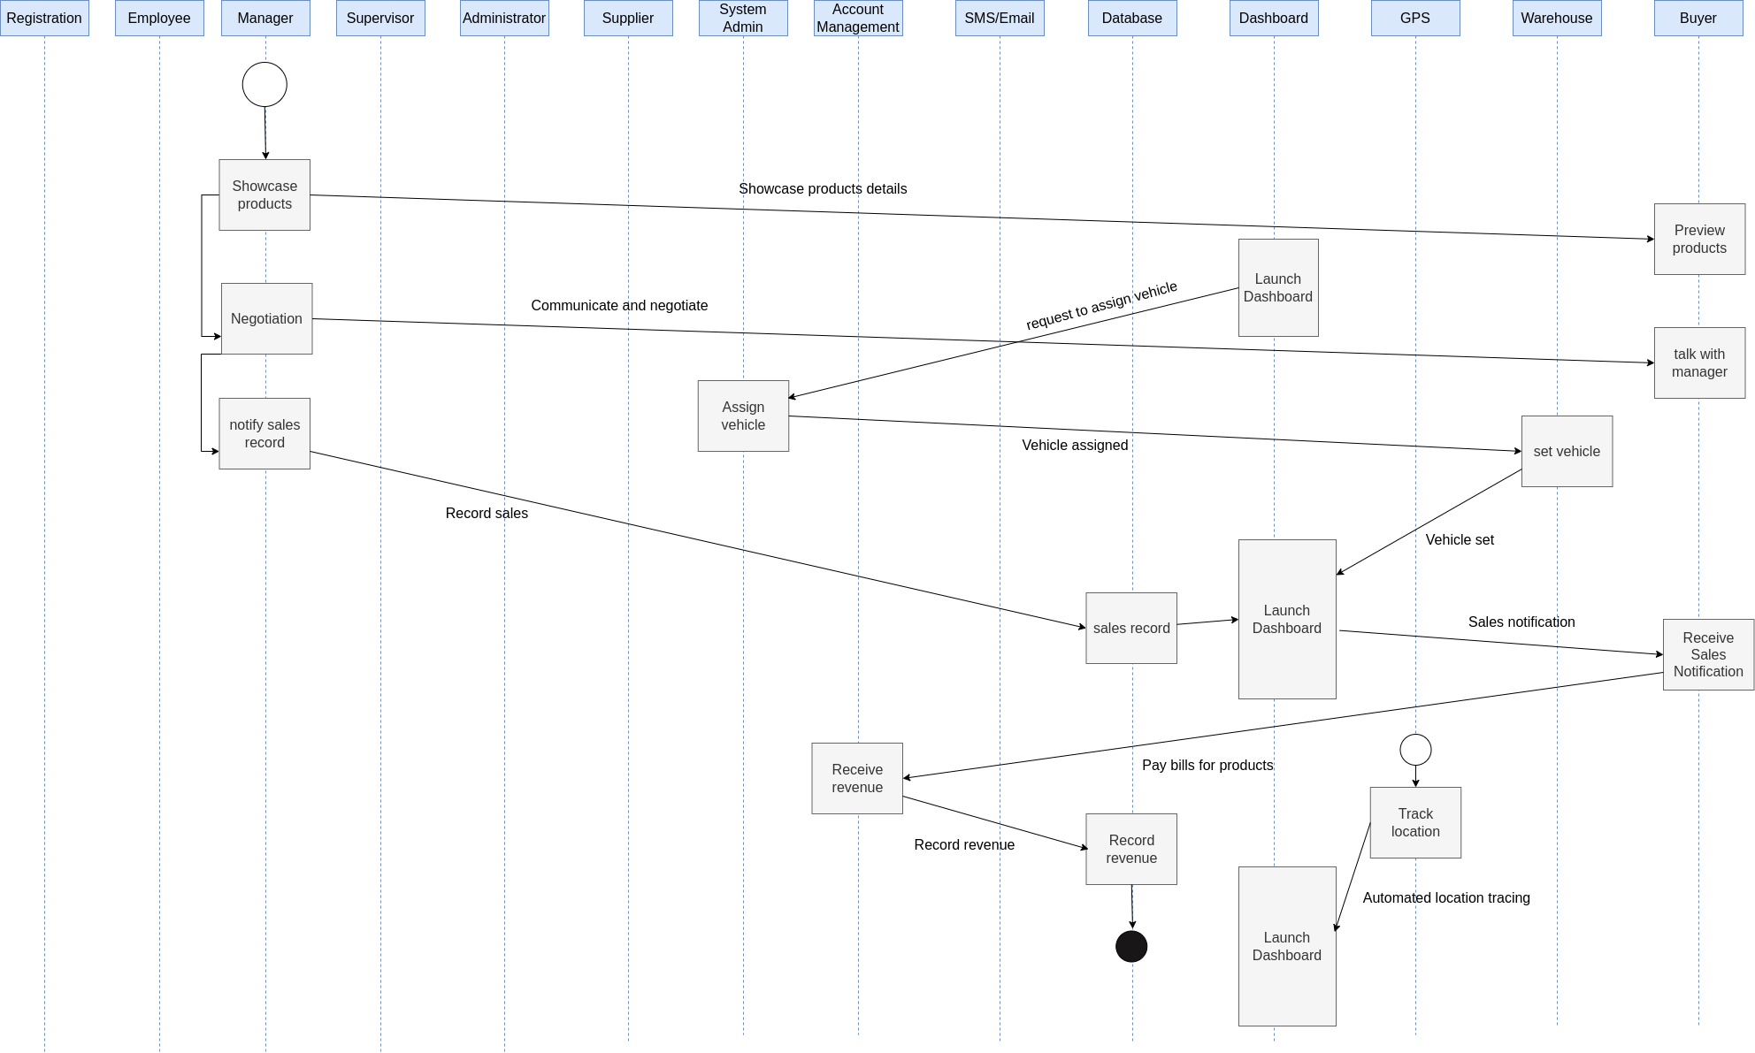

**7. Data flow Diagram**

ID: 0

Name : ASCMS

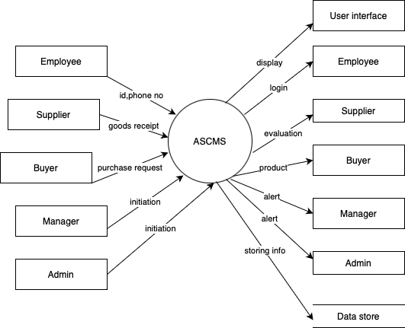

ID : 1.1

Name : Registration and Authentication System  
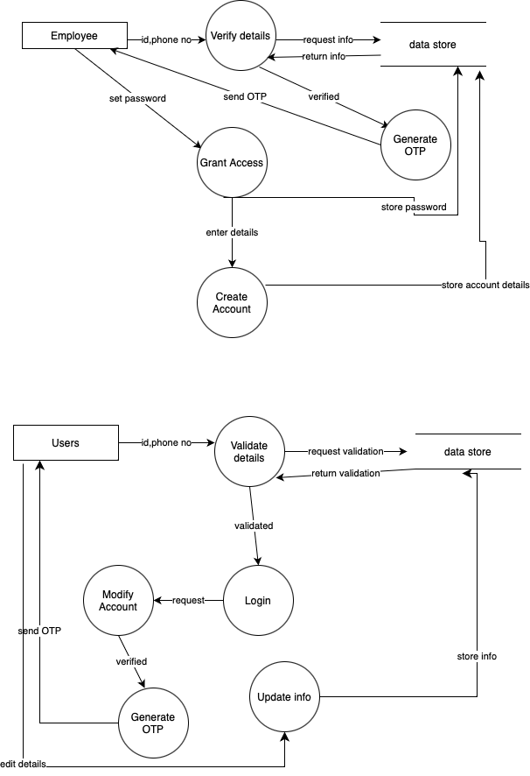

ID: 1.2

Name : HRM System

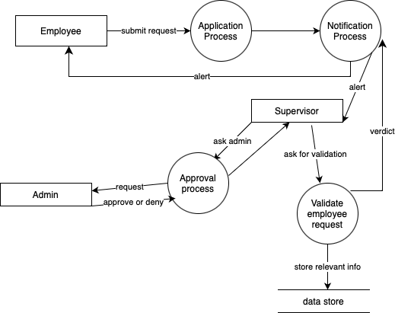

ID: 1.3

Name: Purchase Management System

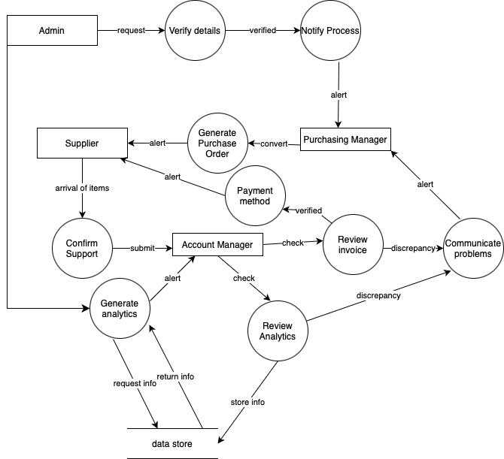

ID : 1.4  
Name : Account management system

ID : 1.4.1 (Payment)

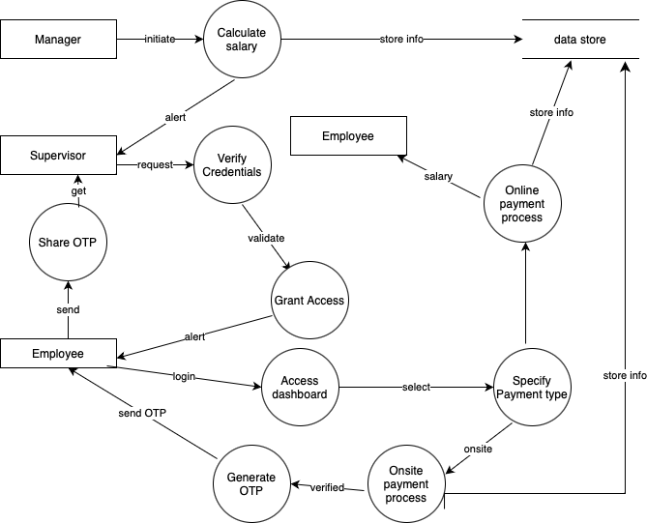

ID : 1.4.2 (report)

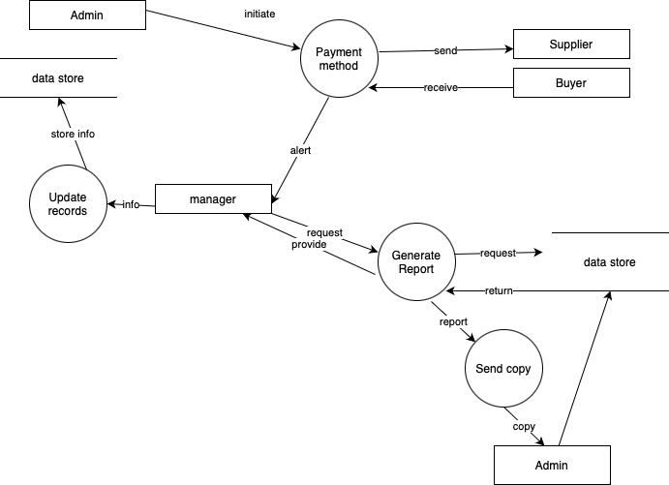

ID : 1.5

Name : Warehouse Management System

ID : 1.5.1 (Inventory)

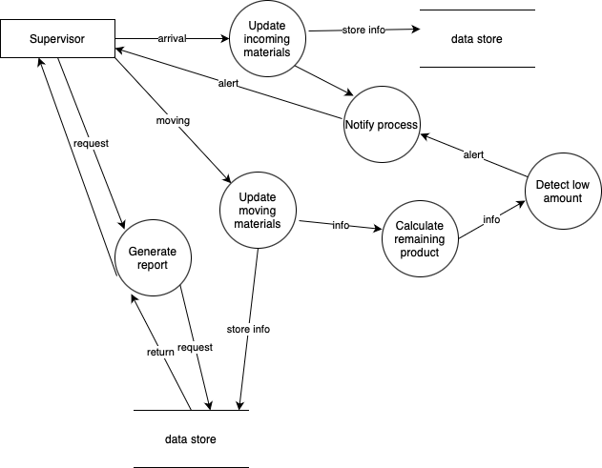

ID : 1.5.2 (Transport)

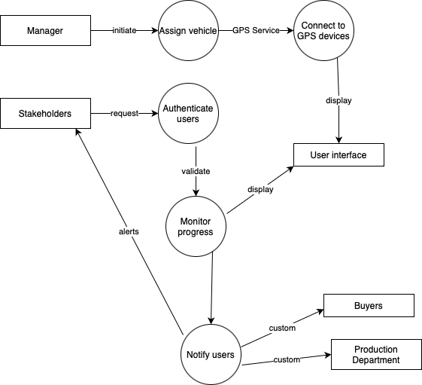

ID: 1.5.3 (Logistics and distribution)

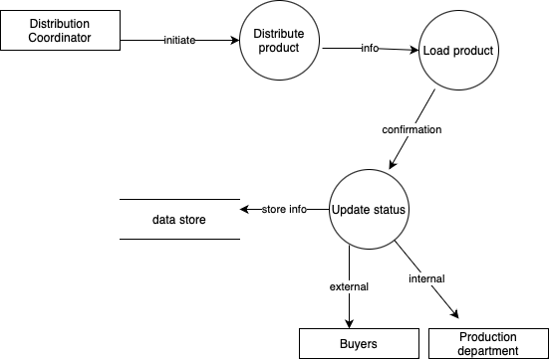

ID : 1.6

Name : Production and buyer interaction system

